

E-Project

**Web Designing**

GRACIOUS GARMENTS

|  |  |
| --- | --- |
| **Authors** | **Aptech - C1906L - Group 1** |
| |  |  | | --- | --- | | 1. Student1200898 | TRINH DINH THI THUY | | 1. Student1219050 | BAO NGO GIA | | 1. Student1209092 | MAN PHAM MINH | | 1. Student1200872 | CUONG NGO HUNG | |
| **Centre Name** | Aprotrain Aptech |
| **Date** | **30-Mar-2020** |
| **Semester** | 1 |
| **Instructor** | PHUOC DUONG HUU |

**HCM City, 30-Mar-2020**

Table of Contents

**PREFACE** 4

CHAPTER I: OVERVIEW 5

***1.*** ***Introduce the topic:*** 5

***2.*** ***Sitemap:*** 5

***3.*** ***Purpose of website:*** 6

***4.*** ***Some main pages:*** 6

CHAPTER II: TENDER REQUIREMENTS 7

***1.*** ***Functional Requirement*** 7

CHAPTER III: E-PROJECT DESIGN 7

***1.*** ***DFD Design for eProject*** 7

➢ **DFD Analysis: Design main functions of system** 8

***2.*** ***Database Structure Design for eProject*** 9

CHAPTER IV: INTERFACE SNAPSHOT 10

CHAPTER V: USER GUIDE 18

***1.*** ***Homepage*** 18

***2.*** ***Register New Account*** 22

***3.*** ***Login:*** 24

***4.*** ***Manage Profile:*** 25

***6.*** ***Logout:*** 27

***7.*** ***View and Select Product:*** 28

***8.*** ***Manage Cart and Make Payment:*** 29

***9.*** ***View About Us:*** 31

CHAPTER VI: ADMIN GUIDE 32

***1.*** ***Get to Administrator View*** 32

***2.*** ***Manage Product Brand*** 37

***3.*** ***Manage Product Category*** 41

***4.*** ***Manage Product*** 44

***5.*** ***Manage Customer*** 48

***6.*** ***Manage Order*** 51

***7.*** ***Manage Homepage Content*** 56

CHAPTER VII: DEVELOPER GUIDE 61

***1.*** ***Install Xampp or Wampp*** 61

**a.Change Port:** 61

**b.Create Account for user Wampp:** 63

**c.Create Database and Data** 65

**d.Access the website** 66

**PREFACE**

Today, information technology has developed strongly following width and depth. Electronic computers are no longer a rare medium is becoming more and more a popular tool for children to work and play people, not only in the workplace but also in the family. Especially public Information technology is applied in all fields of economics, politics, society ... Applications Information technology and computerization are considered one of the decisive factors set in national, organizational and in-store operations. It plays the role The game is very important and can create a powerful breakthrough.

The INTERNET network is one of the most valuable and great products become an indispensable tool, the foundation for transmission and exchange global information. By INTERNET, we have done the merits The faster speed, much lower cost than the traditional way. This, in turn, promotes the birth and development of e-commerce around the world, significantly altering the cultural face, improving people's lives. In production and business activities, the typical trade has been confirmed to be exposed advancing and promoting the development of enterprises. For an online shop, advertising promote and introduce products to customers to meet increasing shopping needs Customer's will be necessary. Therefore, our group has carried out the topic "Building Website development for selling beauty care”. Shop will be the place where customers can choose for themselves the favorite products and in accordance with the current fashion trend.

The website is called GRACIOUS GARMENTS and will be the place where the store best promotes all the products they sell. Through this we would like to express our sincere thanks and express gratitude to you dedicated instruction of teachers in the school "Aptech international programmer training system". Especially Mr. PHUOC HUU DUONG, who directly instructed, taught and helped us during the implementation of this project.

# CHAPTER I: OVERVIEW

1. ***Introduce the topic:***

Business - buying is an indispensable need for each of us. In the current competitive era, the introduction of business products to individuals with low cost and high efficiency is a dilemma of business people with the demand for shopping with multi-products, Quality and affordability of consumers. So, our team conducted the website design to buy and sell goods online to help the stores grow faster, helping the store owners to manage their stores in a better way.

1. ***Sitemap:***

The website includes two parts: Customer Site and Administrator Site

* **Sitemap for Customer Site**

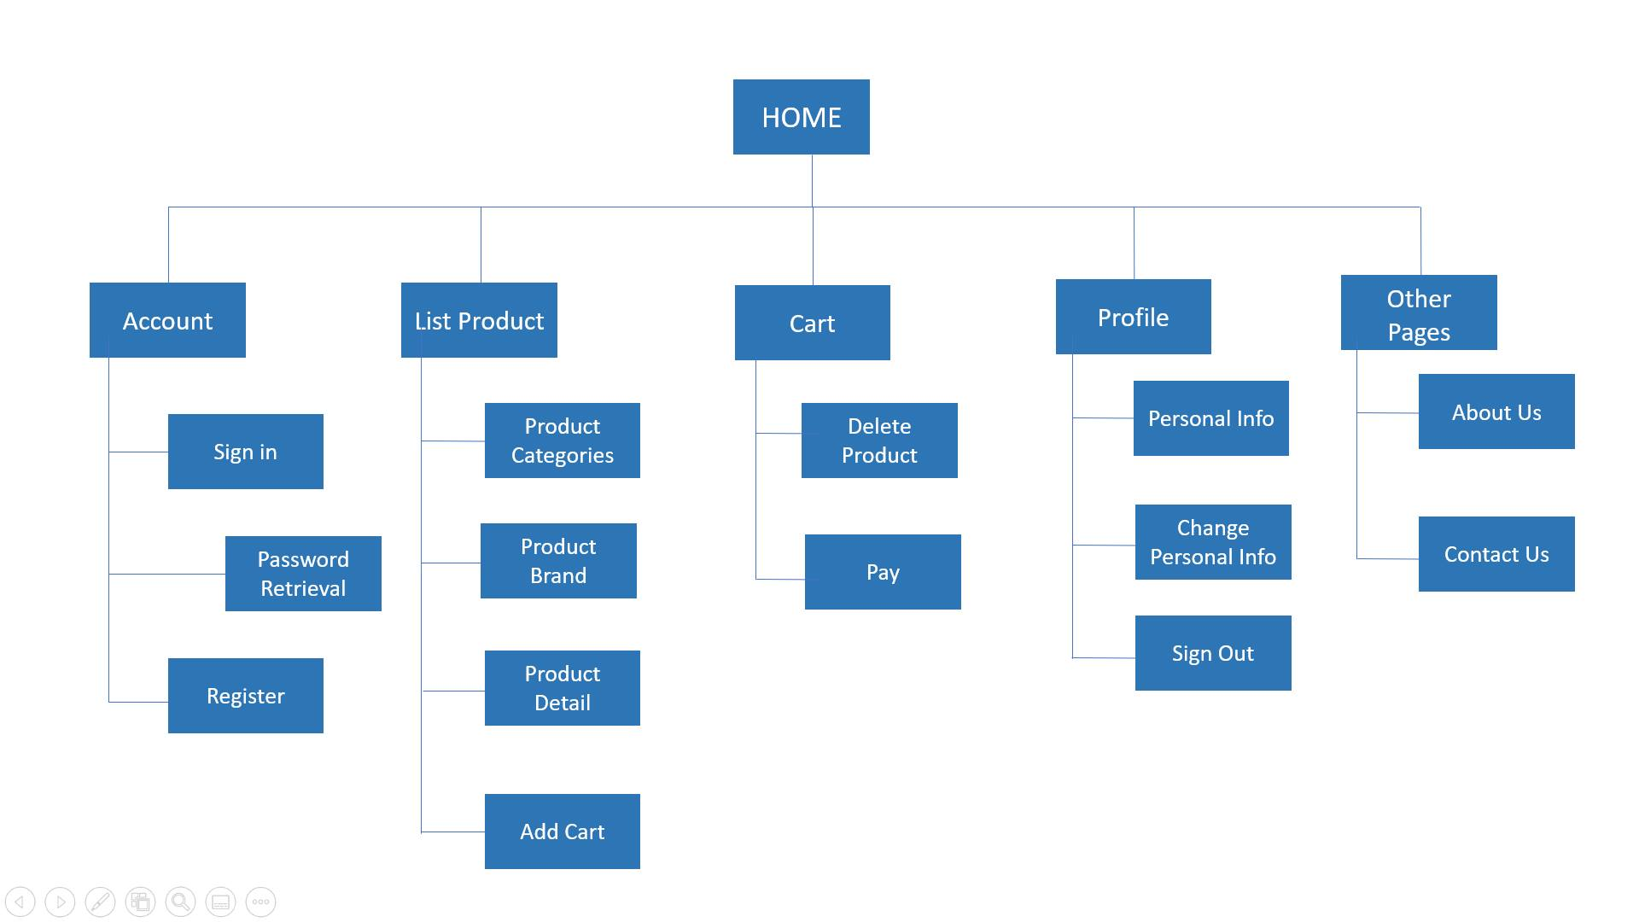

* **Sitemap for Admin Site**

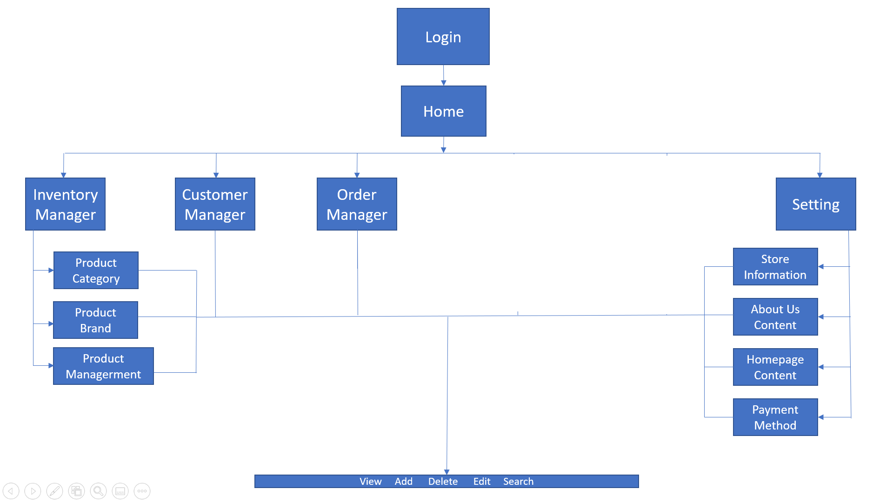

## ***Purpose of website:***

GRACIOUS GARMENTS is selling various types of GARMENTS for both MEN and WOMEN. The company advertises by distributing the pamphlets, advertising on television and so on. Due to rapid development in internet field, the company decides to launch a website where people will get all the information about the various products available with them easily.

You are supposed to create a website for them with the below mentioned requirement specifications.

The website is to be developed for the Windows Platform using HTML5, JavaScript and Geolocation. The site should work well in all leading browsers including Chrome, IE, Firefox etc.

## ***Some main pages:***

* **Home page**: This is an introduction page of the shop's best selling products. In addition, you can learn more about collections, hot shop promotions, links to page like products, about us, contact us, login, register, ,..
* **Products**: This is the products page to view and add products to cart if the customer want to buy.
* **About us**: This page introduces customers with more information of stores.
* **Contact us page**: This page displays the location of shop for customer come to buy. This page contains shop information (such as: location, website, phone, …) for customers to contact.

CHAPTER II: TENDER REQUIREMENTS

1. ***Functional Requirement***
2. The Home Page should be created making use of Frames with a suitable logo.
3. Home Page should contain details of different Garments with suitable images.
4. The site should display a menu which will contain the options for brief introduction about the various garments available, location of the shop and any other information if required.
5. The information should be categorized according to the brand names of the products like if a User wants to see only “Van Heusen” products or any other companies products then he/she can click on a Link/button/menu etc and can see only that Brand products.
6. When a user selects any particular brand, a list of products for that brand will be displayed
7. A brief summary of features of individual products should be displayed on the Web Page along with the product but detailed Features should be stored in Individual Word documents which can be downloaded or viewed by the User who wishes to see the same.
8. The user should also be able to compare the various products of different as well as similar brands.
9. There should be a “Contact Us” page which will have the Address of the Company which is as follows and the mail address which when clicked will invoke the local mail client from where they can send an email. Address of the Company should be displayed using GeoLocation API (eg. GoogleMaps).
10. ***Non-Functional Requirement***

**Hardware**

* A minimum computer system that will help you access all the tools in the courses is a Pentium 166 or better
* 64 Megabytes of RAM or better

**Software**

* Notepad/HTML editor
* Dreamweaver
* IE 5.0/ Netscape 6.0

# CHAPTER III: E-PROJECT DESIGN

1. ***DFD Design for eProject***

* **Define DFD**
* Data Flows Diagram (DFD) describes the information flow in the system. The next step of system analysis is to consider in detail the information necessary for the implementation for functions discussed above and the one necessary for the improvement of the functions. Modeling tool frequently used for this purpose is DFD. DFD will support 4 main activities.
  + **Analysis:** DFD is used to determine requirement of users. From DFD, all system stakeholders can share the same view on how the data will flow within the system and between the functions.
  + **Designing:** DFD is used to map out plan and illustrate solution to system analysts and other stakeholders while designing a new system.
  + **Communication:** DFD provides simplicity and ease-to-understand to system analysts as well as other stakeholders.
  + **Document**: DFD is used to provide special description of requirement and system design. DFD provide an overview of key functional components of the system, along with other tools like database dictionary, process specification, relevant stakeholders will get the idea of which information will be exchanged and how.
* **Main Components of DFD**

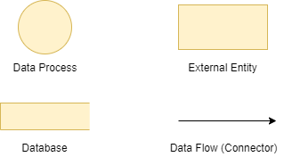

* 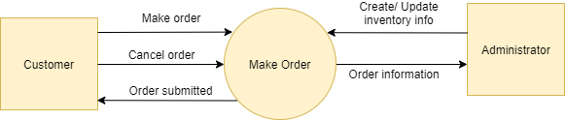**DFD Analysis: Design main functions of system**

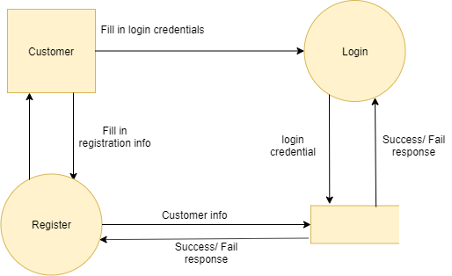Level 0: Making Order

Level 1: Login and Register Account

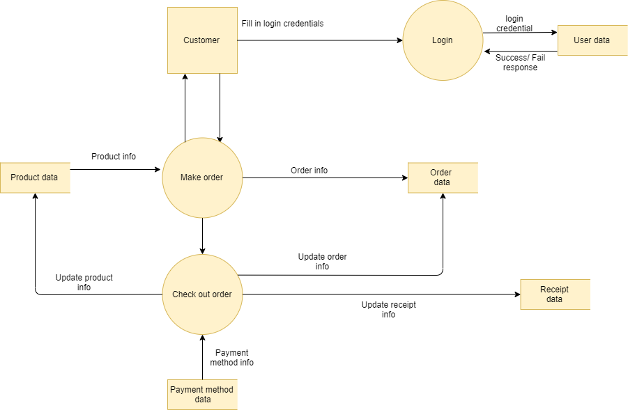

Level 2: Making Order and Payment

1. ***Database Structure Design for eProject***

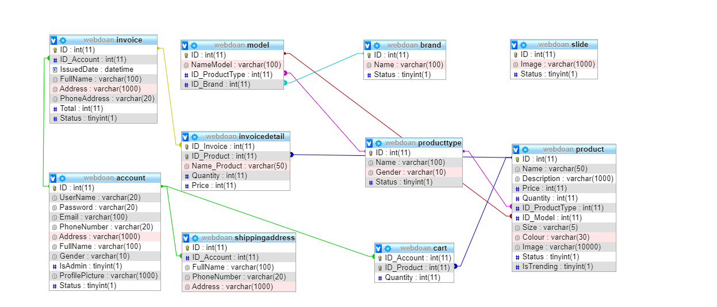

CHAPTER IV: INTERFACE SNAPSHOT

* **Home Page:**

Figure : Homepage

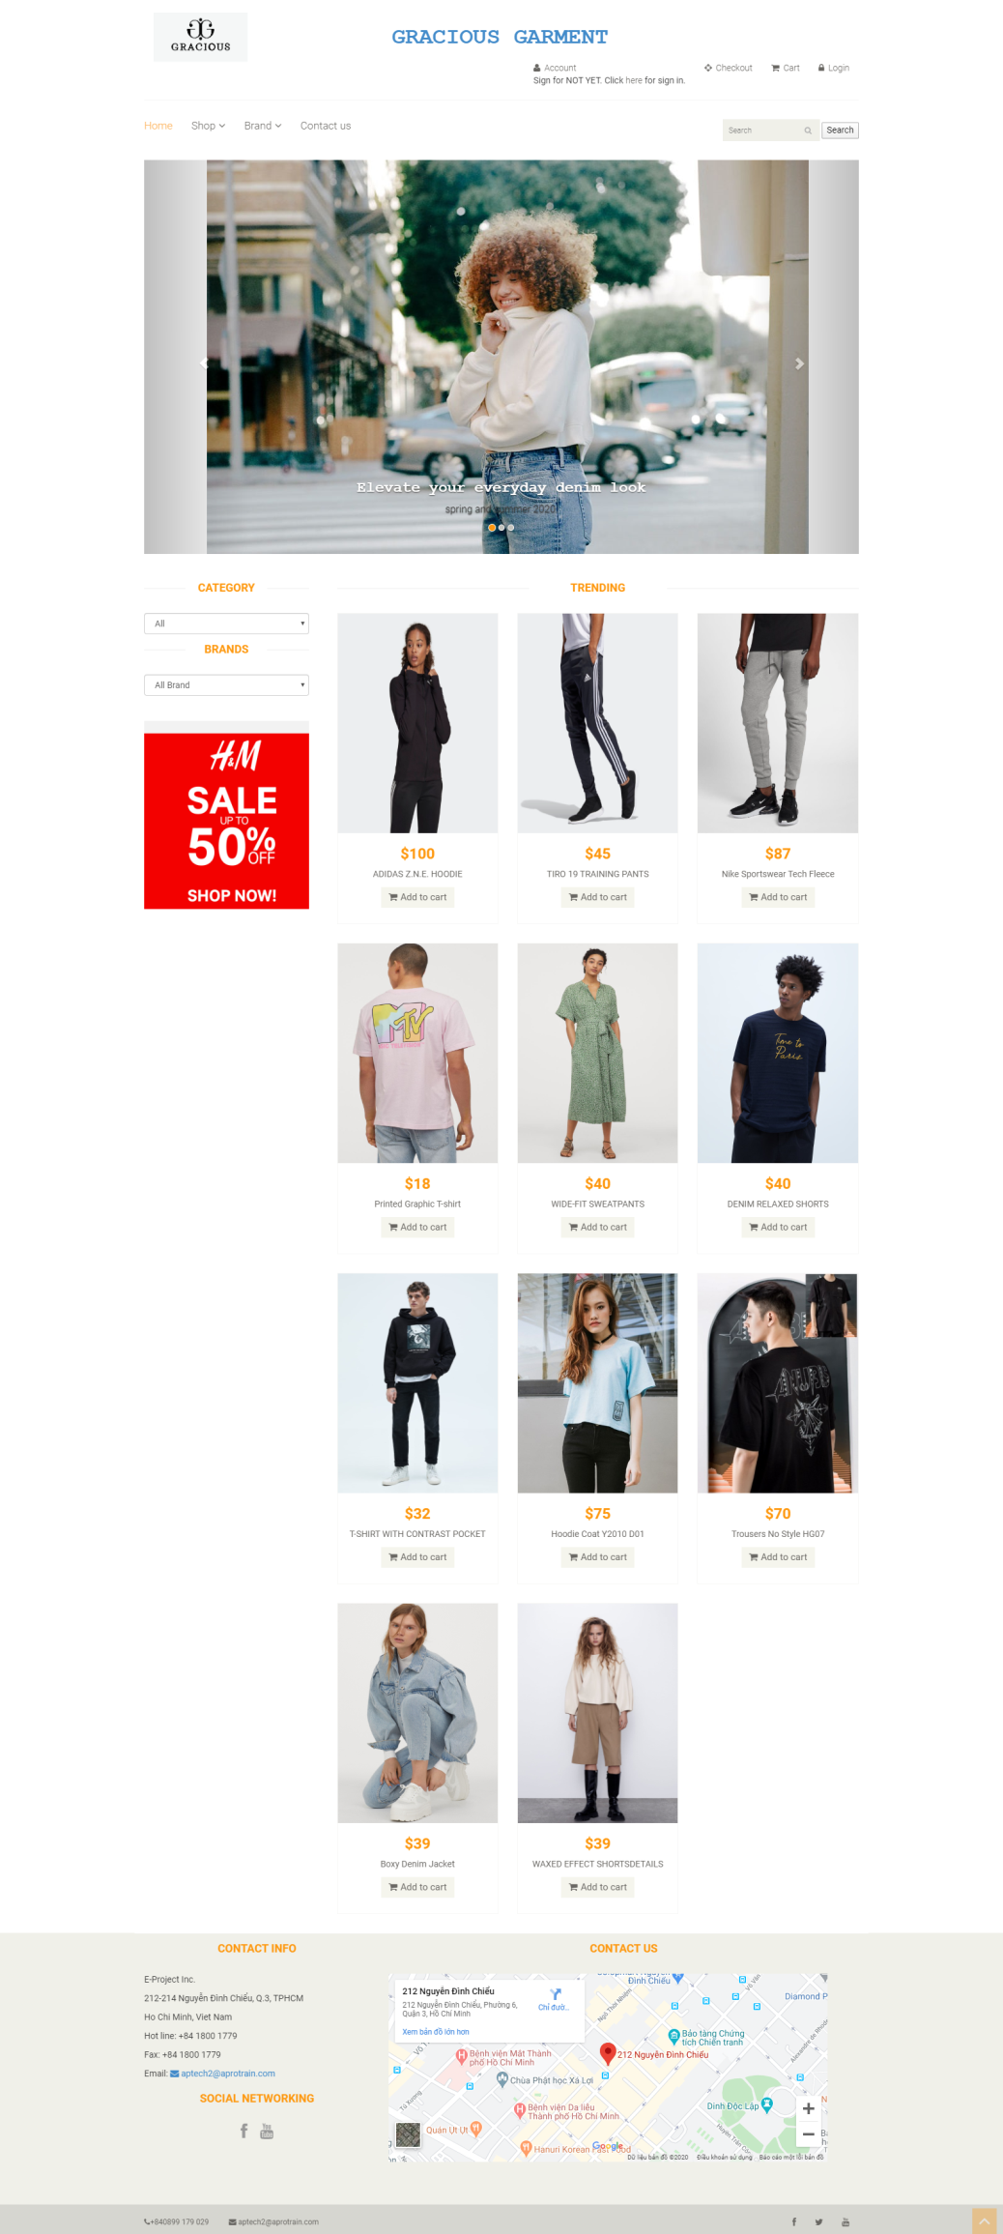

* **Register and Login**

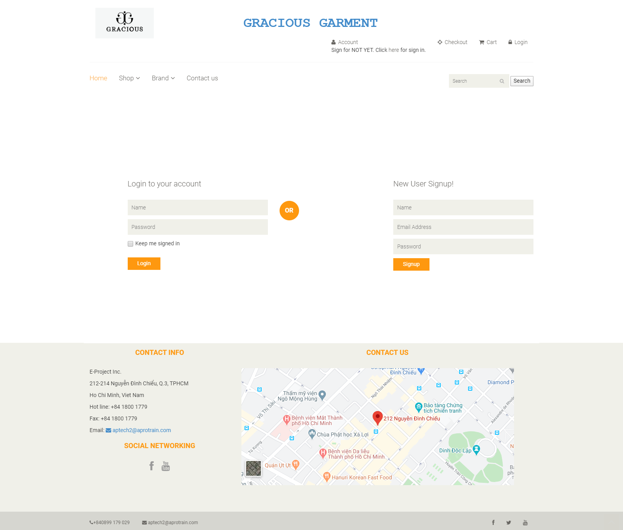

* **Product List:**

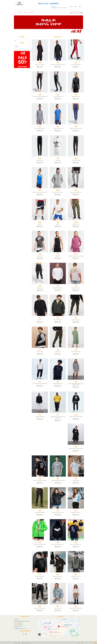

* **Product Detail:**

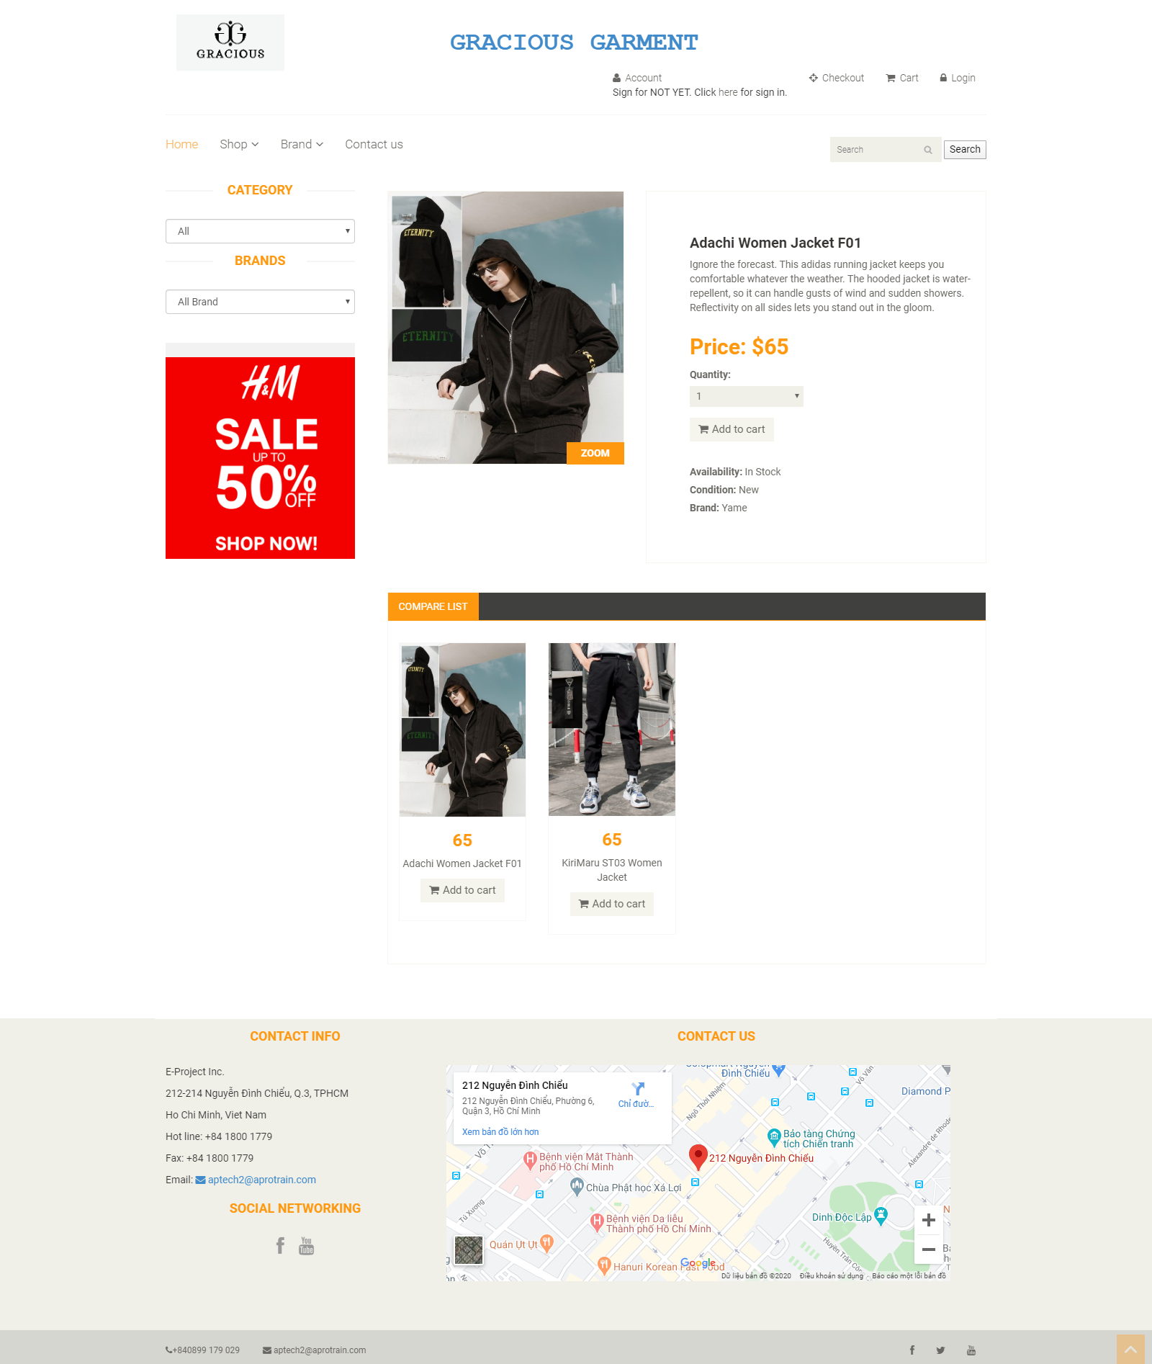

* **Profile, Profile History, Old Detail Order**
* 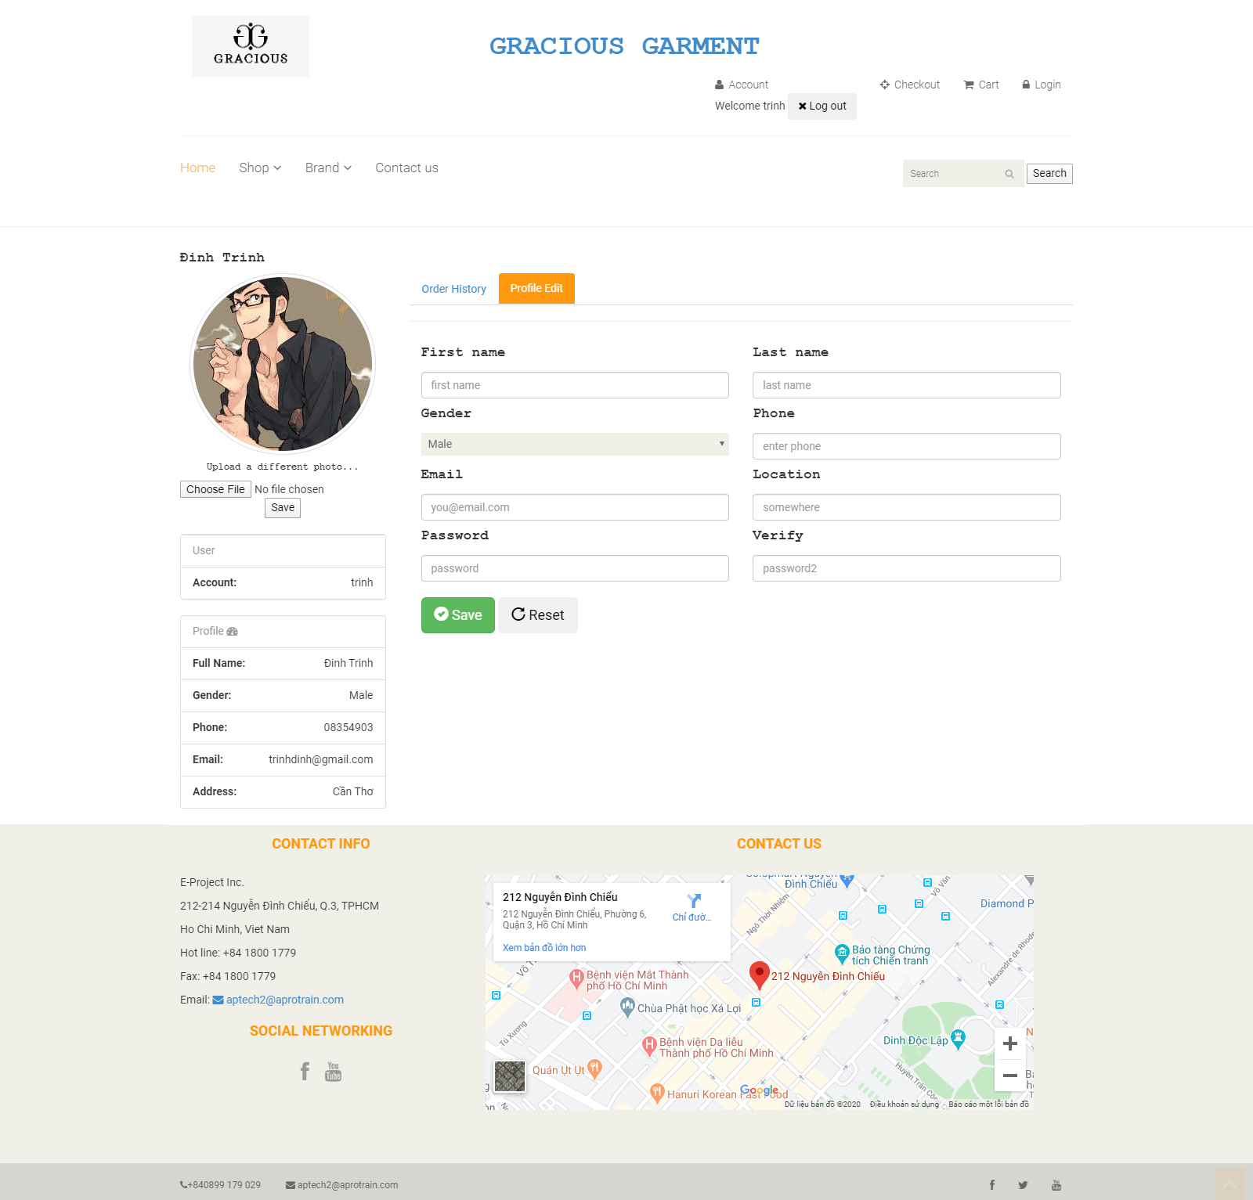

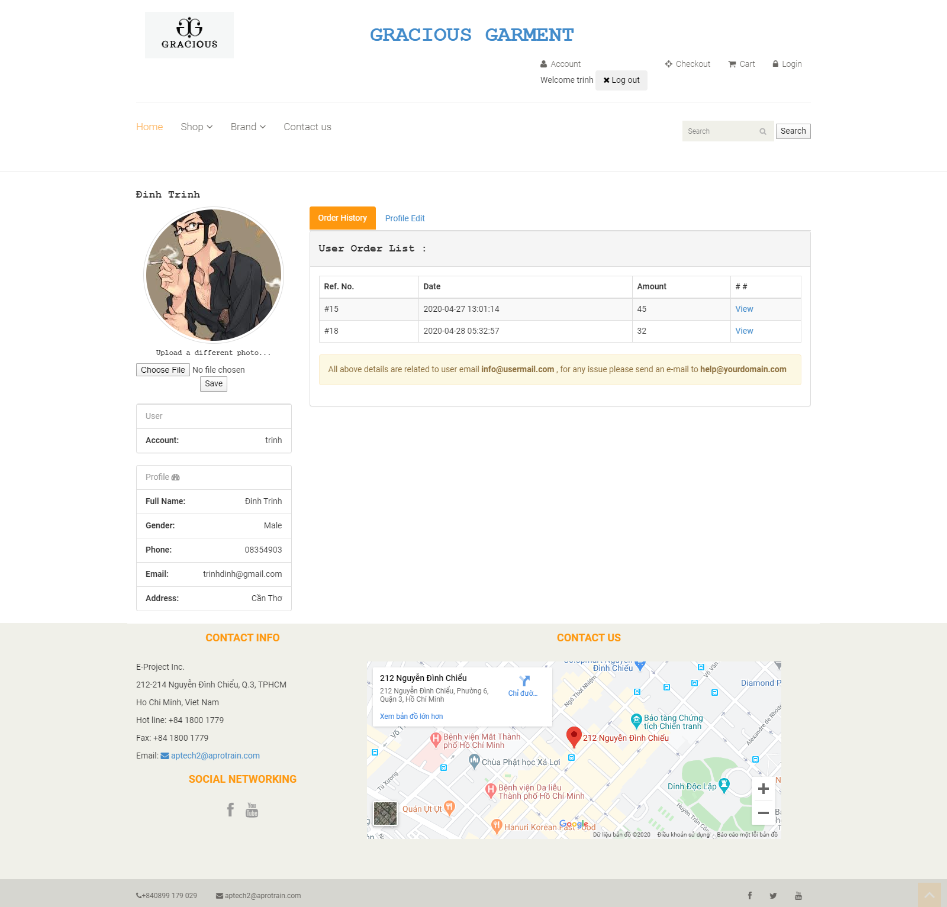

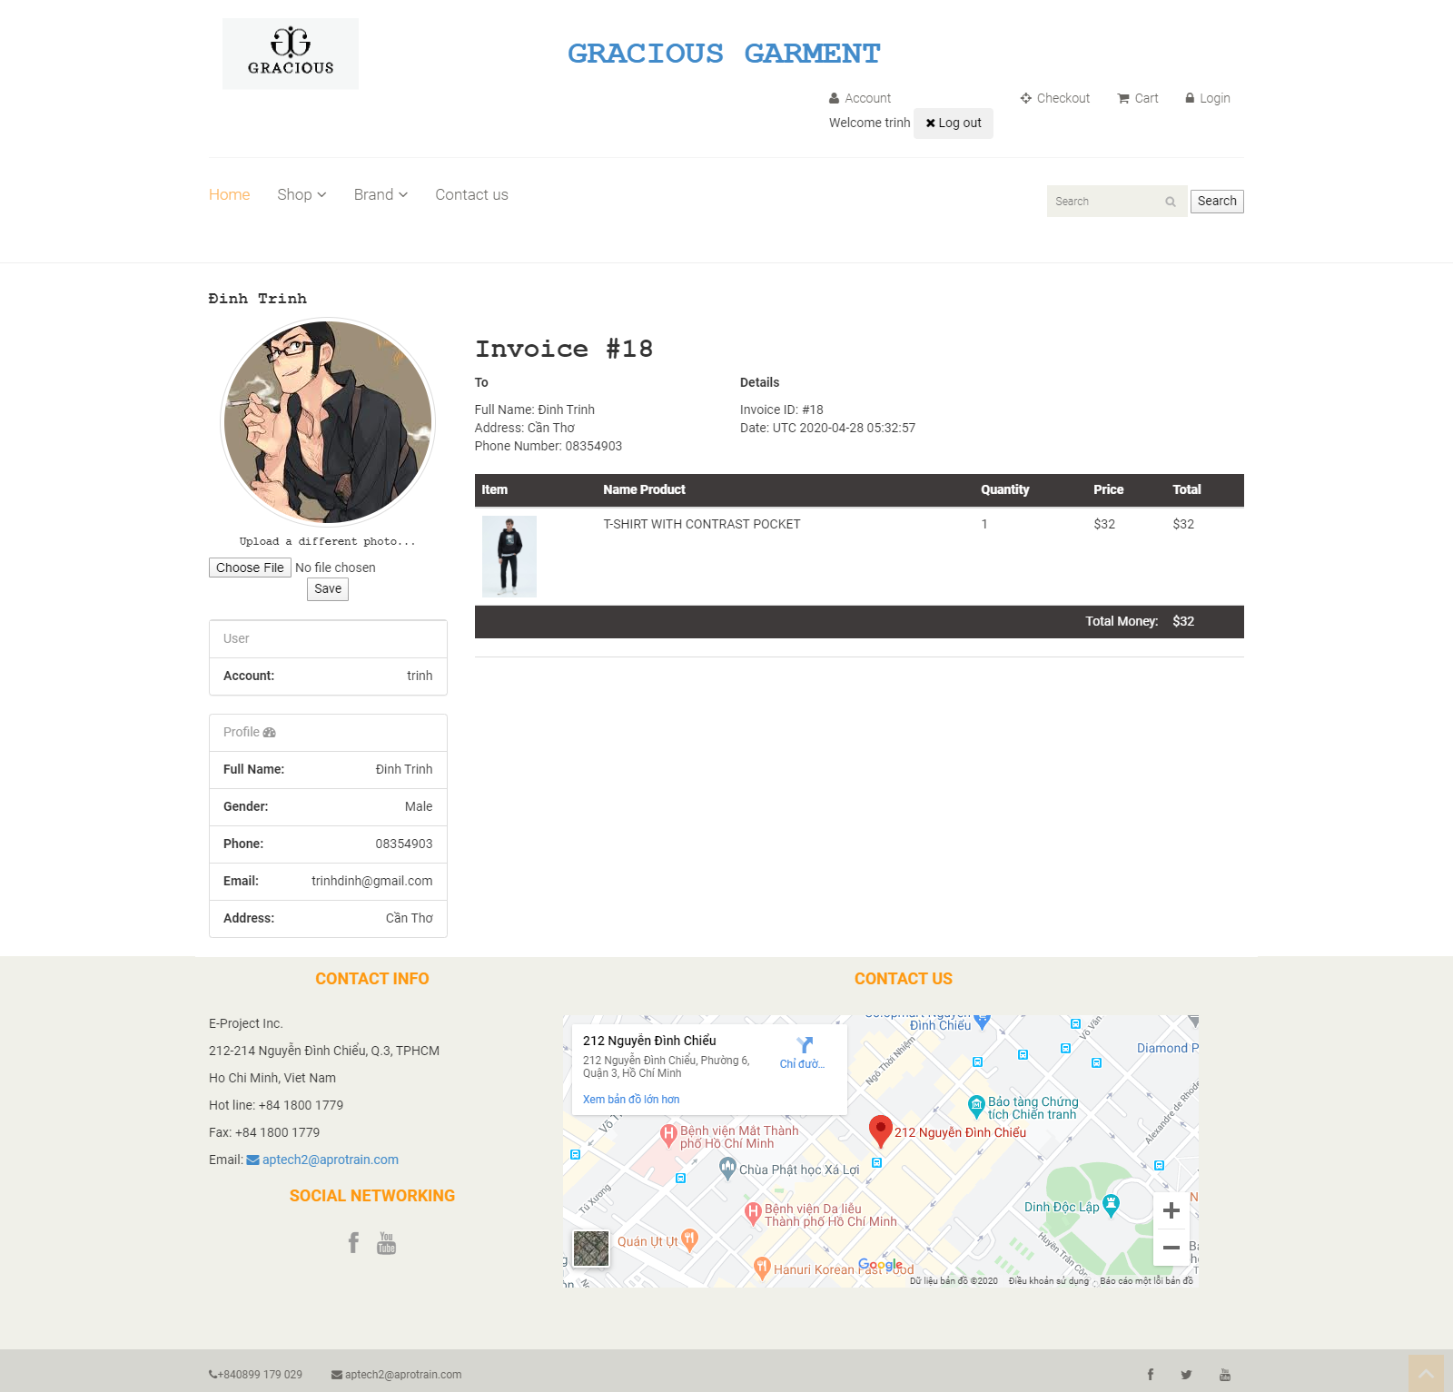

* **Cart Page:**

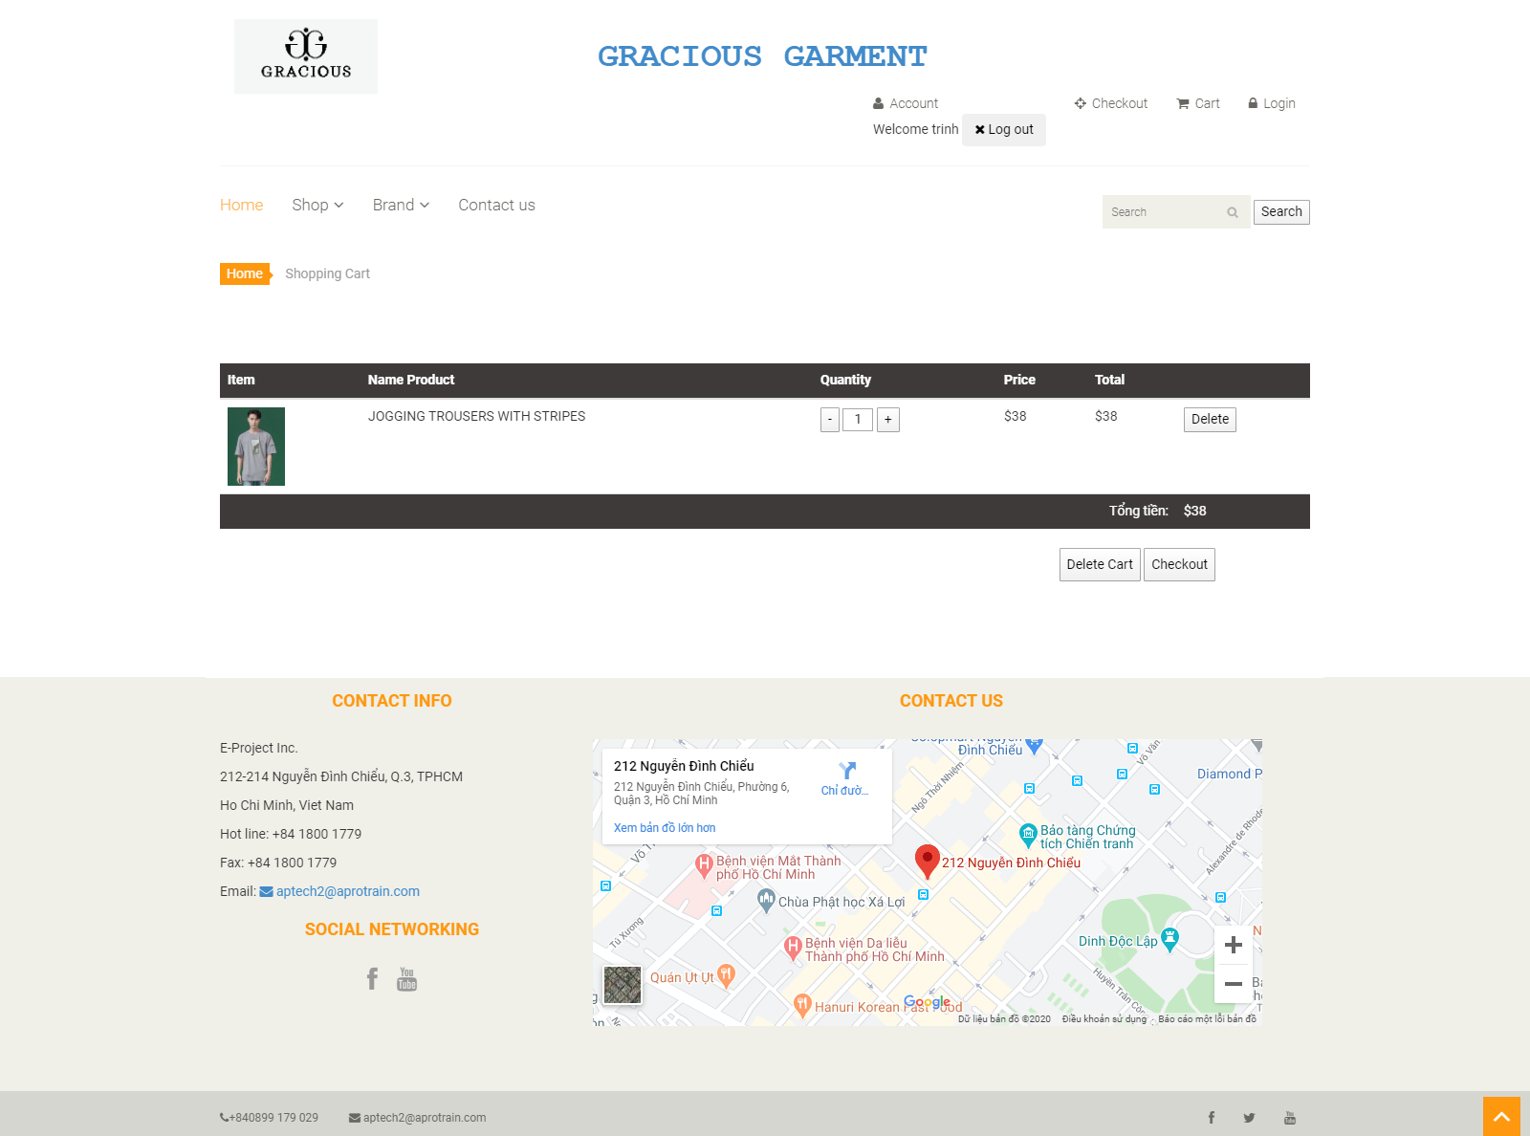

* **Payment Page**

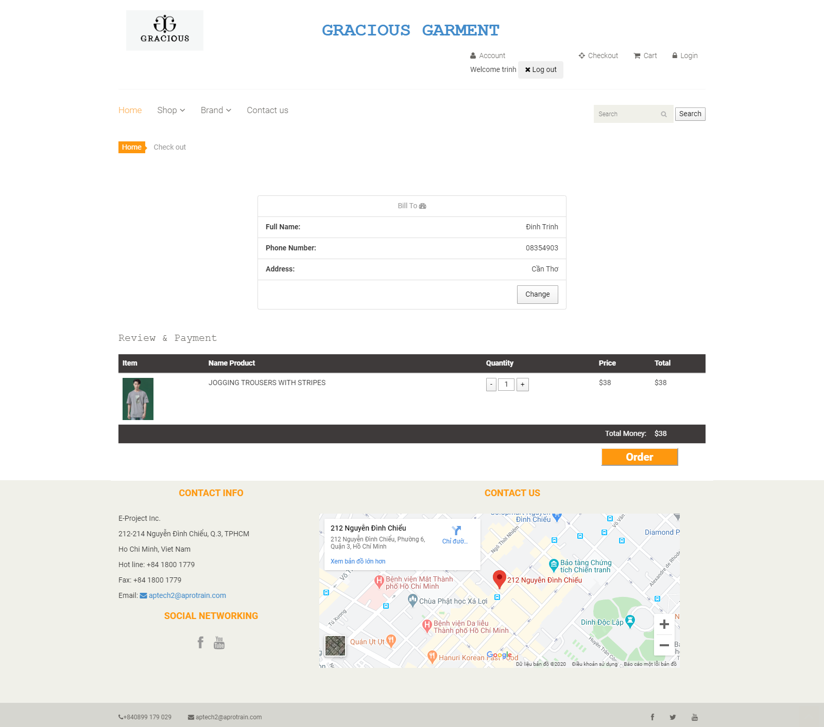

CHAPTER V: USER GUIDE

1. ***Homepage***
   * + - 1. **Description:**

* The Homepage of the website will be the default page that end users will see when they get to use the website. The Homepage includes the following information/sections:
  + Gallery of main images that system administrators set up to display on the interface to attract customers.
  + The collection of best-selling products.
  + The list of popular product brands.
  1. **Design and Operation:**
* **The Homepage:**



* **How to get to other functions:**
* **View list of products:** Customers can go to this function to have an overview of all products of **various types of GARMENTS for both MEN and WOMEN** which are currently available to sell.

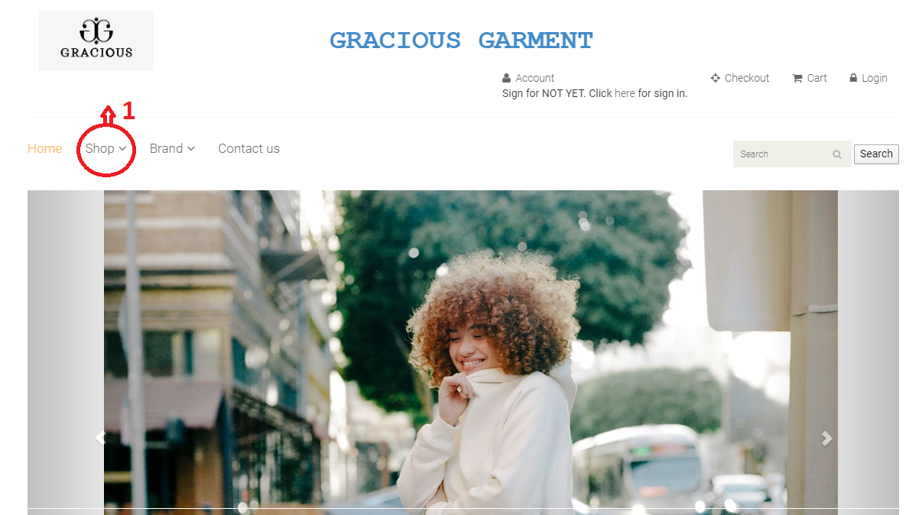

**View list of Brand**

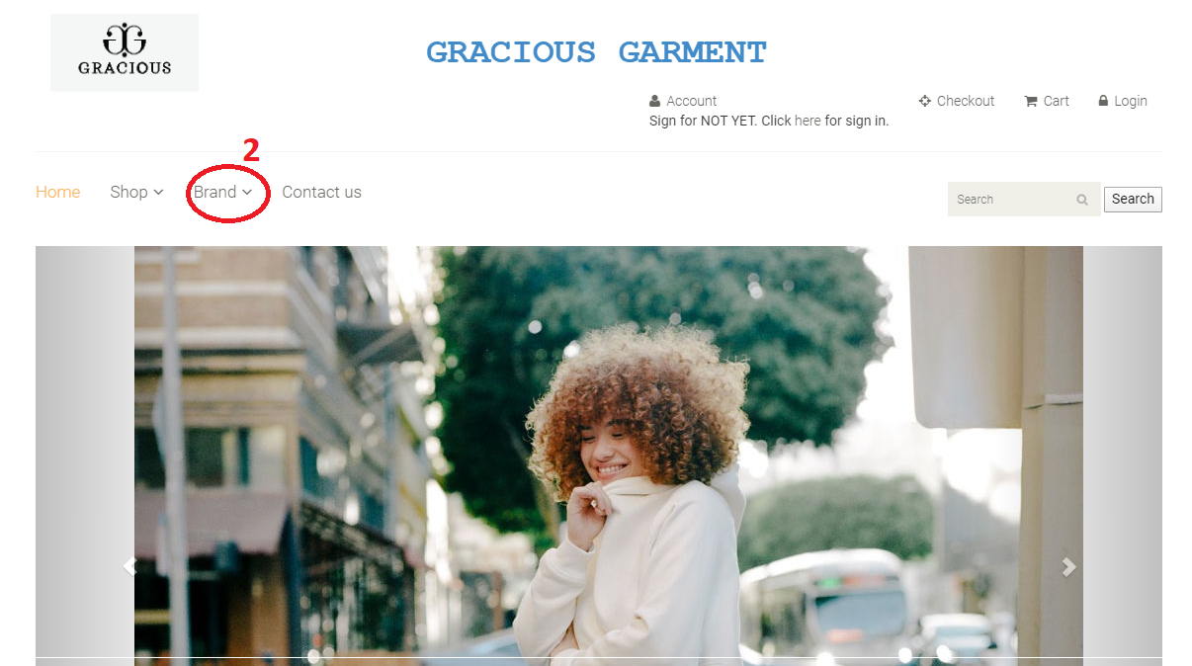

* **View “Contact Us”:** Customers can view the contact information of Symplon’s Beauty Care Center so that they can contact the center in case of any support needed. *(Refer to “Chapter V 🡪 1. Homepage 🡪 11. View Contact Us” for further information)*

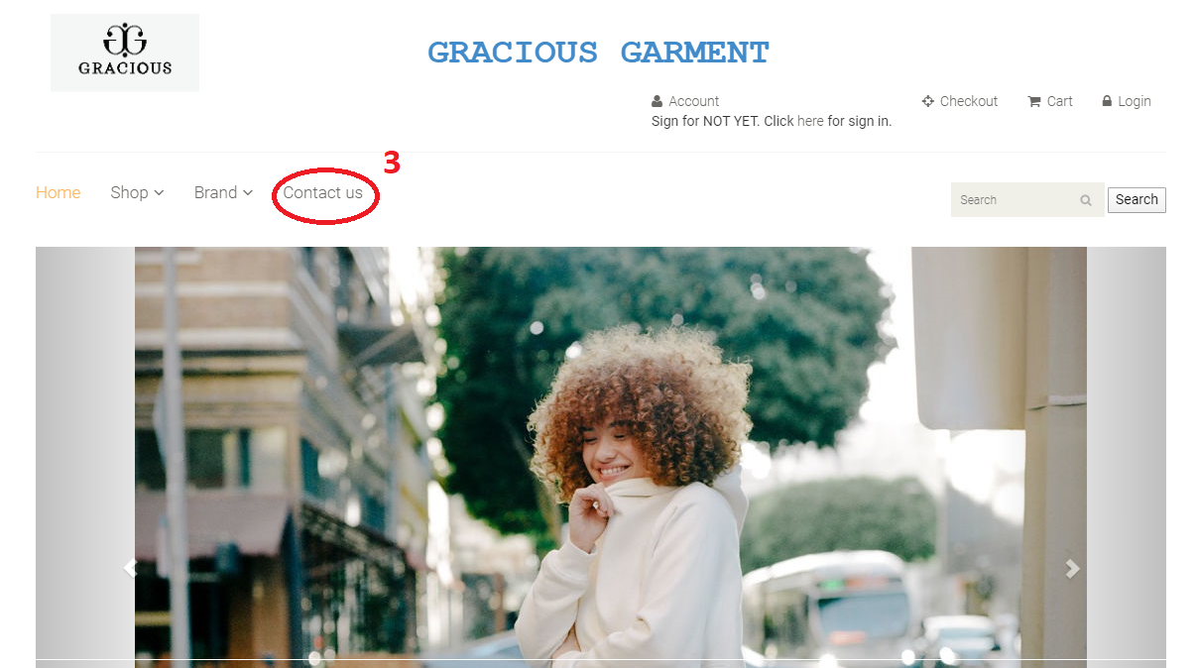

* **View user’s profile:** Customers can view their information, old order, old detail Invoice and change their profile.

**When sign for not yet**

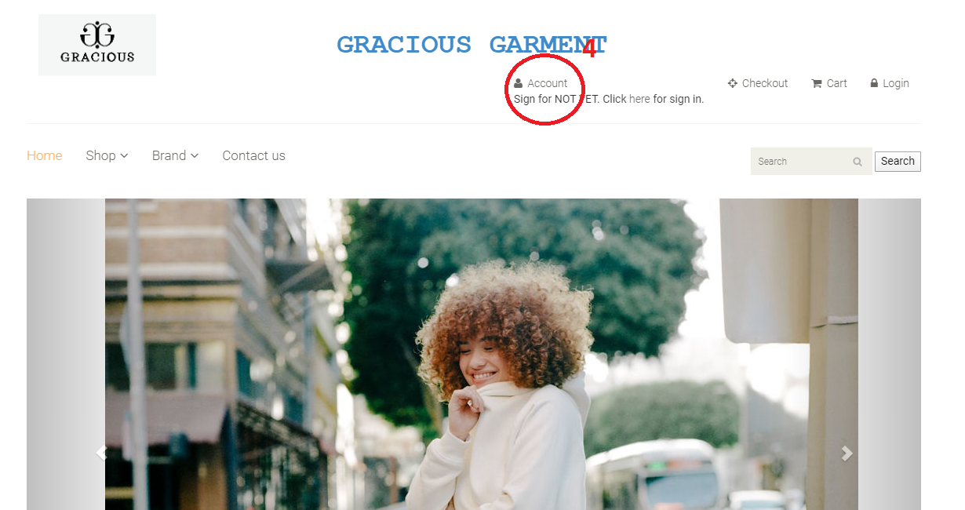

**When signed in**

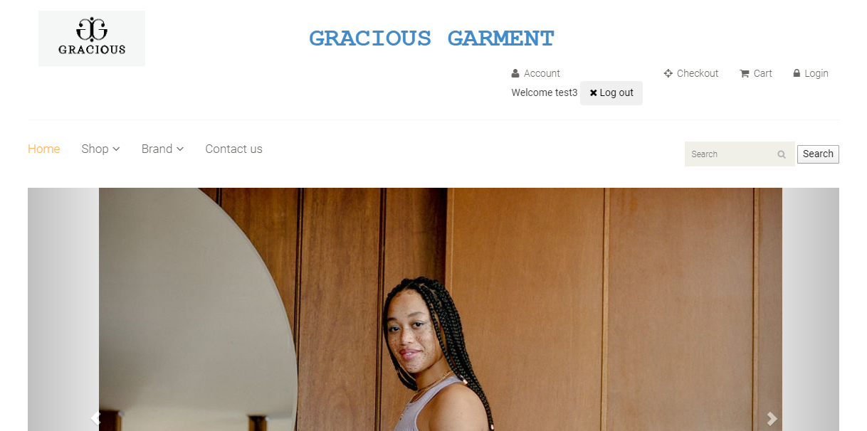

* **View cart’s detail:** Customers can view their cart as well as the list of products which have been selected to buy.

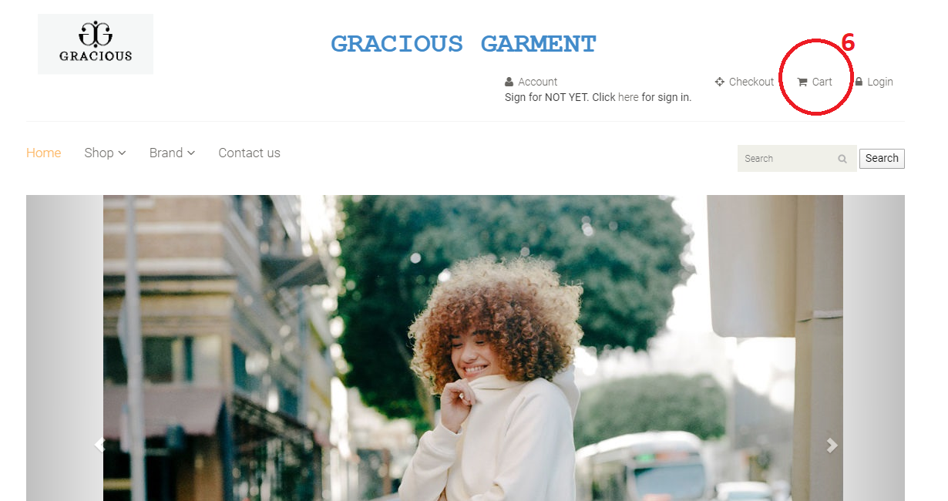

* **View cart’s detail:** Customers can view their cart as well as the list of products which have been selected to

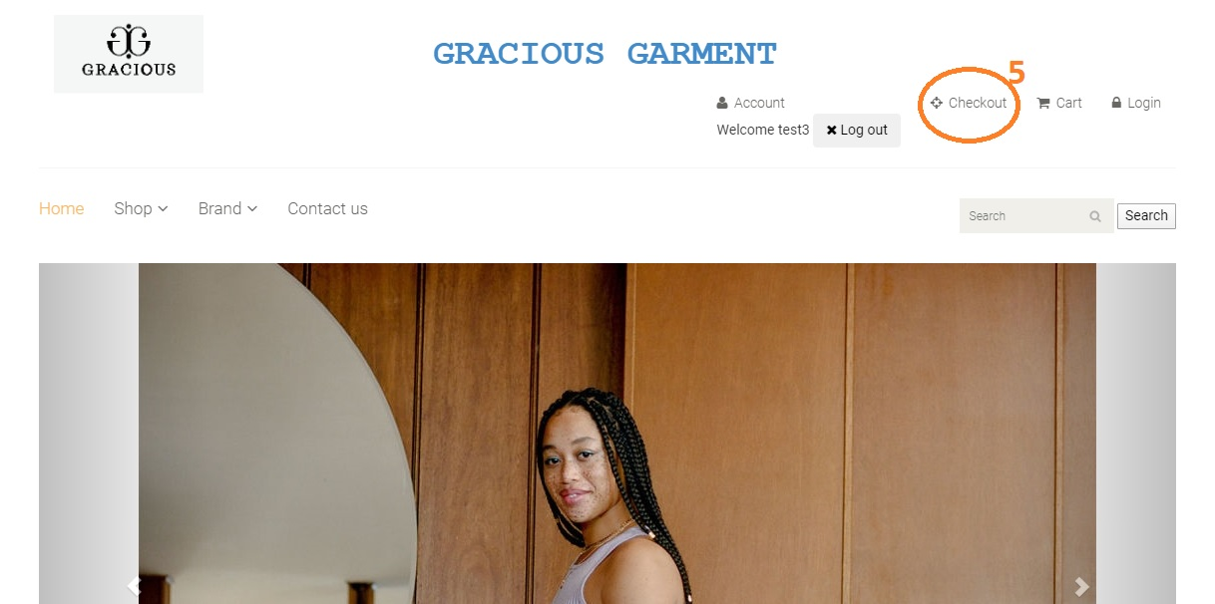

* **Get back to homepage:** Customers can get back to the homepage from any other module.

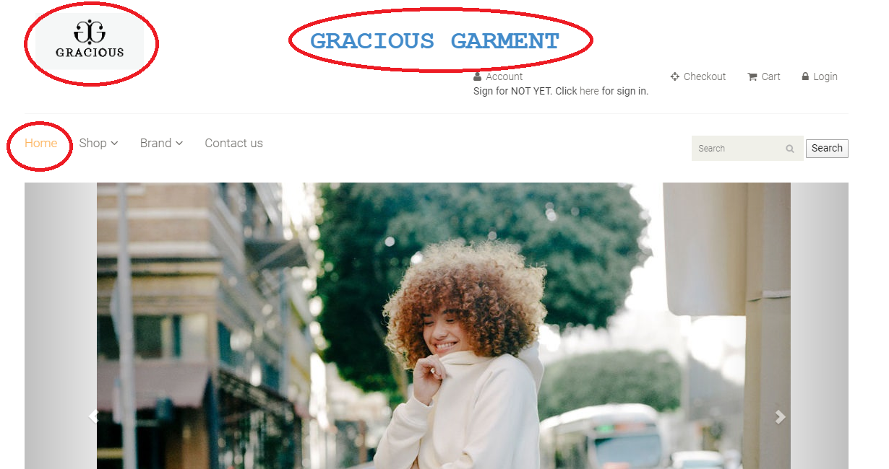

1. ***Register New Account***
   * + - 1. **Description:**

* Users can register for their new account so that they can do more action on the website which guest-users cannot do, such as:
  + Add products to cart.
  + Make payment.
    - * 1. **Design and Operation:**
* **How to get to registration page:** When users haven’t yet signed in, then on the header menu of the website, there will be the “Sign for not yet. Please click here for sign in” option for user to register a new account.

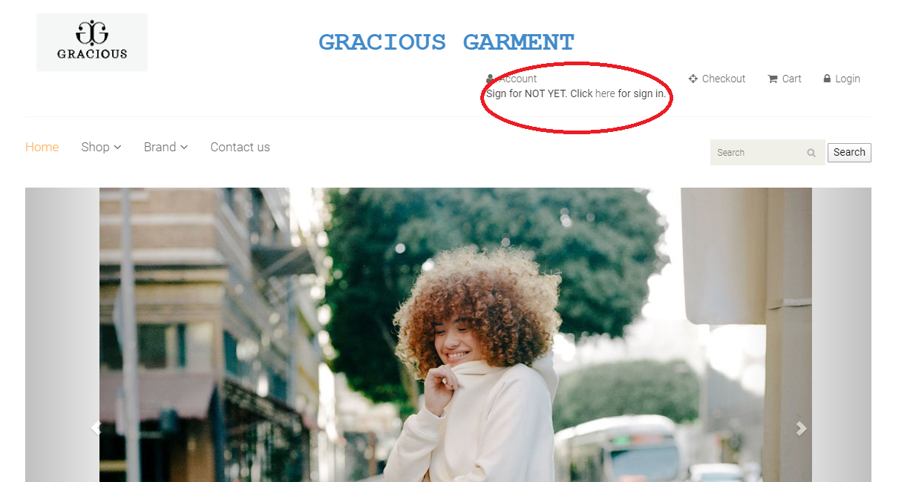

* **Change profile in User:**

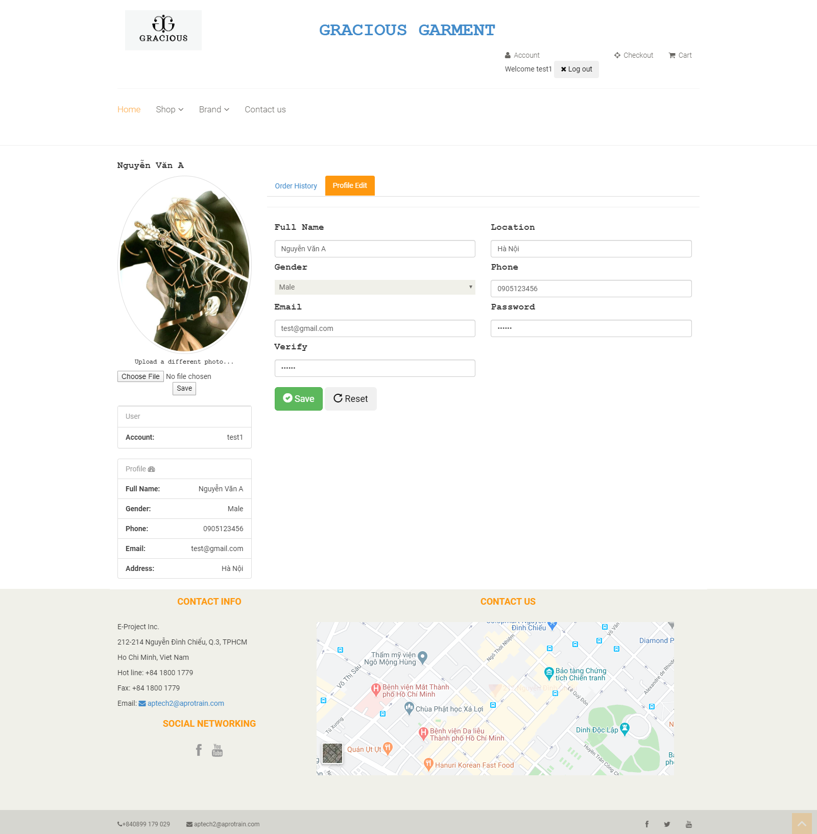

* + To finish registering new account, user needs to input all mandatory fields on the form:

|  |  |
| --- | --- |
| **Fields** | **Description** |
| Photo | * This field is not mandatory. * User can upload the photo to use as his/her avatar. * User can only upload image file with current supported extension as: .png .gif .jpge .jpg. * User can only upload image file whose size is not larger than 5MB. |
| Name | * This field is mandatory. * Name will be display throughout the website. |
| Pin Code | * This field is mandatory. * Pin Code will be used as security code to reset customer’s password. Therefore, it is only shown when user register a new account, there is no other place where this value will be shown. |
| Username | * This field is mandatory. * This field will be used as login credential along with customer’s password. * Username can only contain alphabet and digit character, cannot include space or special character. * Username must be unique in the system. |
| Password | * This field is mandatory. * This field will be used as login credential along with customer’s username. * Password can contain alphabet, digit character and special character, cannot include space. |
| Confirm Password | * This field is mandatory. * This field must be matched with the “Password” field. |
| Gender | * This field is mandatory. * Allow user to select his/ her gender |
| Email | * This field is mandatory. * Allow user to input his/ her email. Email format must be correct. |
| Phone | * This field is not mandatory. * Allow user to input his/ her phone |
| Address | * This field is not mandatory. * Allow user to input his/ her address |

* + When user submits to register new account and all the information are correct, user’s account will be created in the system with role as “customer” and the user will be directed to the login page.

1. ***Login:***
2. **Description:**

* Users can sign in into the website to have permission on all features within the customer’s site.

1. **Design and Operation:**

* **How to get to login page:** When users haven’t yet signed in, then on the header menu of the website, there will be the “Login” option for user to sign in into their account on the website.

**.**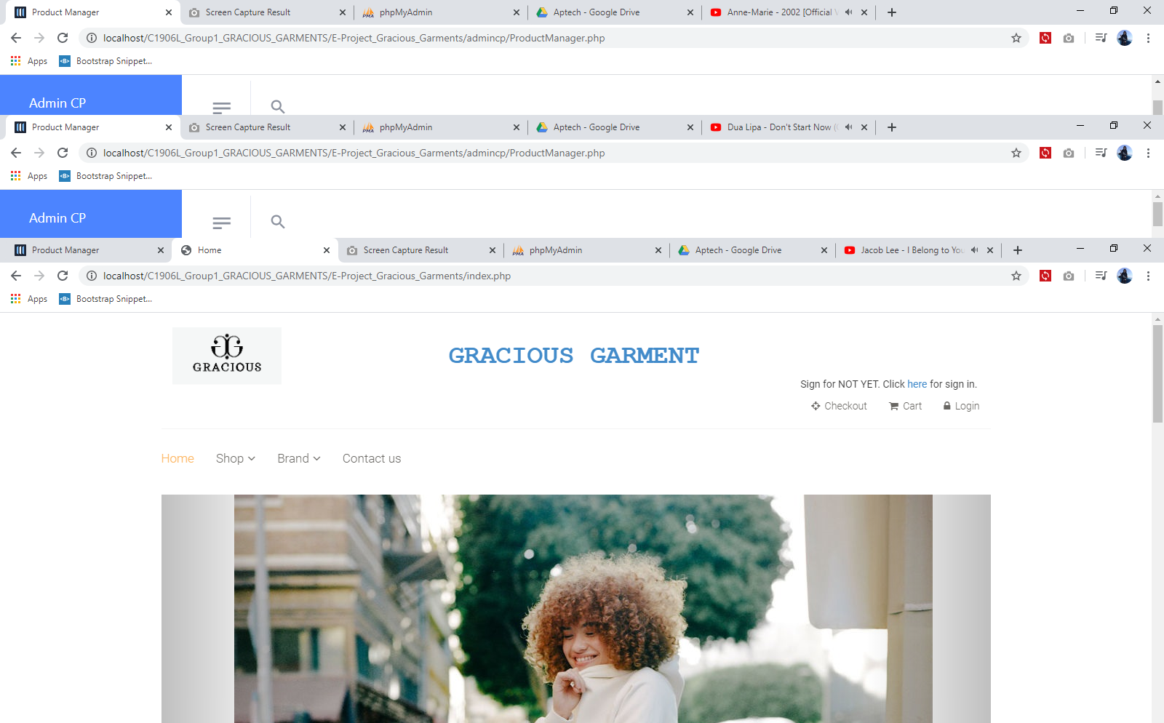

|  |  |
| --- | --- |
| **Operation No.** | **Description** |
| 1 | Click on this item on the header menu will direct customers to the Login page |
| 2 | Click on this option will direct user to the page for him/her to reset his/her password |
| 3 | Click on this option will direct user to the page for him/her to reset his/her password |

* **Login into website:**

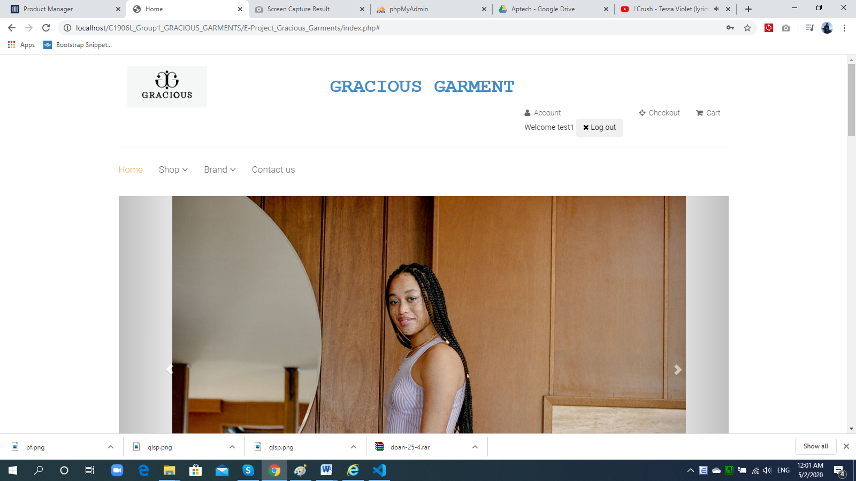

* + To login into the website, user needs to input the login credentials on the login form:

|  |  |
| --- | --- |
| **Fields** | **Description** |
| Username | * This field is mandatory. * This field will be checked if it exists as well as it is mapped with the inputted password or not. |
| Password | * This field is mandatory. * This field will be checked if it is mapped with the inputted username or not. |

* When user submits to login and all login credentials are correct, user will sign in into system successfully with his/ her user account and the user will be directed to the homepage.

1. ***Manage Profile:***
2. **Description:**

* Users can manage his/her profile information as well as his/ her history transaction (if any):

1. **Design and Operation:**

* **How to get to user profile page:** When users have already signed in, then on the header menu of the website, user’s name will be displayed. Clicking on the user’s name will show the list of options which contains “Profile” option for user to get to the Profile page to manage his/her profile information.

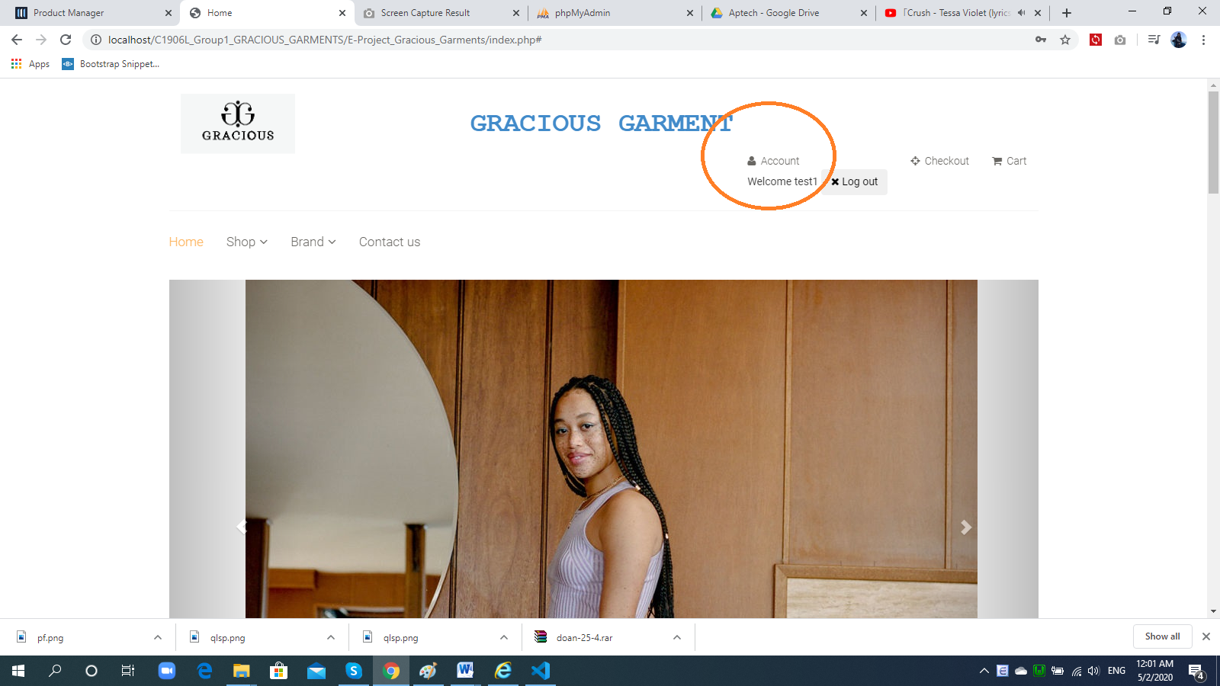

|  |  |
| --- | --- |
| **Operation No.** | **Description** |
| 1 | Click on this option will direct customers to the Profile page |

* **How to get to History Transaction page:** When users have already signed in, then users can view their history transaction via Profile page. Users can also see detail of each order which they’ve made.

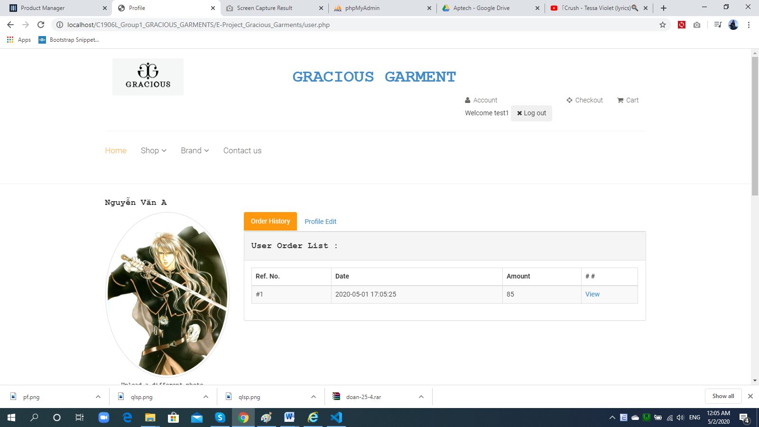

|  |  |
| --- | --- |
| **Operation No.** | **Description** |
| 1 | Click on this option will direct customers to the History page |
| 2 | Click on this option will direct customers to page displaying detail of each history order |

**When click on view**

**`**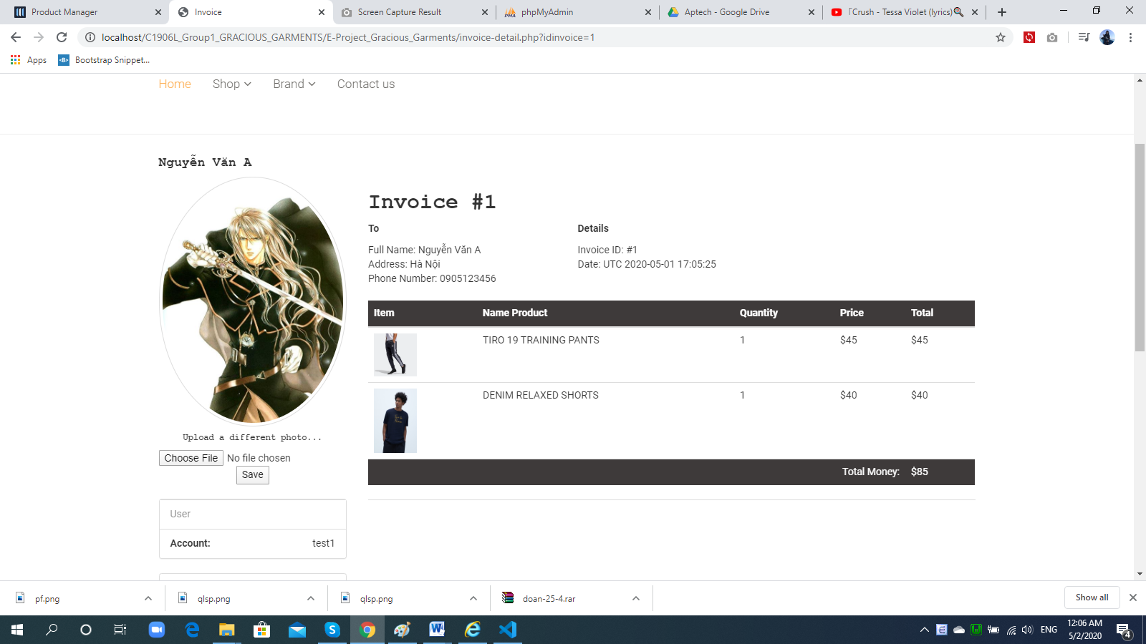

1. ***Change Profile:***
2. **Description:**

* Users can change their old password into a new one.

1. **Design and Operation:**

* **How to get to Change Profile:** When users have already signed in, then on the header menu of the website, user’s name will be displayed. Clicking on the user’s name will show the list of options which contains “Save” option for user to get to the page for resetting his/her profile.

**Before**

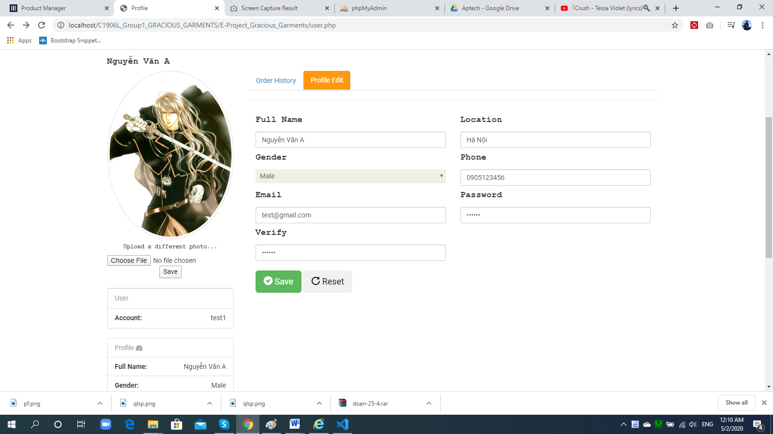

**After**

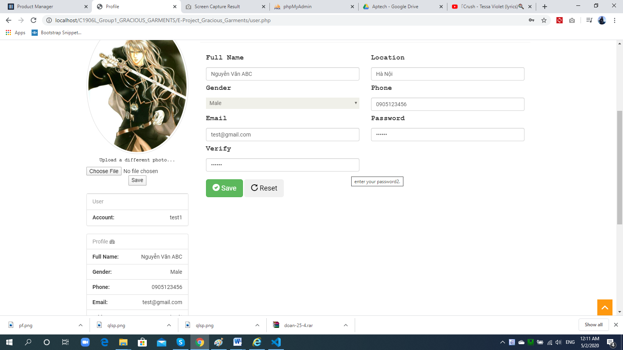

|  |  |
| --- | --- |
| **Operation No.** | **Description** |
| 1 | Click on this option will direct customers to the Change profile |

1. ***Logout:***
2. **Description:**
   * Customer can log out of the website whenever he/she doesn’t want to use his/her account to perform any transaction anymore.
3. **Design and Operation:**

* **How to get log out:** When users have already signed in, then on the header menu of the website, user’s name will be displayed. Clicking on the user’s name will show the list of options which contains “Logout” option for user to log out his/ her account from the website.

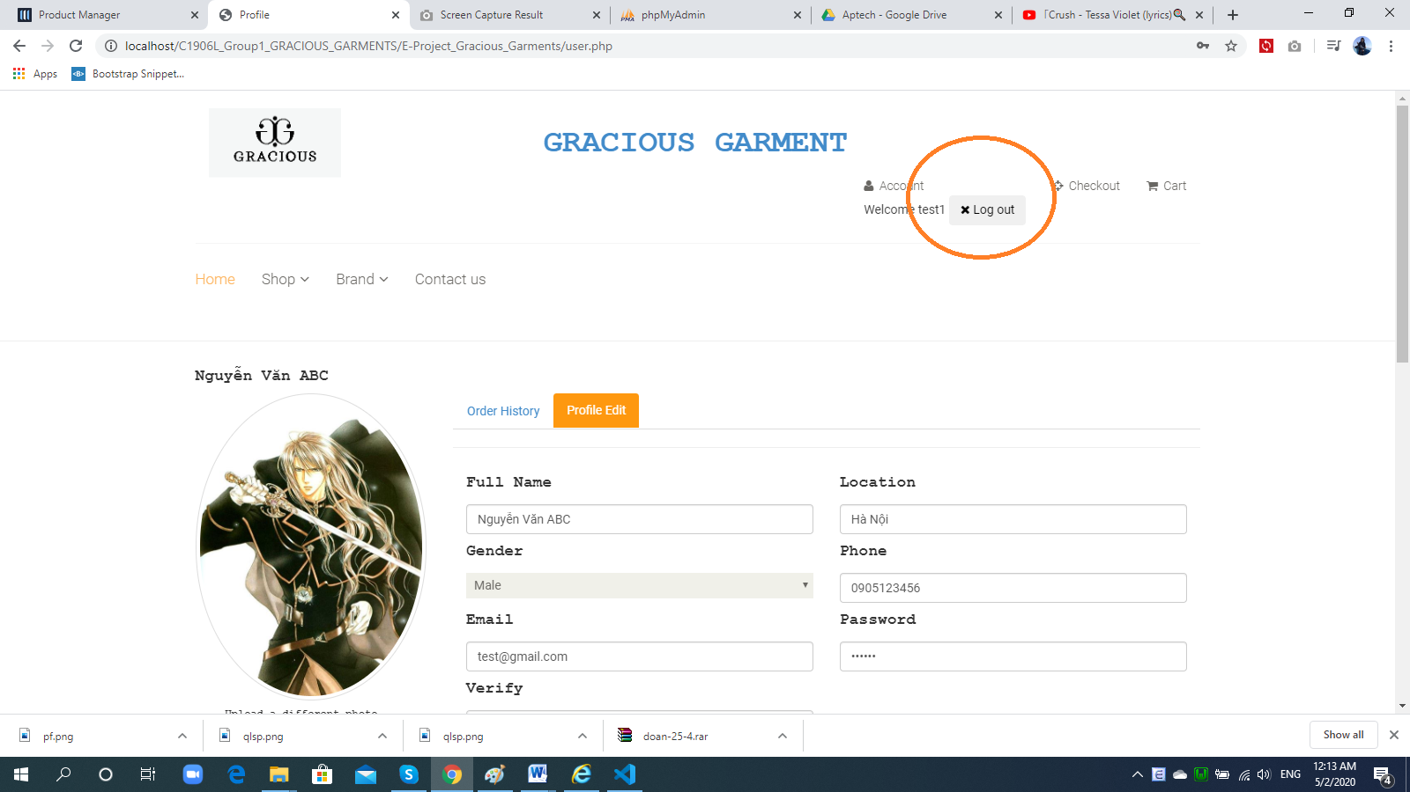

|  |  |
| --- | --- |
| **Operation No.** | **Description** |
| 1 | Click on this option will log out the customer’s account from the website and direct customers to the Homepage |

1. ***View and Select Product:***
2. **Description:**

* User can view the list of products which are currently on sale. On the list of product, customer can:
  + View the main information of each product as well as its current quantity.
  + Select to view the detail of each product.
  + Filter the list of products by product category and/or product brand.
  + Search the products by their names.
* The customer can also select a specific product to add it into the cart to make an order when he/she want to buy the product.

1. **Design and Operation:**

* **How to get to the list of products:** User can view the list of products whenever he/she has already logged in or not. On the header menu of the website, there will be the “Products” option for user to get to the page displaying the list of products which are currently on sale.

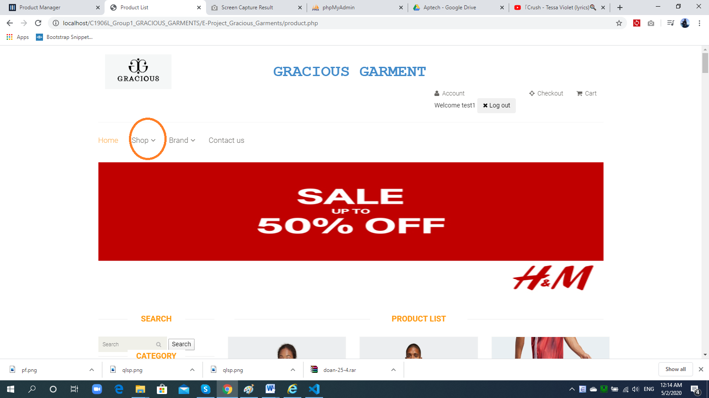

|  |  |
| --- | --- |
| **Operation No.** | **Description** |
| 1 | Click on this option will log out direct the customer to the page displaying list of products |

* **How to get to the page displaying product’s detail:** On the list of products, user can click on the product information or click on the “View Detail” button to go to page displaying the product’s detailed information

**Z**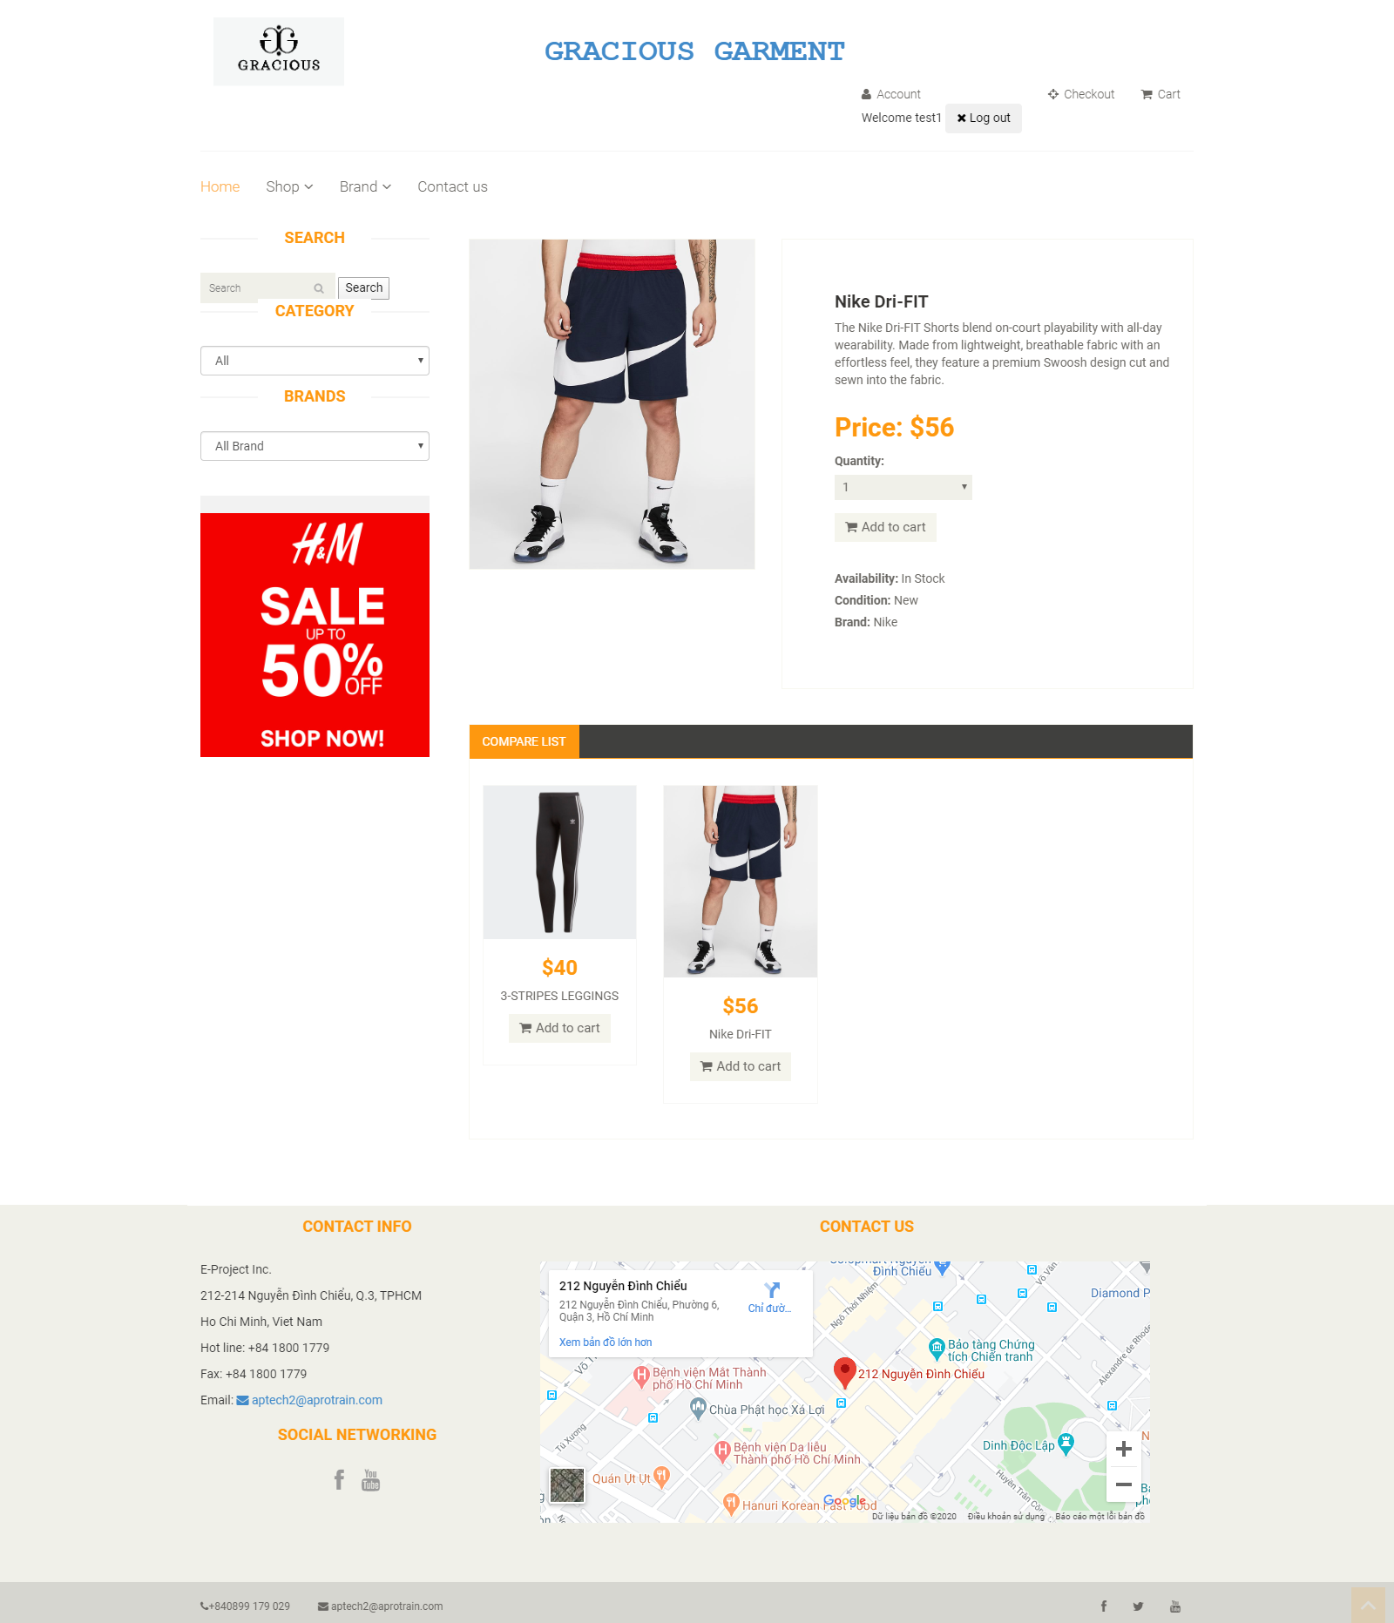

|  |  |
| --- | --- |
| **Operation No.** | **Description** |
| 1 | Click on this option will log out direct the customer to the page displaying detailed information of the product |

* **Select to add product to cart:** Customer can only add product to his/her cart after he/ she has already logged in.

**When customer click add to cart on anywhere. That product will add to their cart.**

* Whenever customer wants to buy the product, he/ she can go to the page displaying product’s detail. From there, customer can select the quantity he/ she wants to buy as well as submit to add the selected product with the selected quantity to customer’s cart.

|  |  |
| --- | --- |
| **Fields** | **Description** |
| Quantity | * This field is mandatory. * This field will be checked if the selected quantity that customer want to add to his/ her cart is sufficient comparing to the product’s current stock or not. |

* When customer submits to add the product to cart with the appropriate selected quantity, the product will then be added to the customer’s cart. If the product has already been added to customer’s cart before. The previously added product will be kept in the cart but its quantity will be increased accordingly. They can edit quantity or delete product if they don’t like.

1. ***Check out:***
2. **Description:**

* Cart is where customer can view the product(s) that he/she has selected to buy but doesn’t make payment yet. From there, customer can proceed to make payment for the order.

1. **Design and Operation:**

* **How to open Check out page:** Customer can only view and manage his/ her after he/ she has already logged in.

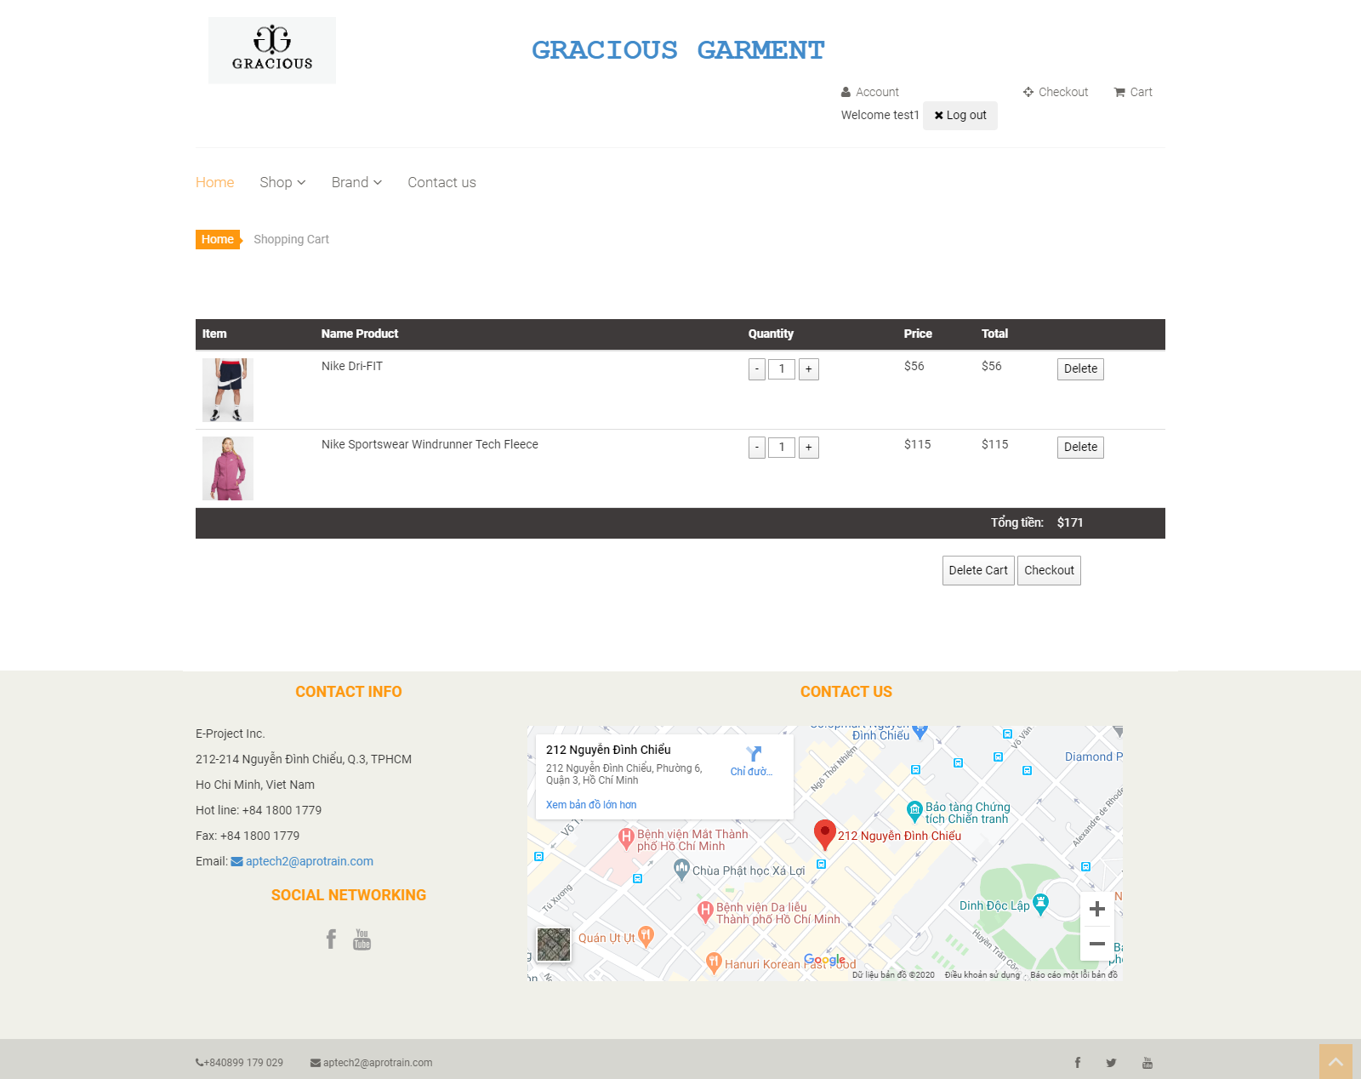

|  |  |
| --- | --- |
| **Operation No.** | **Description** |
| 1 | Click on this option will direct customer to the Cart page. |

* **Change product’s quantity:** Customer can change the current quantity of the product in the cart by clicking on the quantity value. System will direct customer to the page displaying product detail so that he/ she can add more quantity to the product.

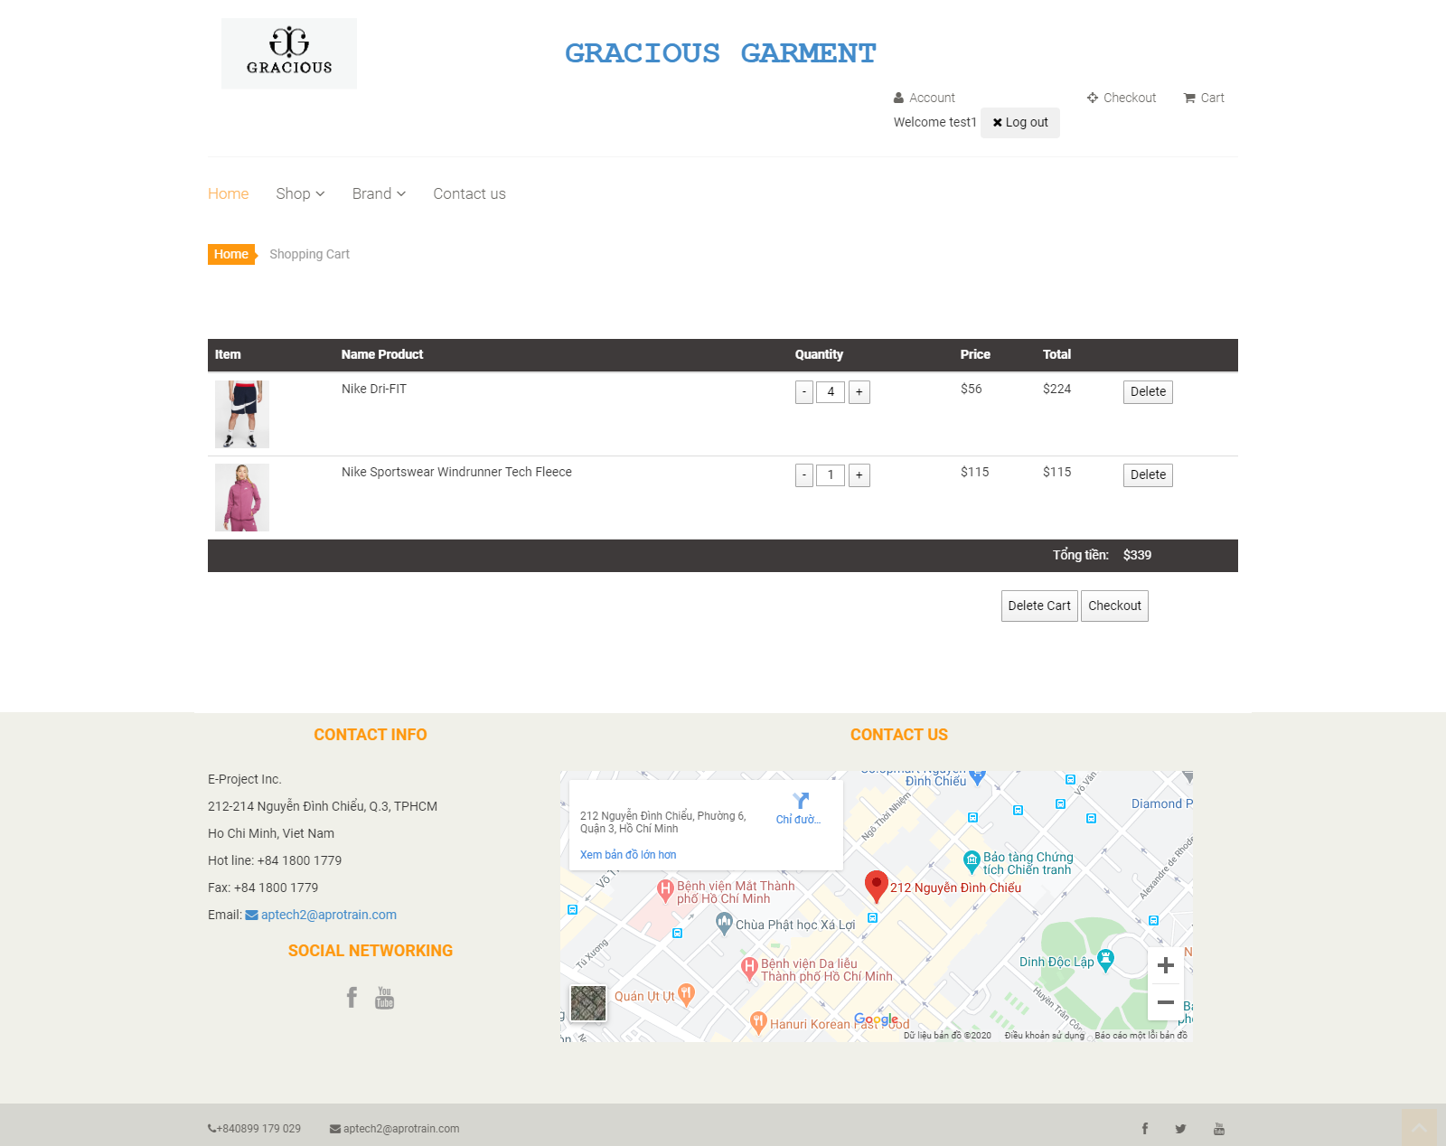

|  |  |
| --- | --- |
| **Operation No.** | **Description** |
| 1 | Click on this option will direct customer to the page displaying list of product(s) in the customer’s cart. |

* **Remove product from the cart:** Customer can remove the selected product out of the cart by clicking on the “Delete” icon.

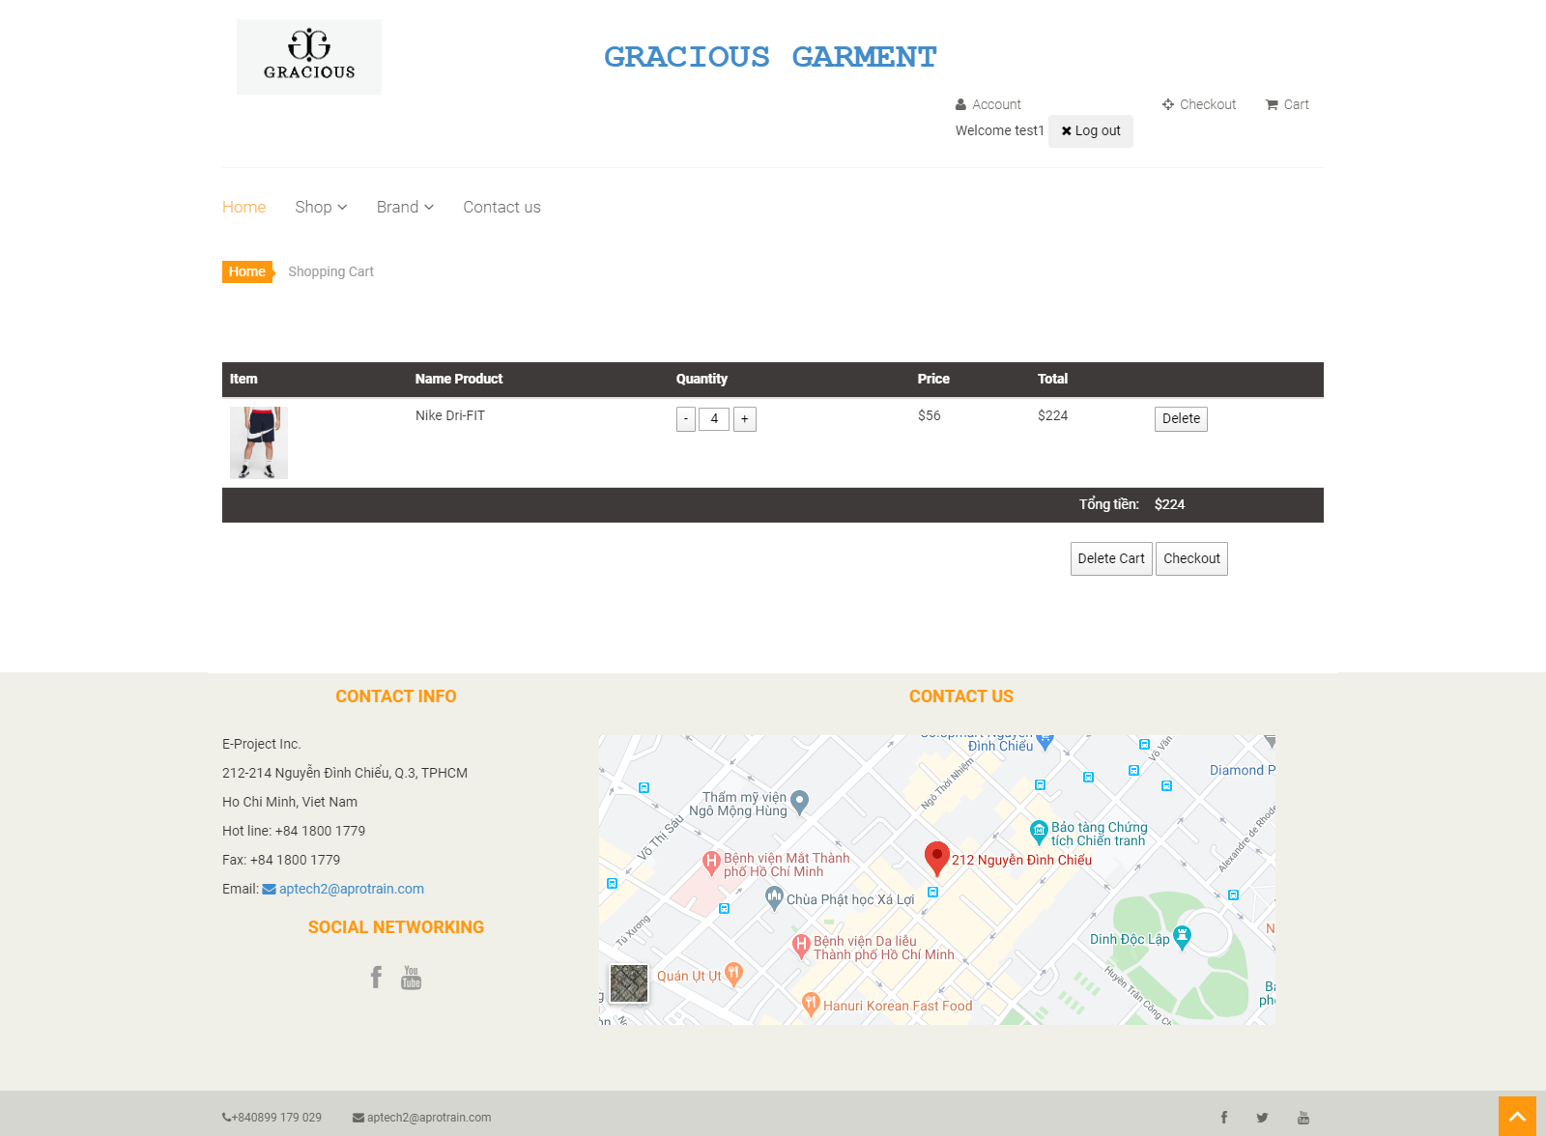

|  |  |
| --- | --- |
| **Operation No.** | **Description** |
| 1 | Click on this icon will remove the product out of the customer’s cart. |

* **Proceed to Payment:** Customer can make payment for his/ her order by clicking on “Proceed to checkout” button.

|  |  |
| --- | --- |
| **Operation No.** | **Description** |
| 1 | Click on this button will direct customer to the page to make payment for the order. |

* **Make Payment:** Customer can make payment for his/ her order by selecting and filling in the relevant information. Then clicks on “Checkout” button.

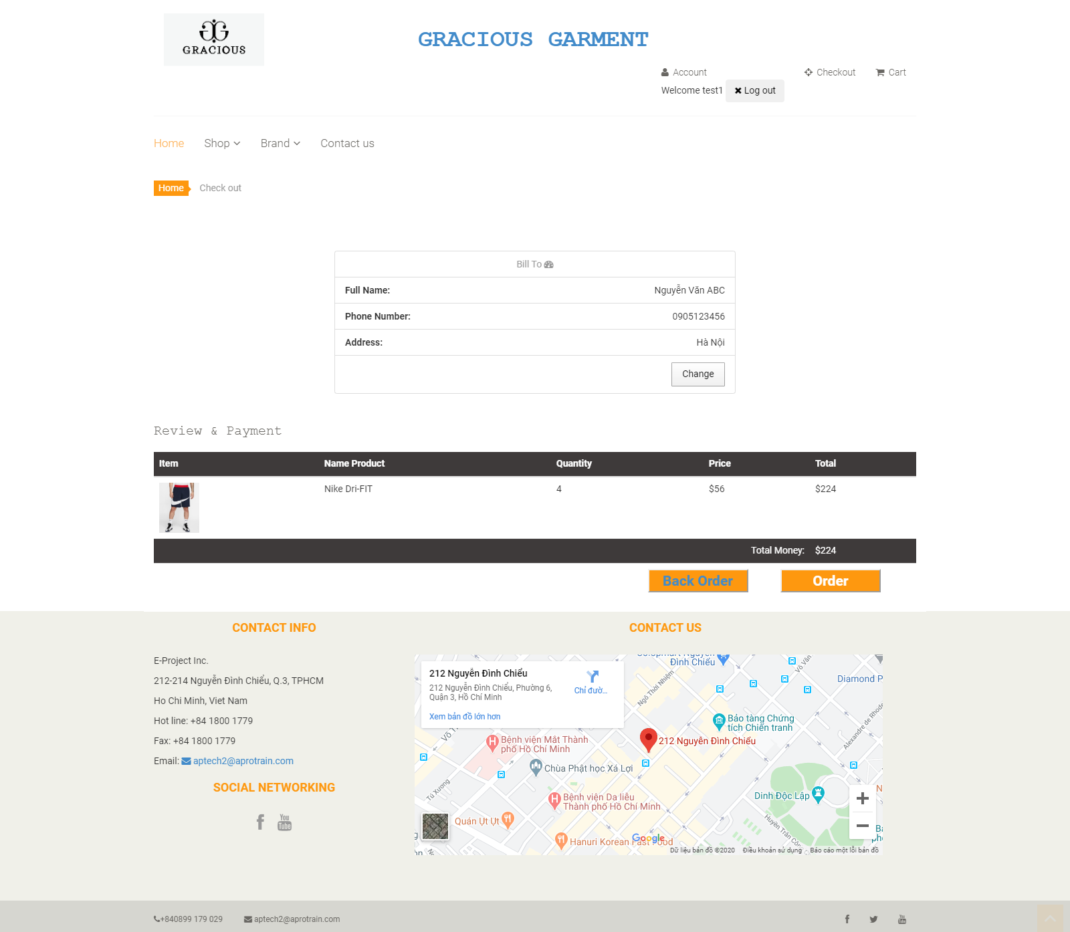

* When customer submits to checkout after filled in all relevant information, a receipt will be generated for the customer and the Gracious Garments will also receive this order from the customer.

1. ***View Contact Us:***
2. **Description:**

* Customers can view the contact information of Gracious Garments so that they can contact the center in case of any support needed.

1. **Design and Operation:**

* **The Contact Us Page:**
* **How to get to Contact Us page:** User can view the About Us page whenever he/she has already logged in or not. On the header menu of the website, there will be the “About Us” option, clicking on this will open About Us page.

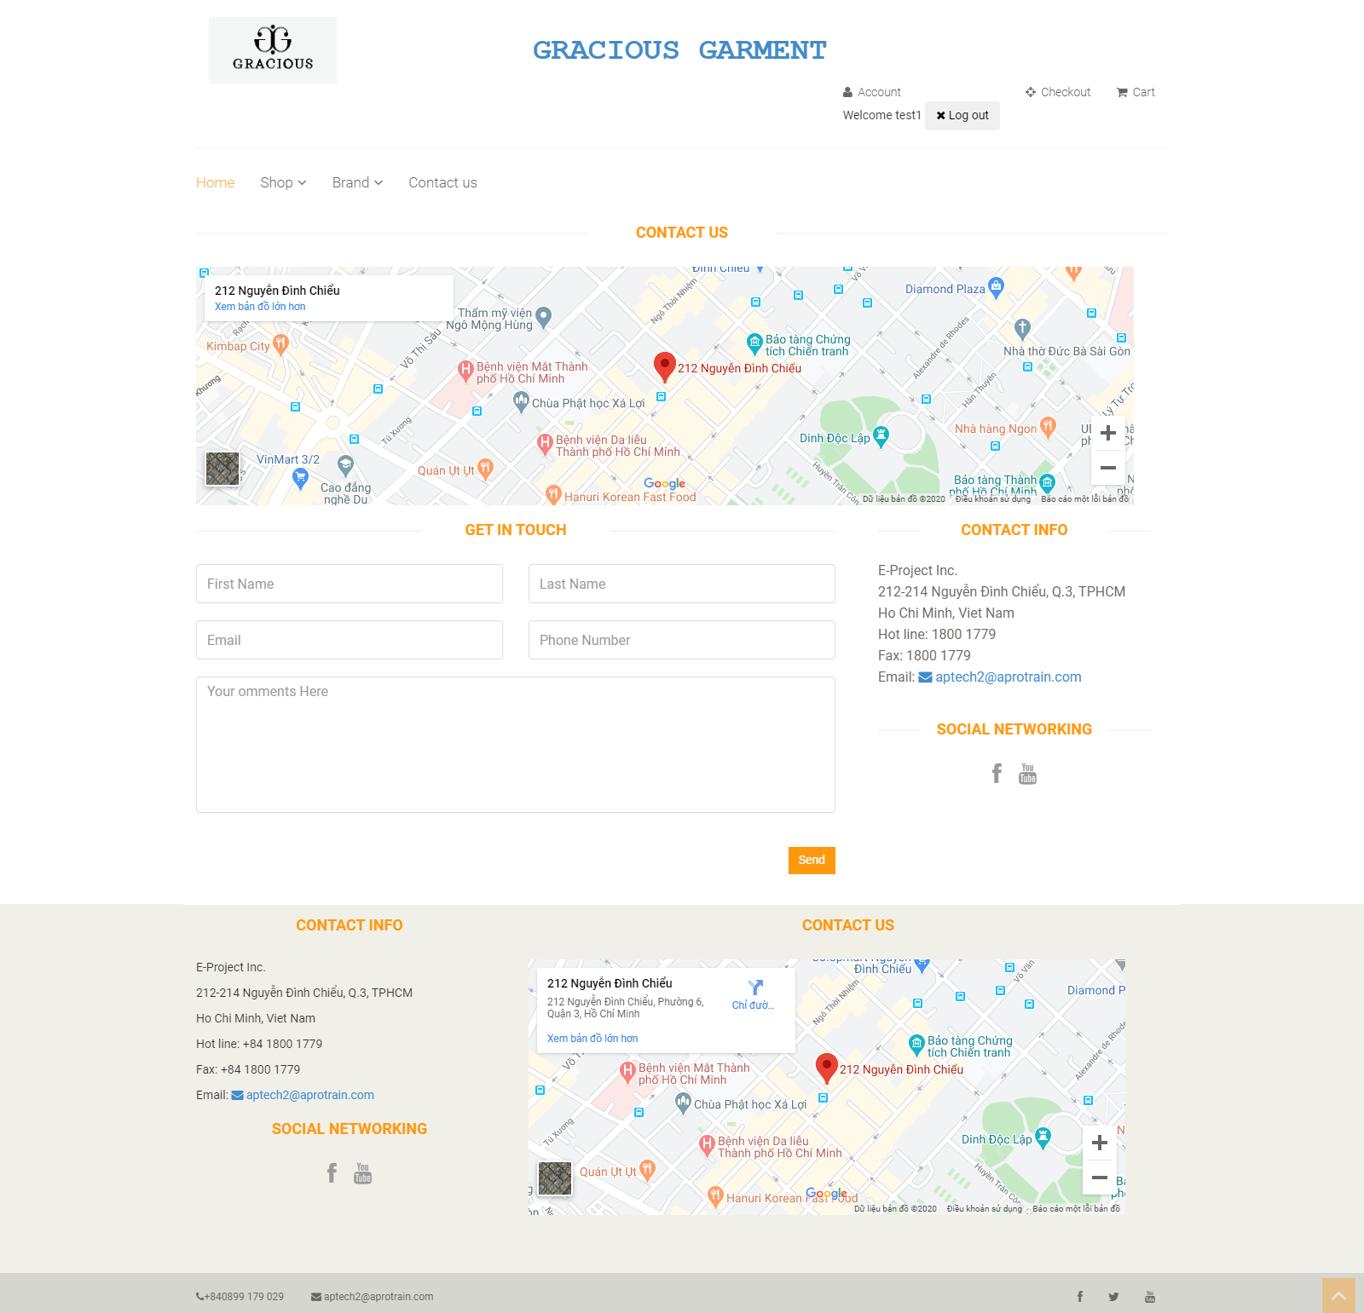

|  |  |
| --- | --- |
| **Operation No.** | **Description** |
| 1 | Click on this item on the header menu will direct customers to the page displaying Contact Us’s content |

CHAPTER VI: ADMIN GUIDE

**Note:** In the system, there will be one super administrator who is already configured in the system. This user has full rights on all features within the system as well as manage all other administrators (Information about the super administrator will be provided in the Data_Initial_Script.sql).

1. ***Get to Administrator View***
2. **Description:**

* If user has role as administrator or super administrator, he/ she can get to the administration page to manage the master data which are used throughout the system.

1. **Design and Operation:**

* **How to get to Administration Site:** Only user with role as administrator or super administrator and has already logged in can get to the administration site. On the header menu of the Customer Site, there will be the “Go to Admin Page” option (only show for user with administrator role). Clicking on this option will direct user to the administration site.

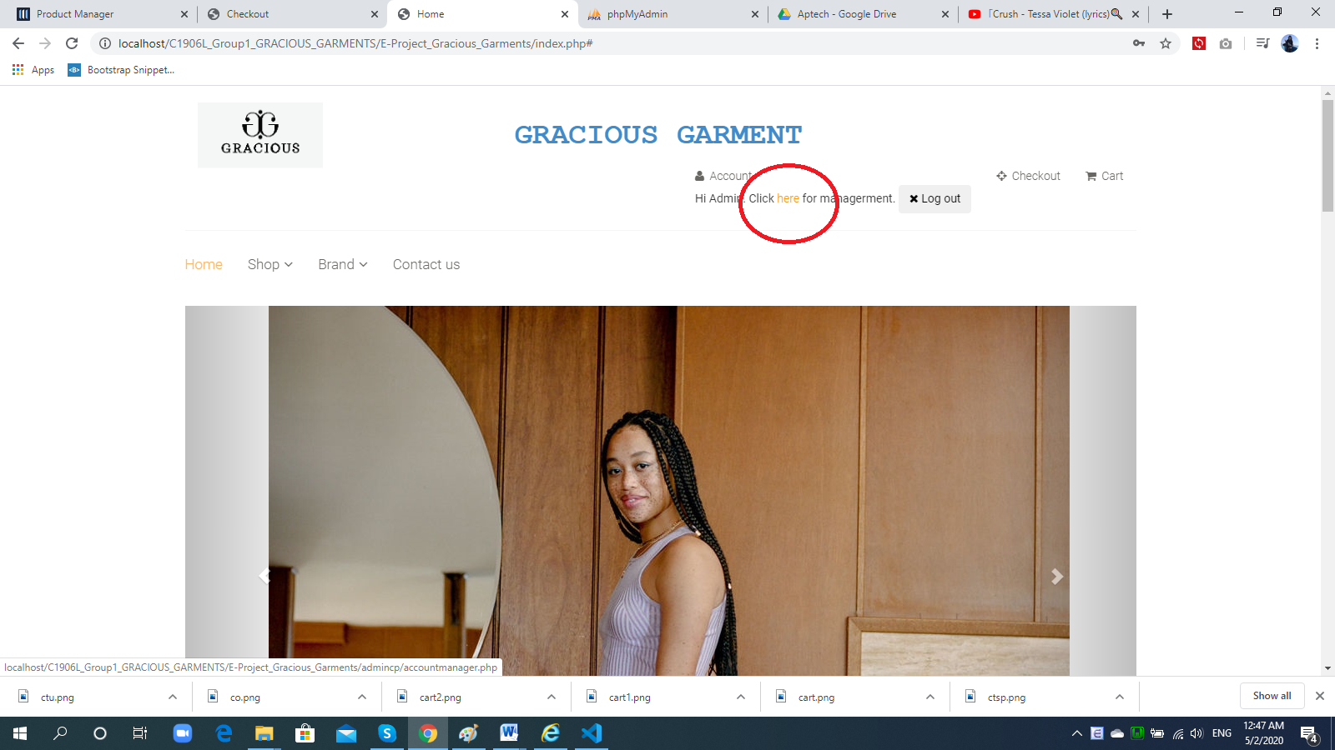

|  |  |
| --- | --- |
| **Operation No.** | **Description** |
| 1 | Click on this option will direct user to the administration site |

1. ***Manage Product Brand***
2. **Description:**

* User can manage all product brands via this feature:
  + View list of product brands
  + Create new product brand
  + Update product brand’s information
  + Delete product brand

1. **Design and Operation:**

* **View list of product brand:** user can view list of all product brands in the system.

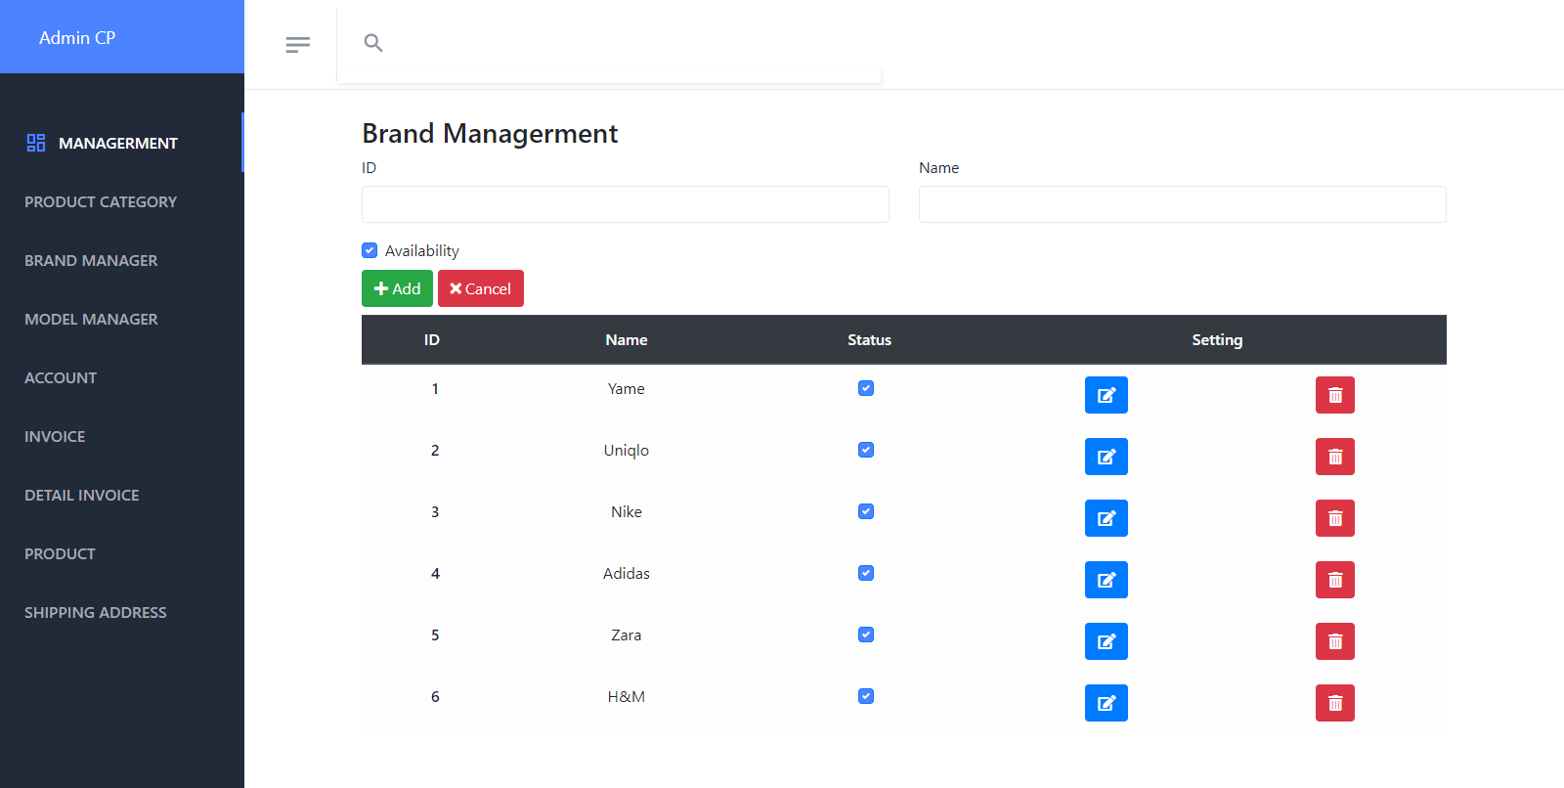

|  |  |
| --- | --- |
| **Operation No.** | **Description** |
| 1 | Click on this option will direct user to the page displaying list of product brands |

* **Create new product brand:** user can create new product brand by filling information and clicking on “Add ” button on the list page.

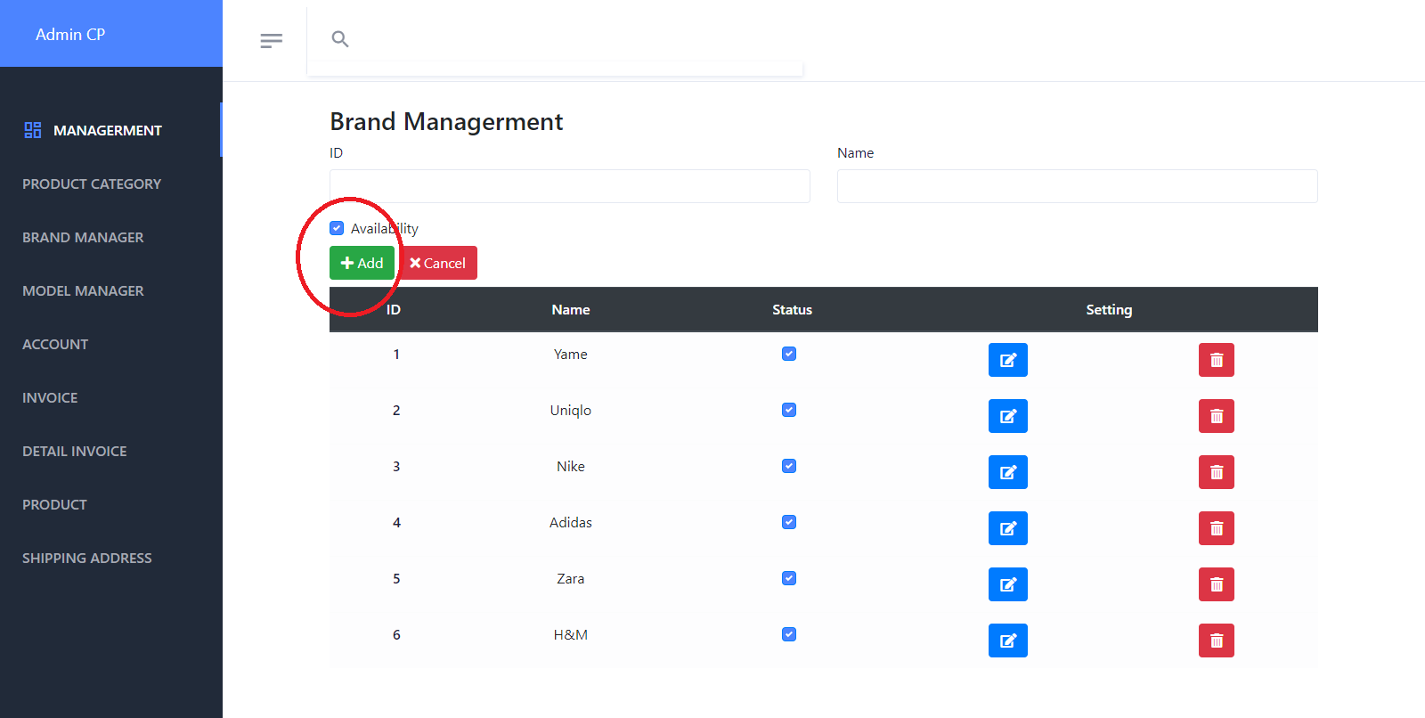

* + To finish creating new product brand, user needs to input all mandatory fields on the form:

|  |  |
| --- | --- |
| **Fields** | **Description** |
| ID |  |
| Name | * This field is mandatory. * Name of product brand will be display throughout the website. |
| Status |  |

* When user submits to create new product brand and all the information are correct, the product brand will be created in the system.
* **Update product brand’s information:** user can update the information of one product brand by clicking on “Edit” icon on the list page.

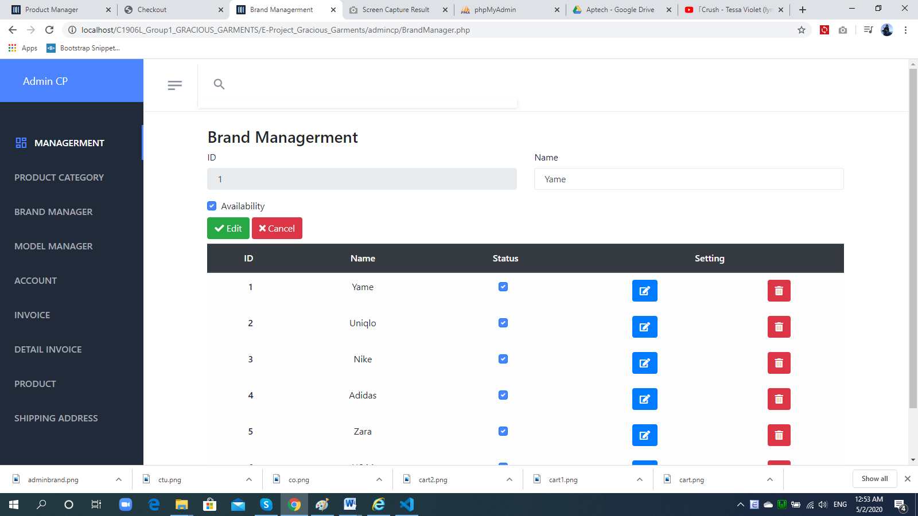

* + To finish updating the information of the product brand, user needs to make sure all mandatory fields on the form are filled in:

|  |  |
| --- | --- |
| **Fields** | **Description** |
| ID | * . |
| Name | * This field is mandatory. * Name of product brand will be display throughout the website. |
| Status | * This field is mandatory. * Allow user to select the status for the product brand. |

* When user submits to update the information of the product brand and all the information are correct, product brand’s information will be updated in the system.
* **Delete product brand:** user can delete the product brand by clicking on “Delete” icon on the list page or “Delete” button on the Edit Detail page (product brand with type as “system default brand” is excluded).

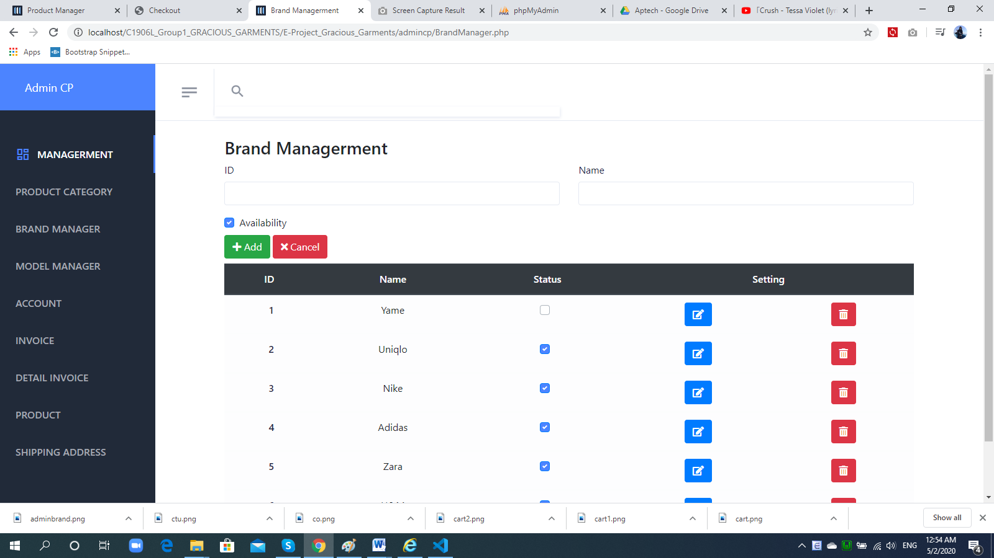re**>**

|  |  |
| --- | --- |
| **Operation No.** | **Description** |
| 1 | Click on this option will show confirmation message if user actually wants to delete the selected product brand. When click on OK Status become non-check. |

1. ***Manage Product Category***
2. **Description:**

* User can manage all product categories via this feature:
  + View list of product categories
  + Create new product category
  + Update product category’s information
  + Delete product category

1. **Design and Operation:**

* **View list of product category:** user can view list of all product categories in the system.

|  |  |
| --- | --- |
| **Operation No.** | **Description** |
| 1 | Click on this option will direct user to the page displaying list of product categories |

* **Create new category:** user can create new product category by clicking on “Add New” button on the list page.

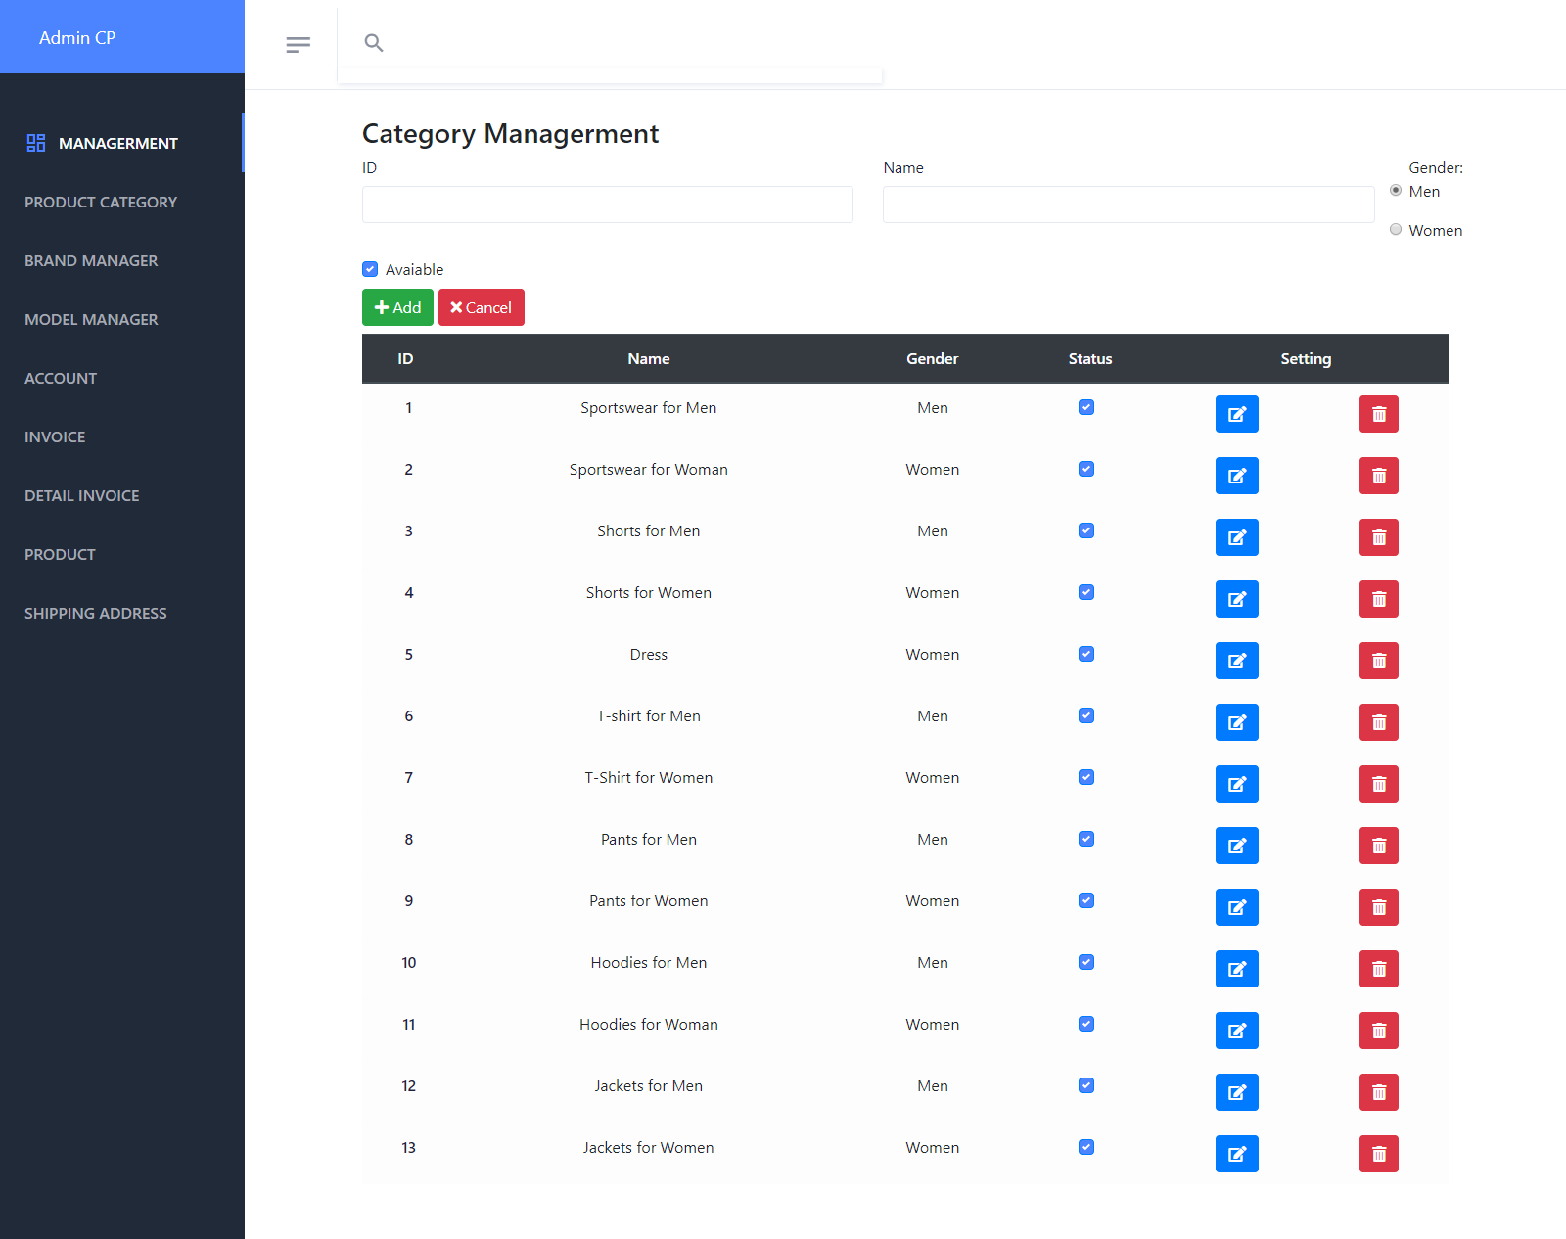

* + To finish creating new product category, user needs to input all mandatory fields on the form:

|  |  |
| --- | --- |
| **Fields** | **Description** |
| Name | * This field is mandatory. * Name of product category will be display throughout the website. |
| Description | * This field is not mandatory. * Allow user to input product category’s description |

* When user submits to create new product category and all the information are correct, the product category will be created in the system.
* **Update product category’s information:** user can update the information of one product category by clicking on “Edit” icon on the list page.

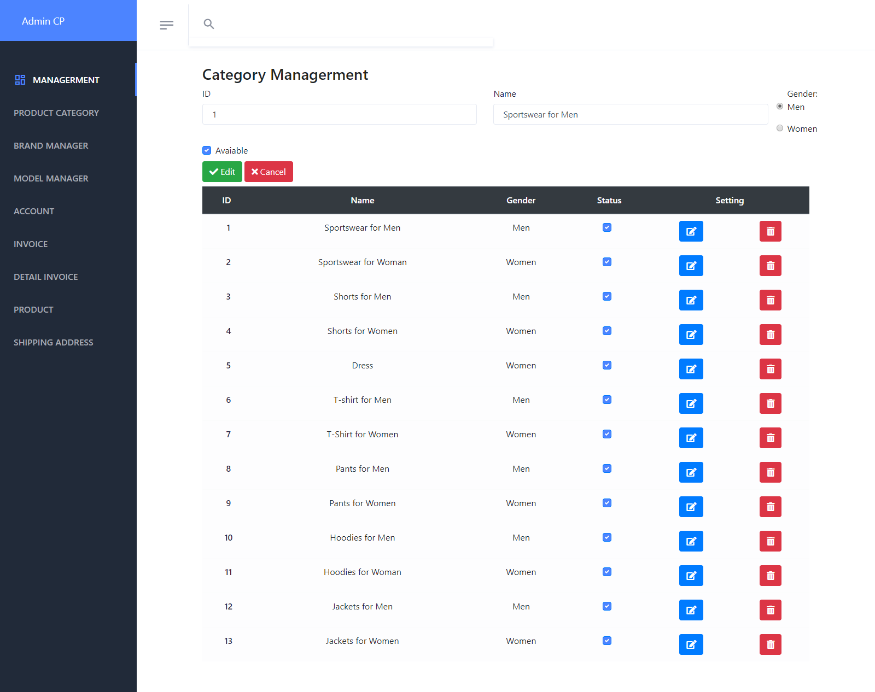

* + To finish updating the information of the product category, user needs to make sure all mandatory fields on the form are filled in:

|  |  |
| --- | --- |
| **Fields** | **Description** |
| Name | * This field is mandatory. * Name of product category will be display throughout the website. |
| Status | * This field is mandatory. * Allow user to select the status for the product category. |
| Description | * This field is not mandatory. * Allow user to input product category’s description |

* When user submits to update the information of the product category and all the information are correct, product category’s information will be updated in the system.
* **Delete product category:** user can delete the product category by clicking on “Delete” icon on the list page or get “avaiable” to non-check on the Edit (product category with type as “system default category” is excluded).

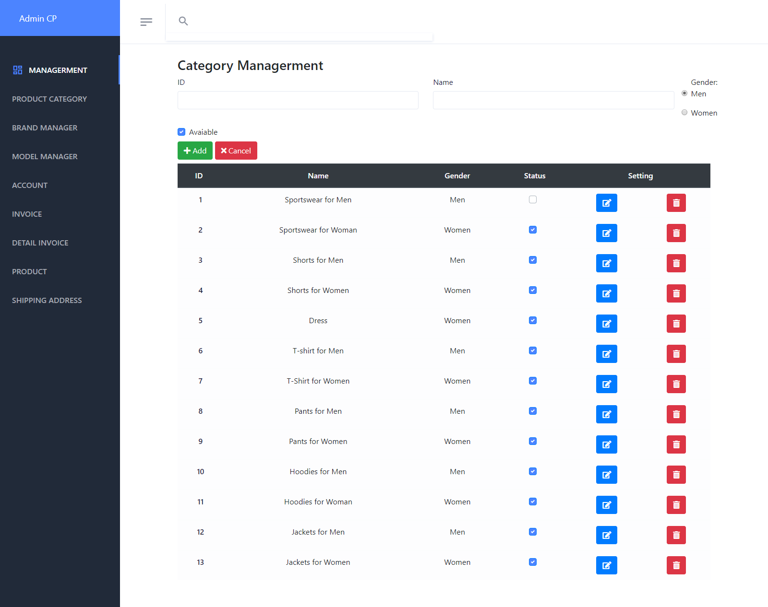

|  |  |
| --- | --- |
| **Operation No.** | **Description** |
| 1 | Click on this option will show confirmation message if user actually wants to delete the selected product category. |

1. ***Manage Product***
2. **Description:**

* User can manage all products via this feature:
  + View list of products
  + Create new product
  + Update product’s information
  + Delete product

1. **Design and Operation:**

* **View list of product:** user can view list of all products in the system.

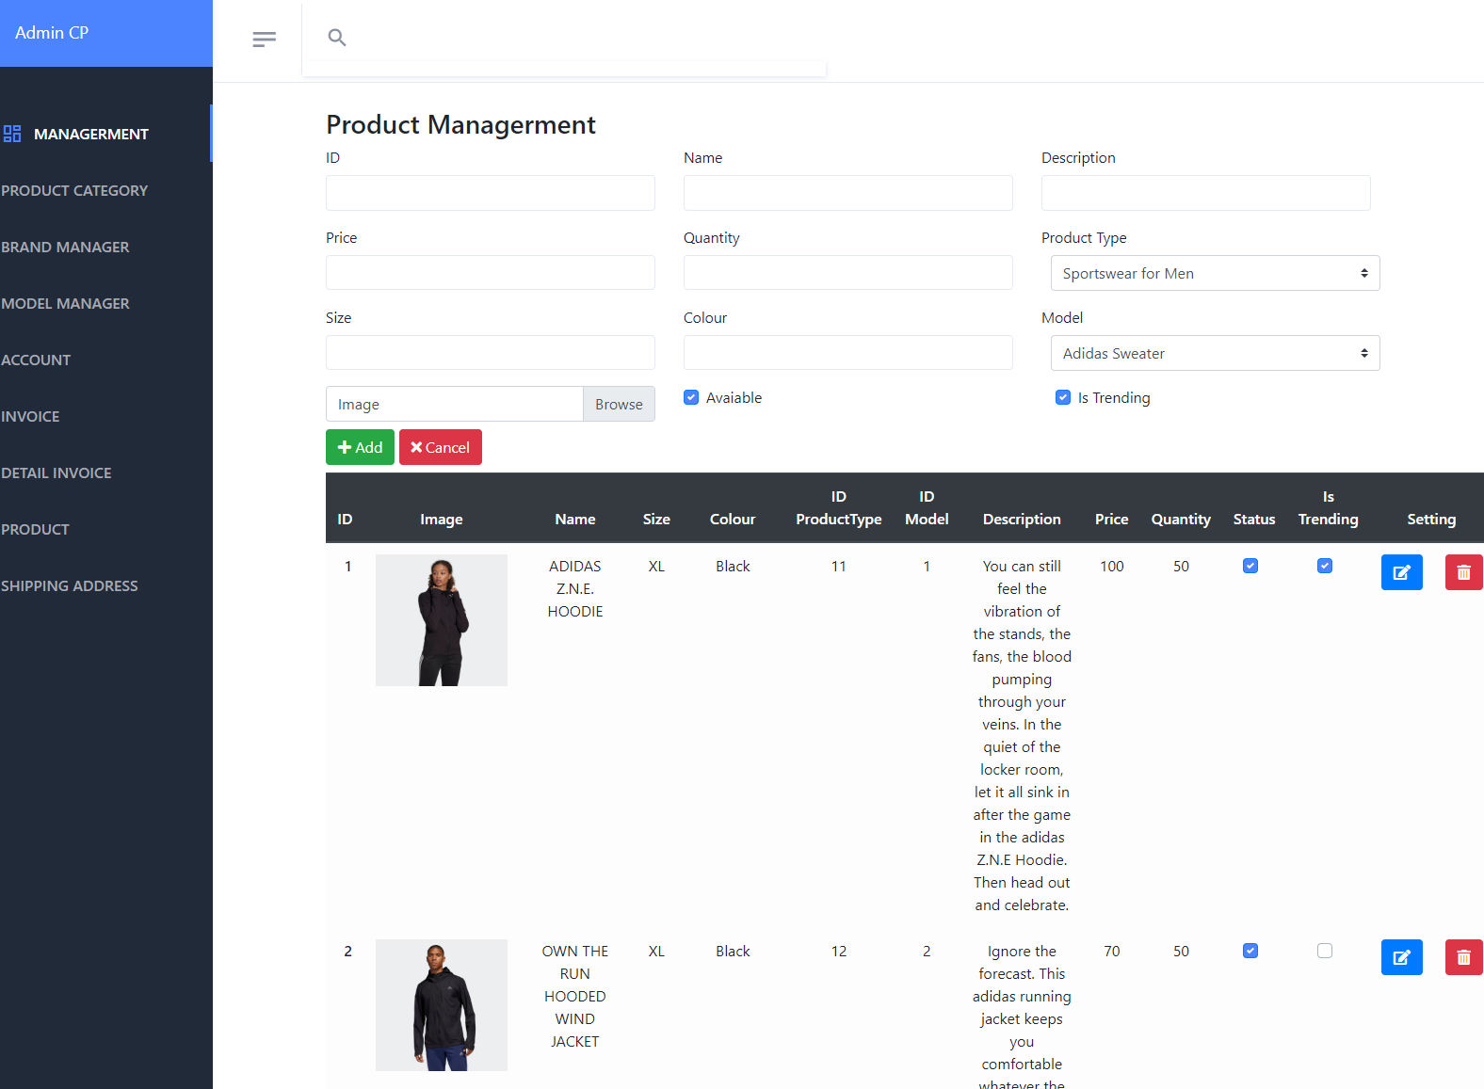

|  |  |
| --- | --- |
| **Operation No.** | **Description** |
| 1 | Click on this option will direct user to the page displaying list of products |

* **Create new product:** user can create new product by clicking on “Add New” button on the list page.

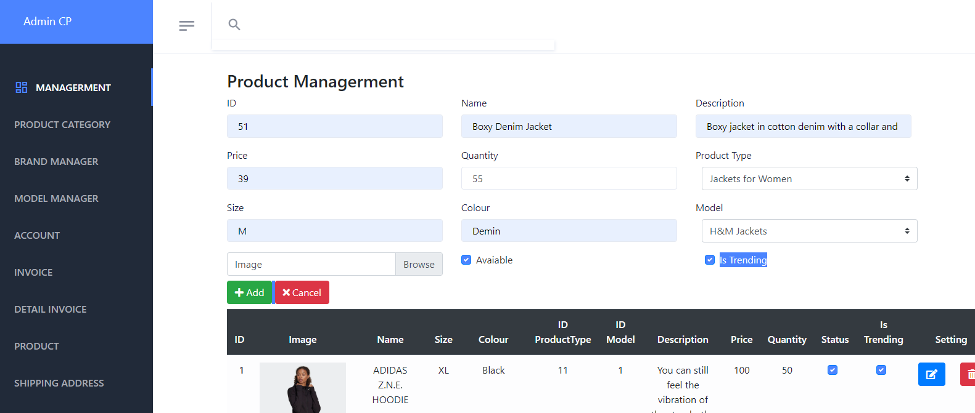

* + To finish creating new product, user needs to input all mandatory fields on the form:

|  |  |
| --- | --- |
| **Fields** | **Description** |
| Photo | * This field is mandatory. * User can upload the photo to use as product’s image. * User can only upload image file with current supported extension as: .png .gif .jpge .jpg. * User can only upload image file whose size is not larger than 5MB. |
| Name | * This field is mandatory. * Name will be display throughout the website. |
| Brand | * This field is mandatory. * Allow user to select brand which the product belongs to. |
| Category | * This field is mandatory. * Allow user to select category which the product belongs to. |
| Price | * This field is mandatory. * Allow user to input the price for the product |
| Quantity | * This field is mandatory. * Allow user to input the quantity/ stock for the product. This quantity will be updated real time whenever customer buy the product |
| Description | * This field is not mandatory. * Allow user to input product’s description |

* When user submits to create new product and all the information are correct, product will be created in the system.
* **Update product’s information:** user can update the information of one product by clicking on “Edit” icon on the list page.

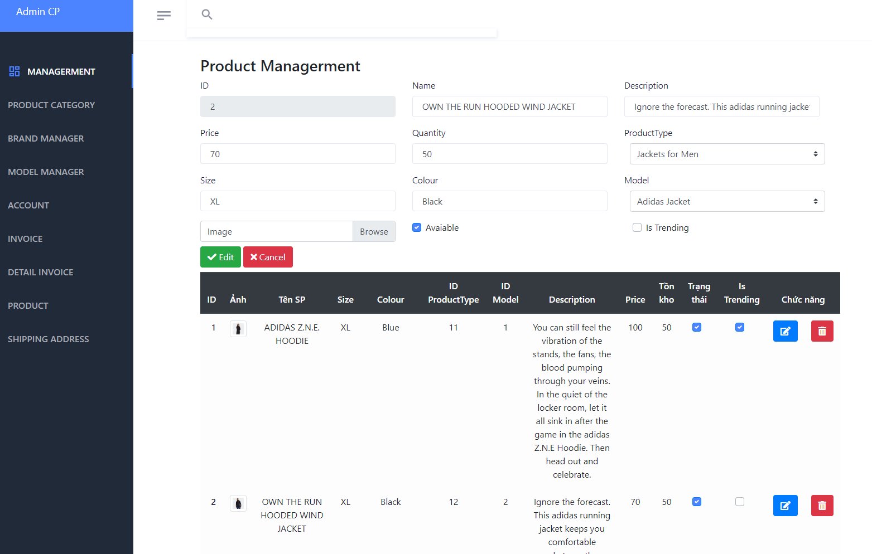

* + To finish updating the information of the product, user needs to make sure all mandatory fields on the form are filled in:

|  |  |
| --- | --- |
| **Fields** | **Description** |
| Photo | * This field is mandatory. * User can upload the photo to use as product’s image. * User can only upload image file with current supported extension as: .png .gif .jpge .jpg. * User can only upload image file whose size is not larger than 5MB. |
| Name | * This field is mandatory. * Name will be display throughout the website. |
| Status | * This field is mandatory. * Allow user to select the status for the product |
| ID_Model | * This field is mandatory. * Allow user to select brand which the product belongs to. |
| ID_Type | * This field is mandatory. * Allow user to select category which the product belongs to. |
| Price | * This field is mandatory. * Allow user to input the price for the product |
| Quantity | * This field is mandatory. * Allow user to input the quantity/ stock for the product. This quantity will be updated real time whenever customer buy the product |
| Description | * This field is not mandatory. * Allow user to input product’s description |
| Colour |  |
| Size |  |

* When user submits to update the information of the product and all the information are correct, product’s information will be updated in the system.

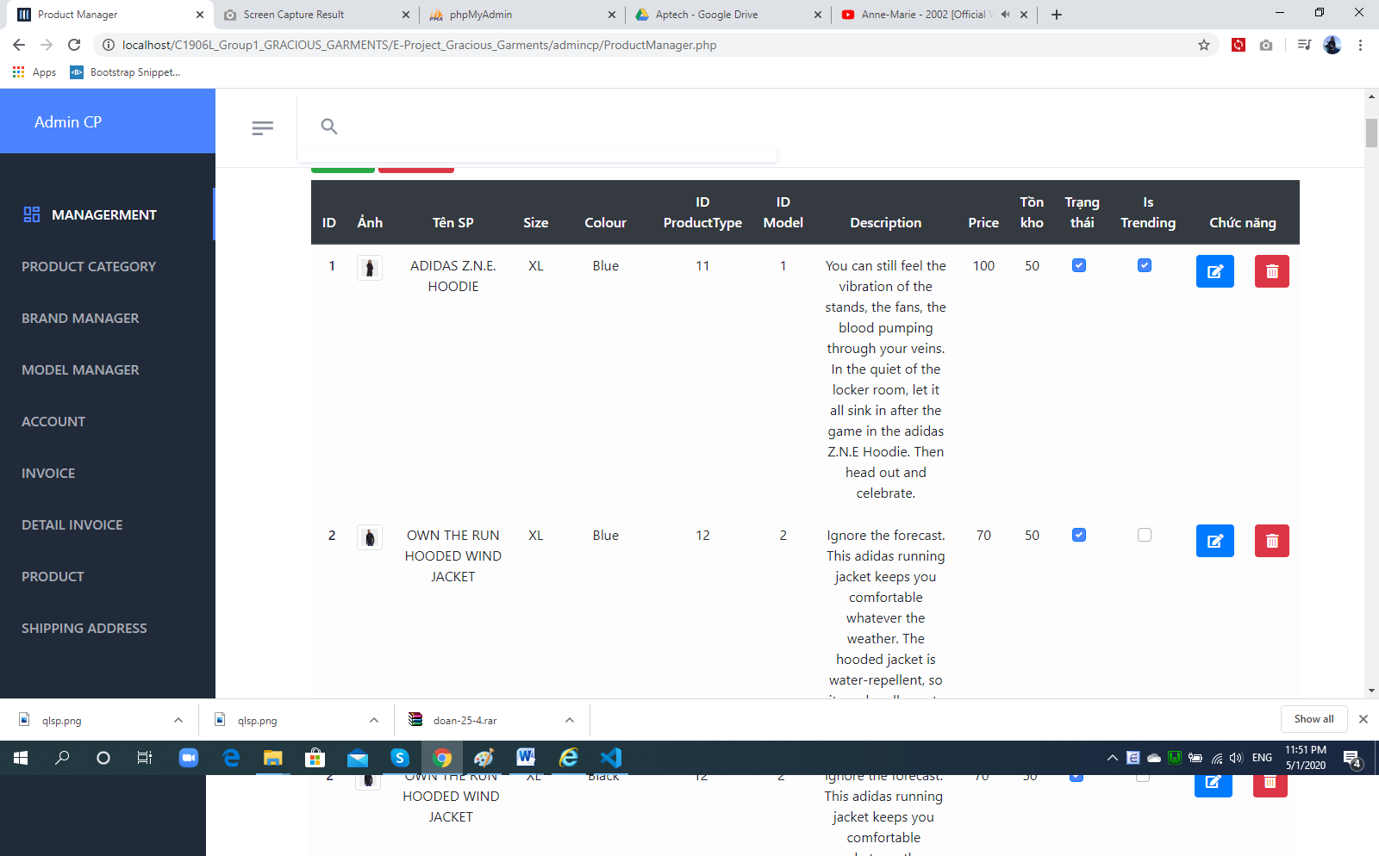

* **Delete product:** user can delete the product by clicking on “Delete” icon on the list page or “Delete” button on the Edit Detail page.

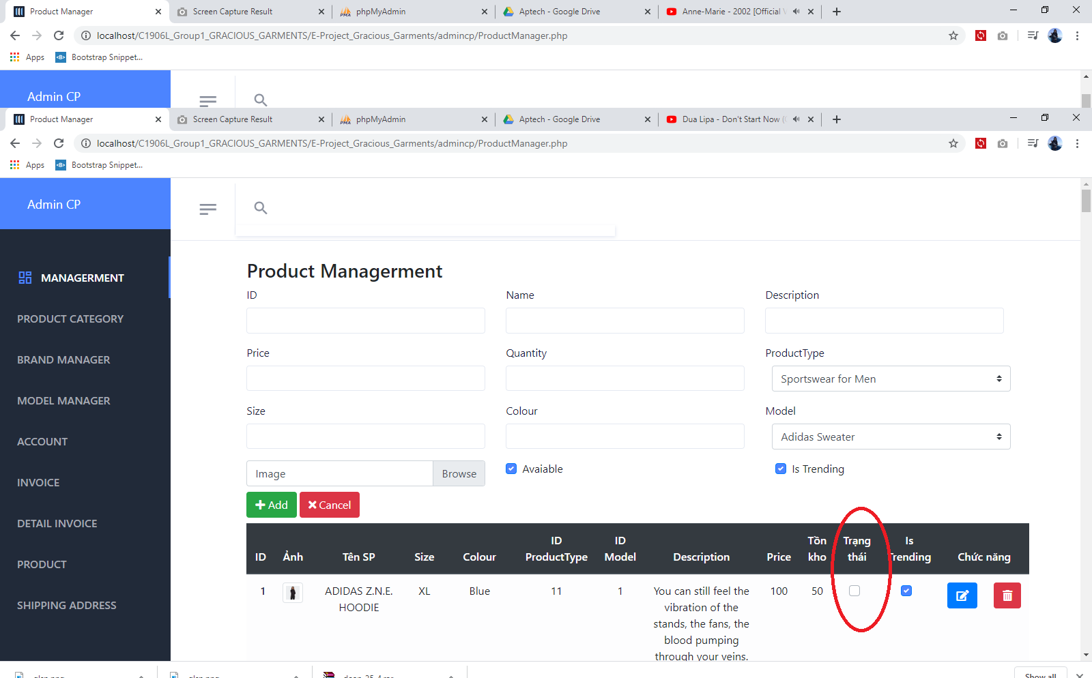

|  |  |
| --- | --- |
| **Operation No.** | **Description** |
| 1 | Click on this option will show confirmation message if user actually wants to delete the selected product. If user selects to proceed, the selected product will be deleted and will not be shown on Customer Site anymore. when click ‘OK’. Status checkbox become non-check. It marks a line was deleted |

1. ***Manage Model***
   1. **Description:**

* User can manage all products via this feature:
  + View list of products
  + Create new product
  + Update product’s information
  + Delete product
  1. **Design and Operation:**

1. **How to open Check out page:   
   Design and Operation:**

* **View list of product category:** user can view list of all Model in the system.

|  |  |
| --- | --- |
| **Operation No.** | **Description** |
| 1 | Click on this option will direct user to the page displaying list of Model |

* **Create model:** user can create new model by clicking on “Add New” button on the list page.

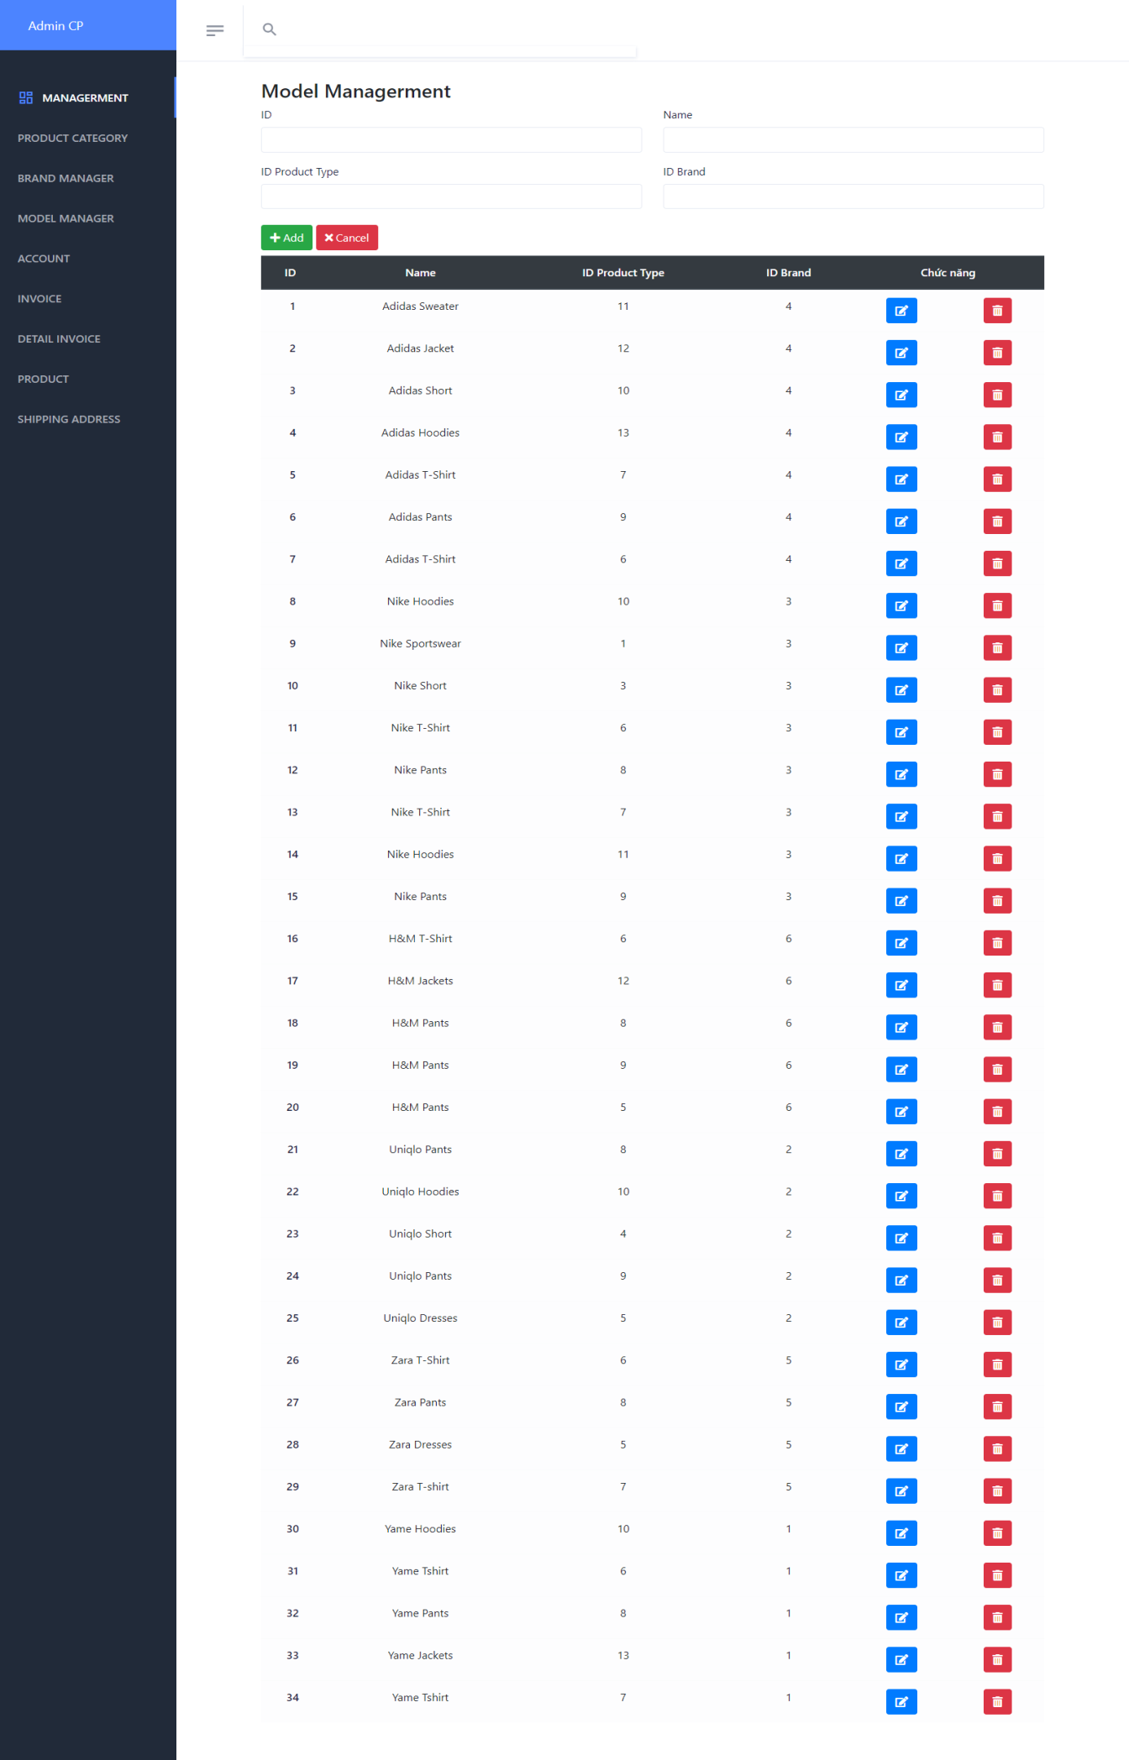

* + To finish creating new model, user needs to input all mandatory fields on the form:

|  |  |
| --- | --- |
| **Fields** | **Description** |
| ID | * This field is mandatory. * Name of product category will be display throughout the website. |
| Gender | * For men or For Women |
| Status |  |
| Name | * This field is not mandatory. * Allow user to input product category’s description |

* When user submits to create new model and all the information are correct, the product category will be created in the system.
* **Update model’s information:** user can update the information of one model by clicking on “Edit” icon on the list page.

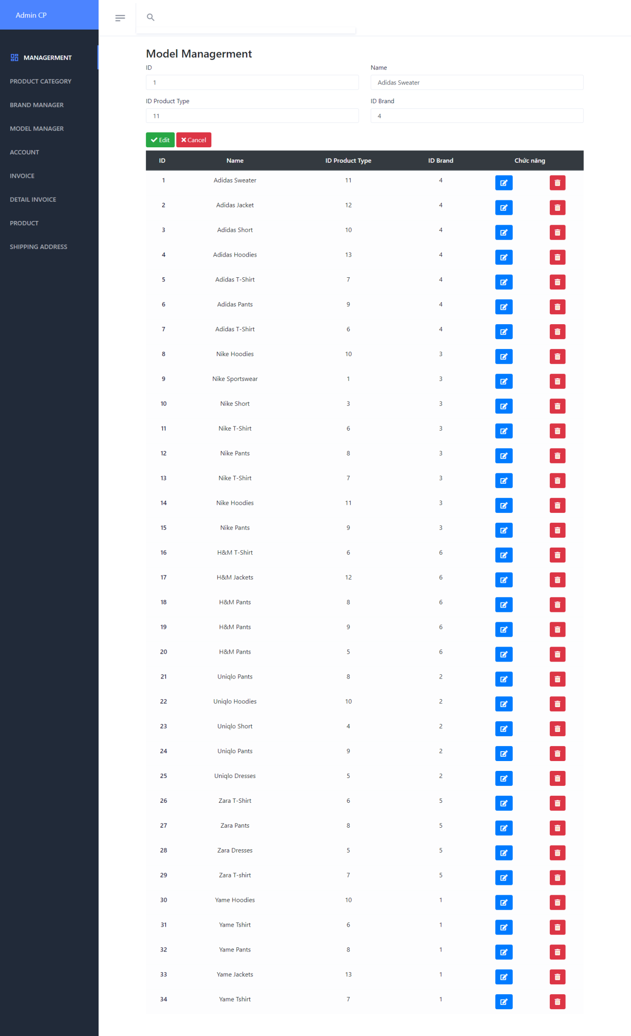

* + To finish updating the information of the product category, user needs to make sure all mandatory fields on the form are filled in:

|  |  |
| --- | --- |
| **Fields** | **Description** |
| Name | * This field is mandatory. * Name of product category will be display throughout the website. |
| Status | * This field is mandatory. * Allow user to select the status for the product category. |
| Description | * This field is not mandatory. * Allow user to input product category’s description |

* When user submits to update the information of the product category and all the information are correct, product category’s information will be updated in the system.
* **Delete product category:** user can delete the product category by clicking on “Delete” icon on the list page or get “avaibility” to non-check on the Edit (product category with type as “system default category” is excluded).

|  |  |
| --- | --- |
| **Operation No.** | **Description** |
| 1 | Click on this option will show confirmation message if user actually wants to delete the selected product category. |

1. ***Manage Customer***
2. **Description:**

* User can manage all customers via this feature:
  + View list of customers
  + Create new customer
  + Update customer’s information
  + Delete customer

1. **Design and Operation:**

* **View list of customer:** user can view list of all customers in the system.

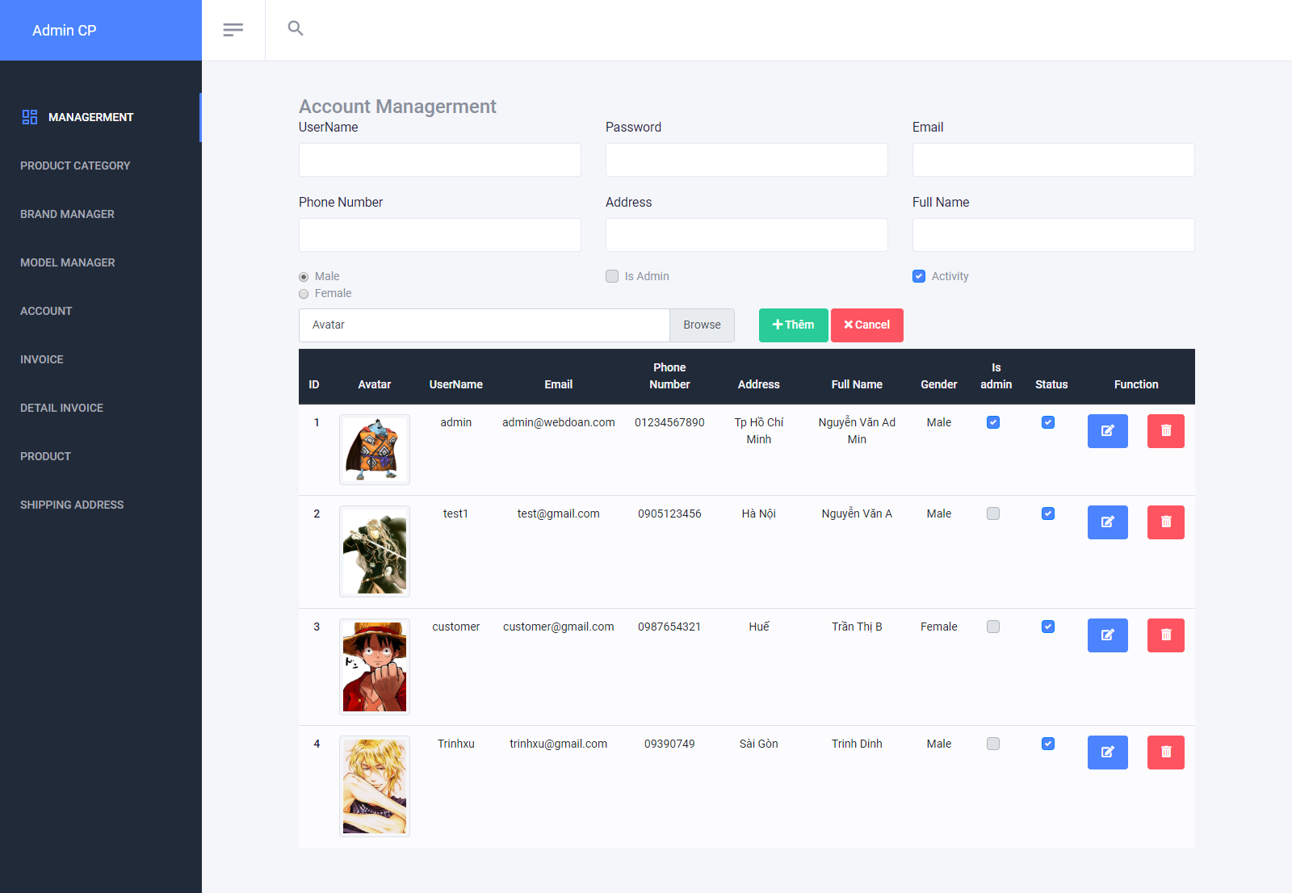

|  |  |
| --- | --- |
| **Operation No.** | **Description** |
| 1 | Click on this option will direct user to the page displaying list of customers |

* **Create new customer:** user can create new customer by filling above form and clicking on “Add” button.

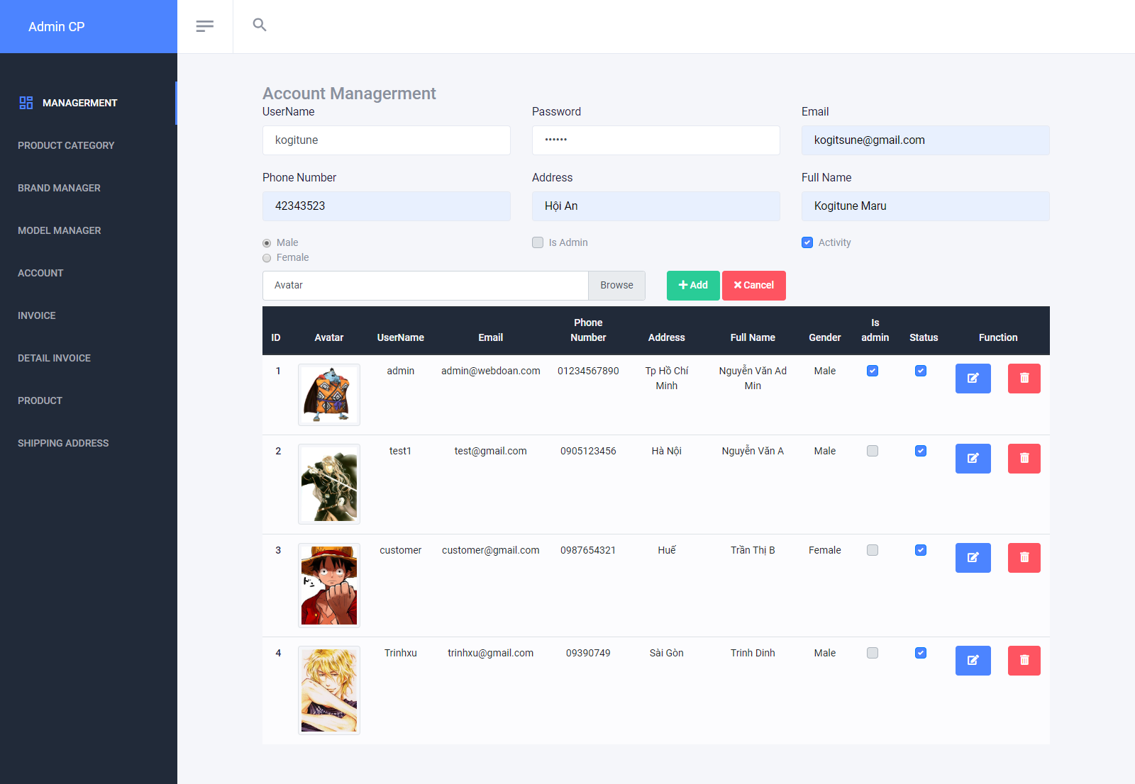

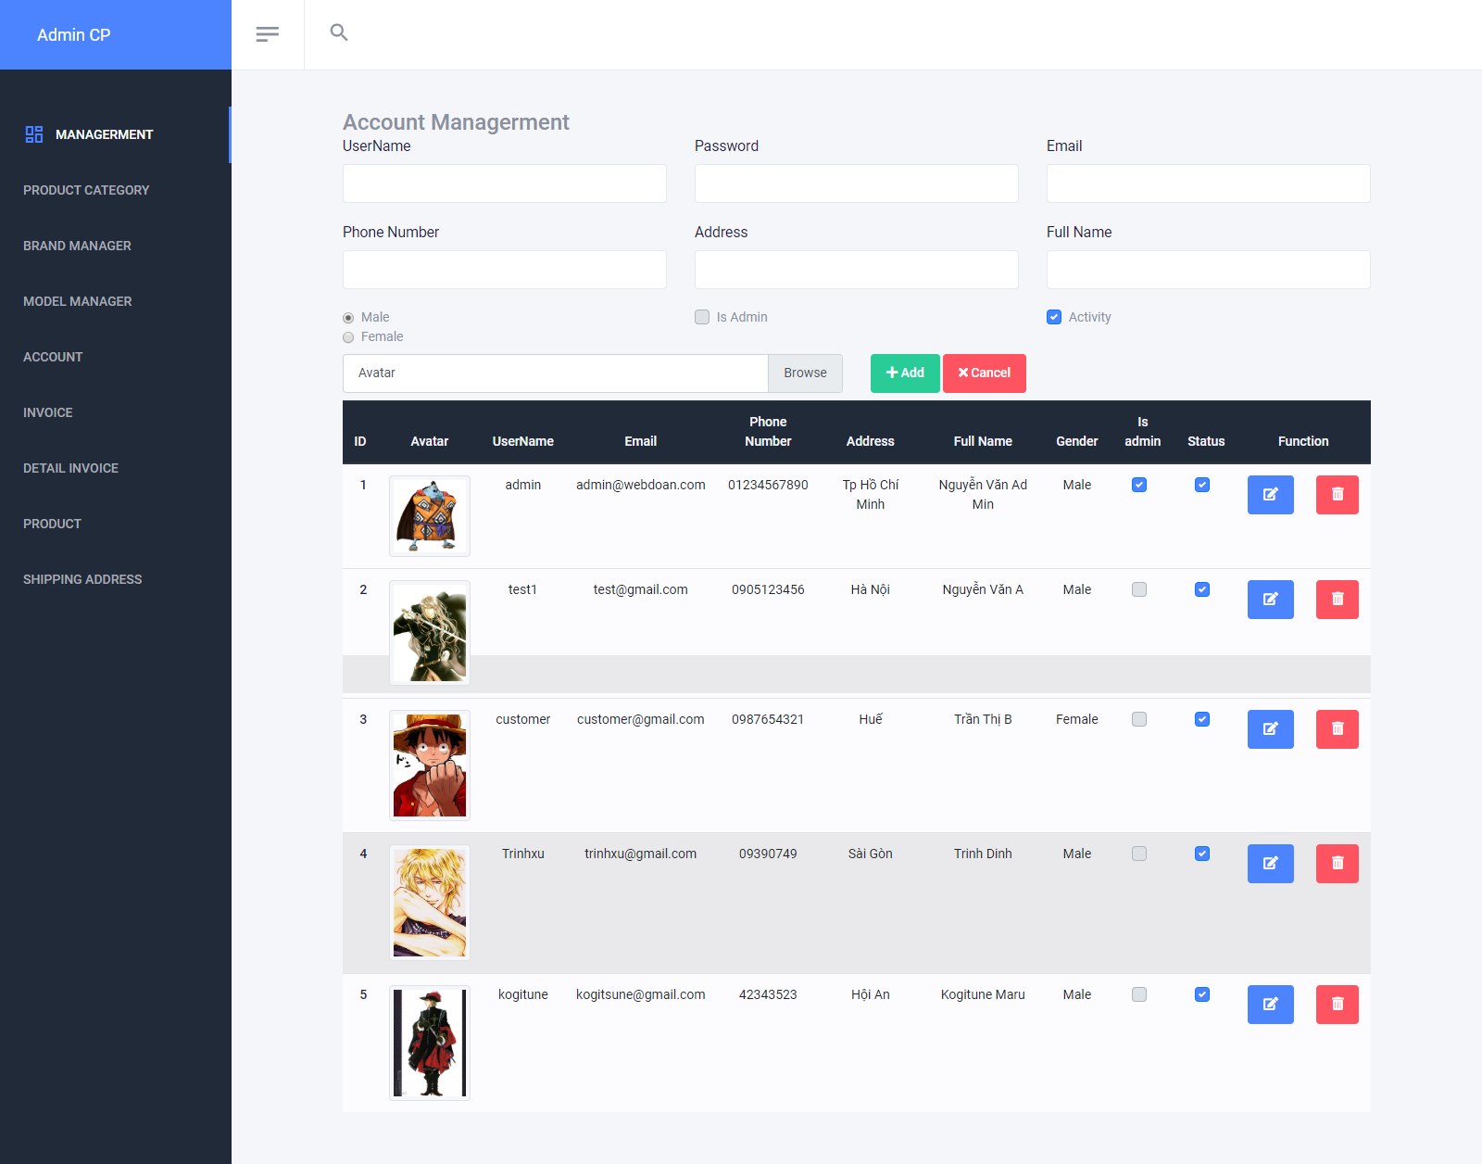

* + To finish creating new customer, user needs to input all mandatory fields on the form:

|  |  |
| --- | --- |
| **Fields** | **Description** |
| Photo | * This field is not mandatory. * User can upload the photo to use as customer’s avatar. * User can only upload image file with current supported extension as: .png .gif .jpge .jpg. * User can only upload image file whose size is not larger than 1MB. |
| Name | * This field is mandatory. * Name will be display throughout the website. |
| Password | * This field is mandatory. * Pin Code will be used as security code to reset customer’s password. Therefore, it is only shown when user create a new account, there is no other place where this value will be shown. |
| Username | * This field is mandatory. * This field will be used as login credential along with customer’s password. * Username can only contain alphabet and digit character, cannot include space or special character. * Username must be unique in the system. |
| Gender | * This field is mandatory. * Allow user to select customer’s gender |
| Email | * This field is mandatory. * Allow user to input customer’s email. Email format must be correct. |
| Phone | * This field is not mandatory. * Allow user to input customer’s phone |
| Address | * This field is not mandatory. * Allow user to input customer’s address |

* When user submits to create new customer and all the information are correct, customer’s account will be created in the system with default password as “abc123”.
* **Update customer’s information:** user can update the information of one customer by clicking on “Edit” icon on the list page. When show account information on form.

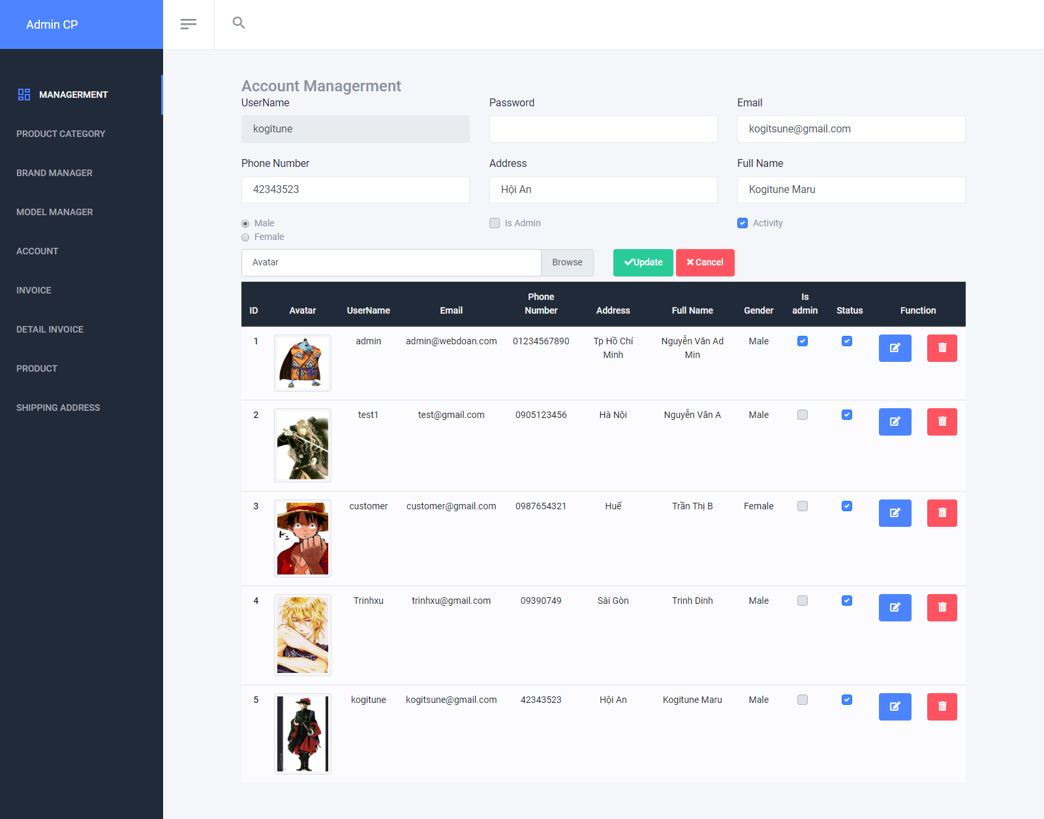

* + To finish updating the information of the customer, user needs to make sure all mandatory fields on the form are filled in:

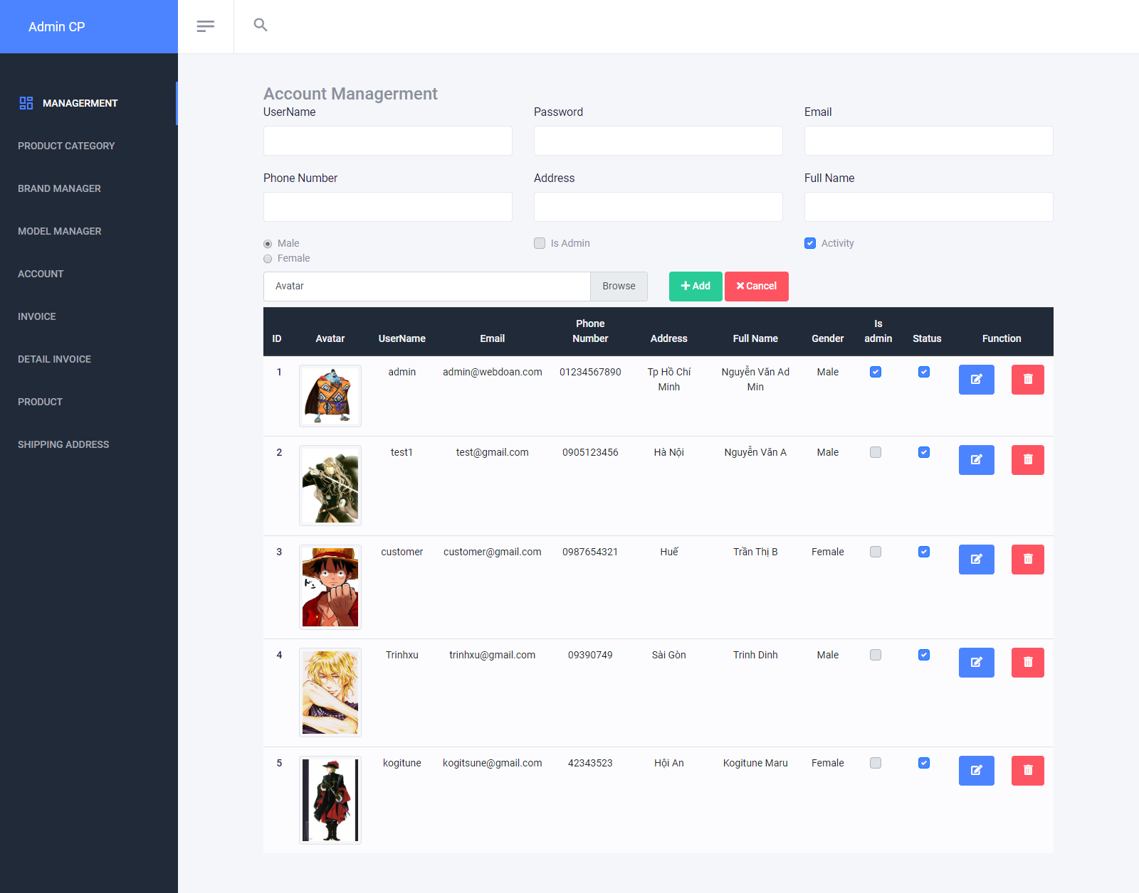

* When user submits to update the information of the customer and all the information are correct, customer’s information will be updated in the system.
* **Delete customer:** user can delete the customer by clicking on “Delete” icon on the list page or “Delete” button on the Edit Detail page.

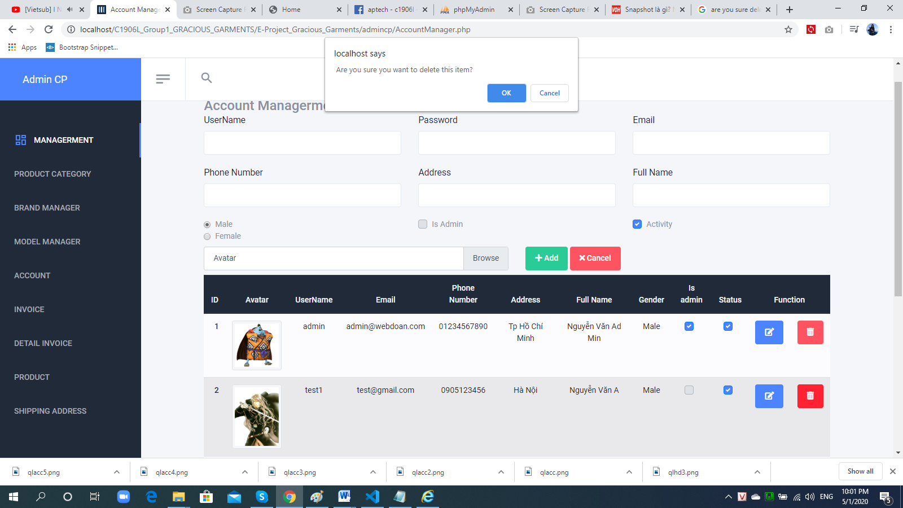

|  |  |
| --- | --- |
| **Operation No.** | **Description** |
| 1 | Click on this option will show confirmation message if user actually wants to delete the selected customer. If user selects to proceed, the selected customer will be deleted and that customer will not be able to login the system anymore. |

when click ‘OK’. Status checkbox become non-check. It marks a line was deleted

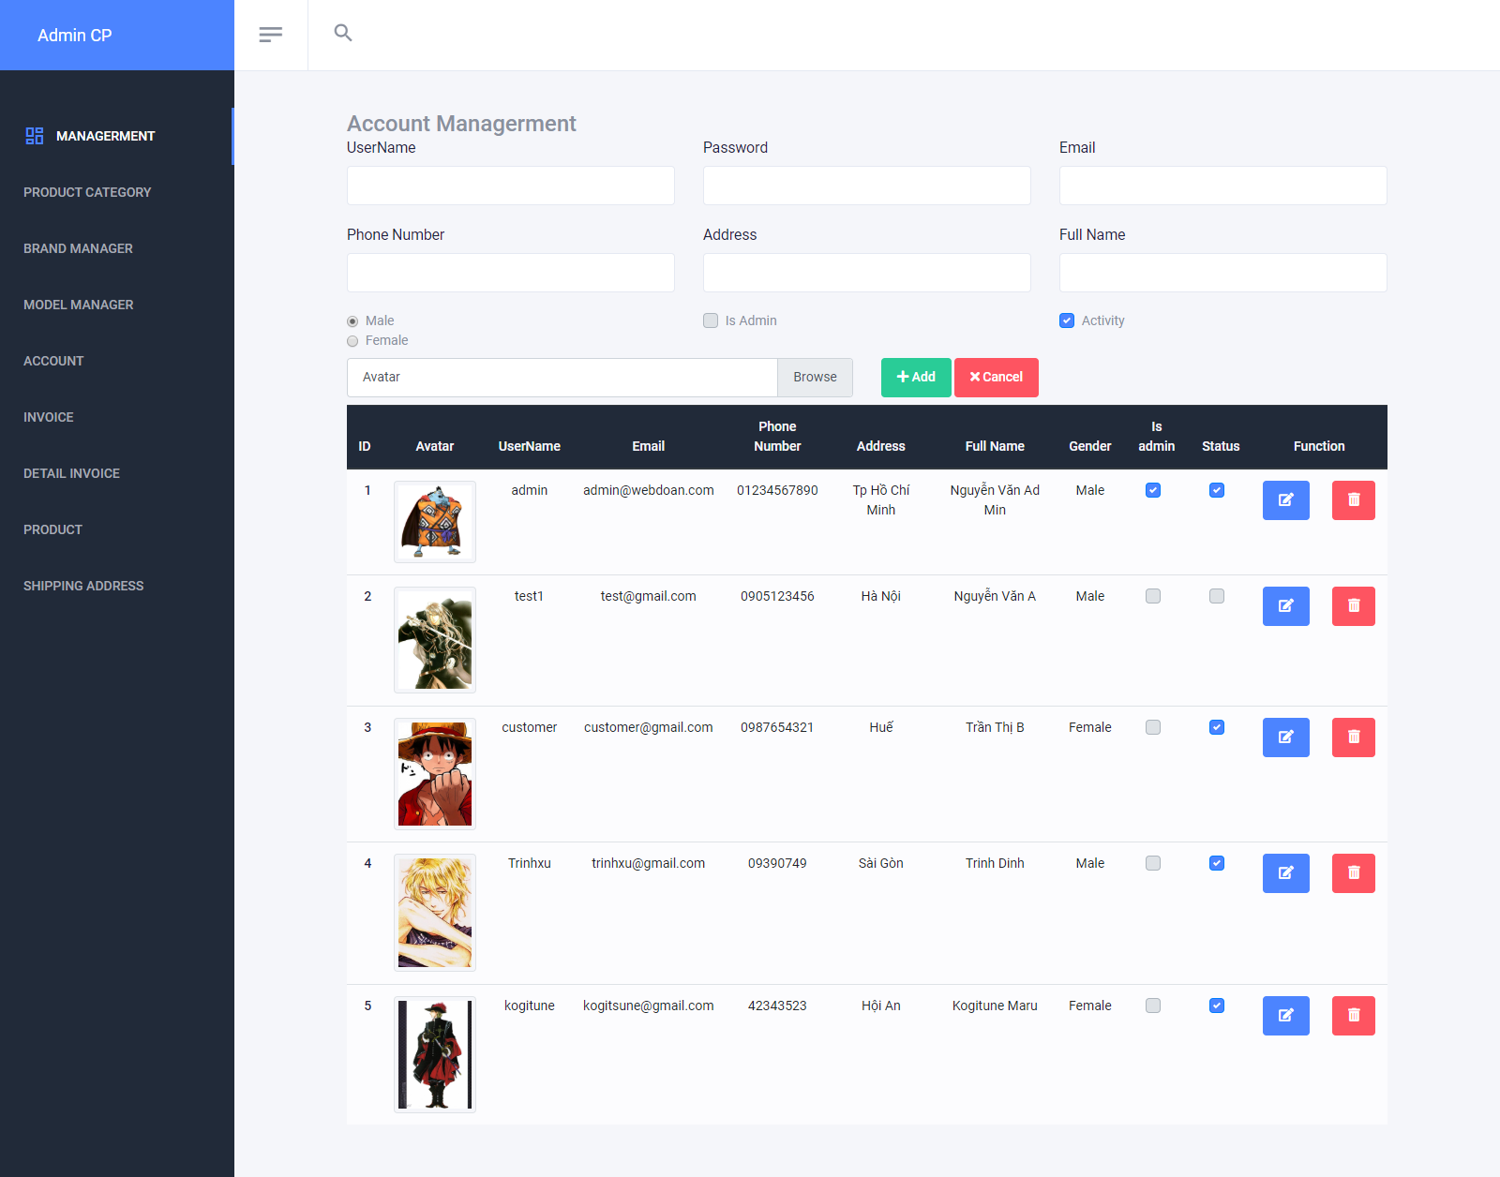

1. ***Manage Invoice***
2. **Description:**

* User can manage all orders via this feature:
  + View list of orders
  + View detail of order
  + Delete and Edit order

1. **Design and Operation:**

* **View list of orders:** user can view list of all orders in the system.

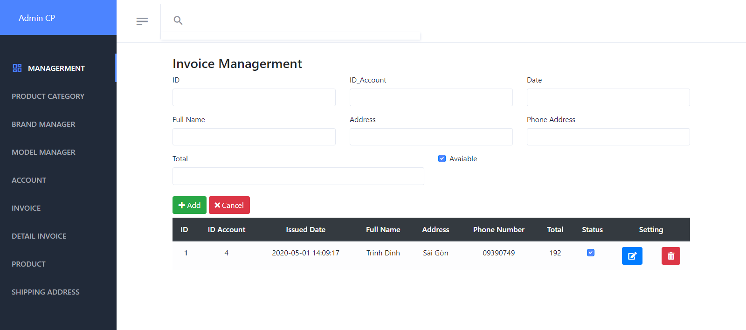

|  |  |
| --- | --- |
| **Operation No.** | **Description** |
| 1 | Click on this option will direct user to the page displaying list of orders |

* **Delete order:** user can delete the order by clicking on “Delete” icon on the list page or “Delete” button on the Edit Detail page. When user click on ‘delete’ icon , will show a confirmation message “ **Are you sure** you want to **delete** this item?”. Click ‘OK’ if you want.

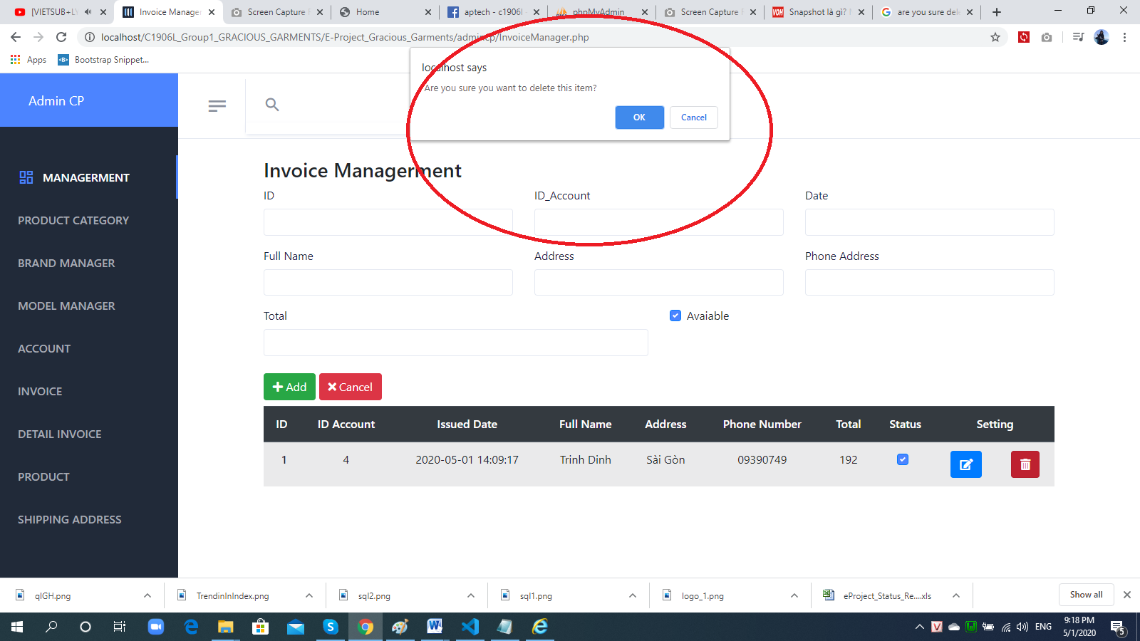

|  |  |
| --- | --- |
| **Operation No.** | **Description** |
| 1 | Click on this option will show confirmation message if user actually wants to delete the selected order. If user selects to proceed, the selected order will be deleted and the quantity of all products in the order will be returned to them own. |

* **Delete order:** when click ‘OK’. Status checkbox become non-check. It marks a line was deleted.  
  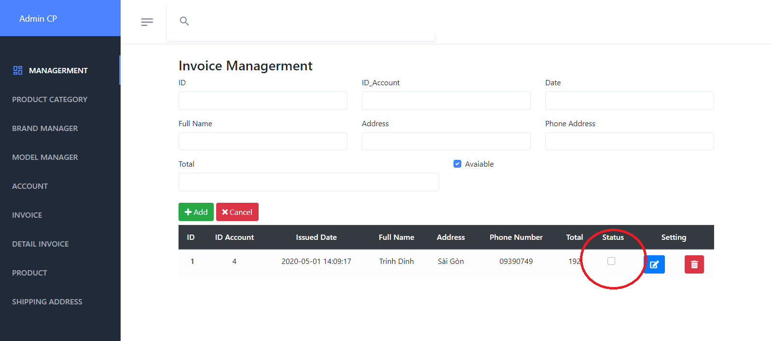
* **Edit order:** when click setting icon. Invoice detail show in above form.

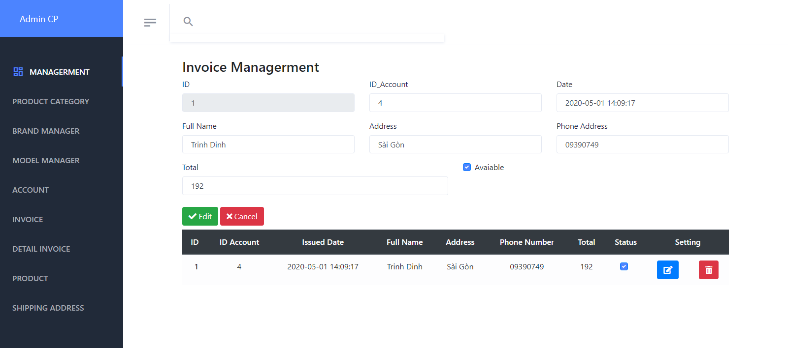

When user change information of Invoice and click Edit button. Below list change too.

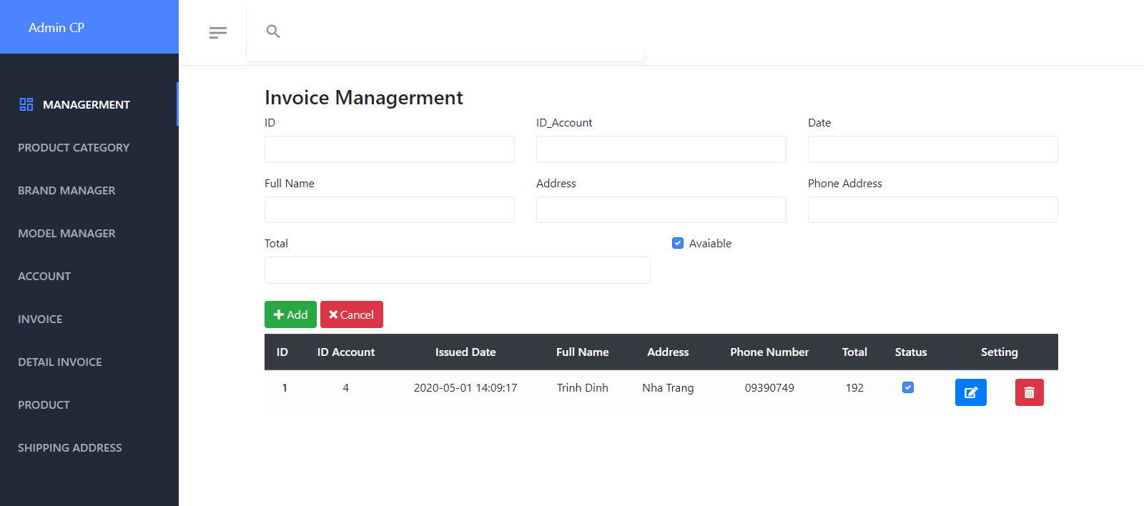

1. ***Manage Invoice Detail***
2. **Description:**

* User can manage all detail orders via this feature:
  + View detail of order
  + Delete and Edit order

1. **Design and Operation:**

* **View list of orders:** user can view list of all orders in the system.

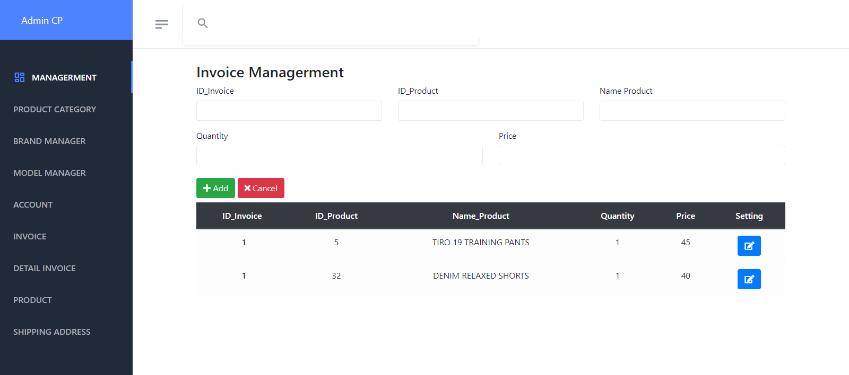

|  |  |
| --- | --- |
| **Operation No.** | **Description** |
| 1 | Click on this option will direct user to the page displaying list of orders |

* **Edit order:** when click setting icon. Invoice detail show in above form.



1. ***Manage Homepage Content***
2. **Description:**

* Admin can manage all homepage images via this feature:
  + View list of homepage images
  + Update homepage image

1. **Design and Operation:**

* **View list of homepage images:** user can view list of all homepage images in the system.

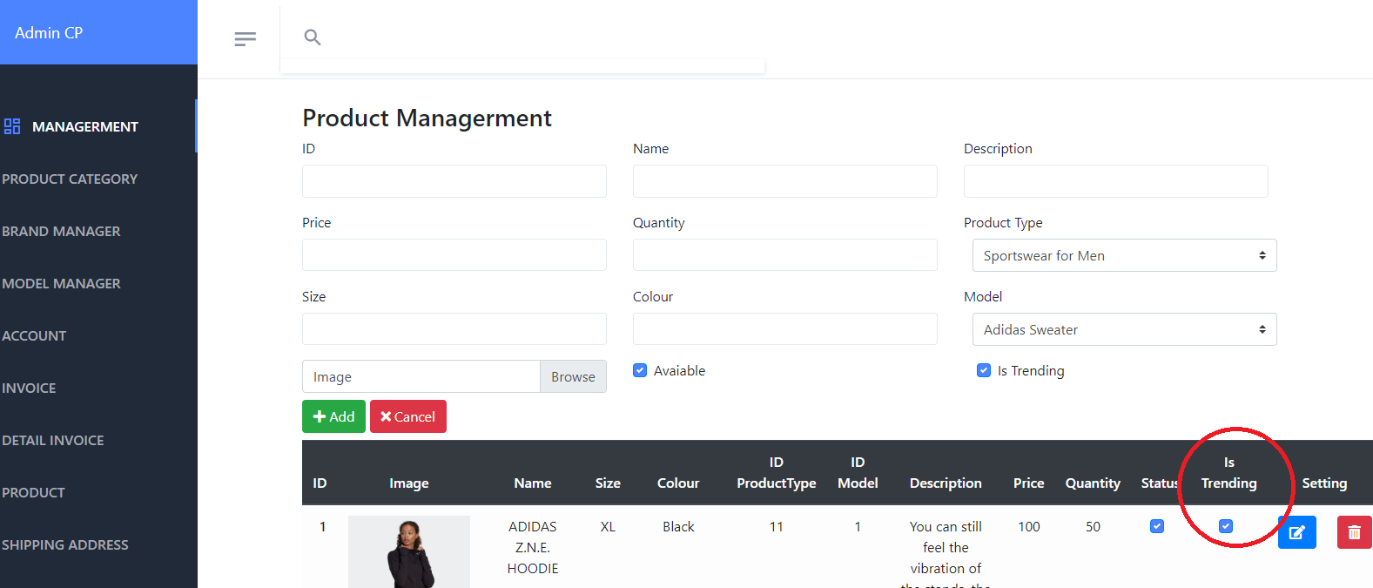

|  |  |
| --- | --- |
| **Operation No.** | **Description** |
| 1 | Click on this option will direct user to the page displaying list of homepage images |

**Slider :** user can change slide in hompage in folder C:\wamp64\www\C1906L_Group1_GRACIOUS_GARMENTS\E-Project_Gracious_Garments\images\Slider

CHAPTER VII: DEVELOPER GUIDE

* + - 1. ***Install Xampp***
         1. **Change Port:**

1. Open the WAMPP control panel, stop all running modules.
2. If Wampp icon don’t change Green. Next step 3
3. Click the “Config” button for the Apache module and select “Apache (httpd.conf)”.
4. Alternately you can open the file located in your WAMPP install folder “/apache/conf/httpd.conf” with a different text editor.
5. Find the following line around line 58 in the file. Port 80 is the default listen port for Apache.

|  |  |
| --- | --- |
|  | Listen 80 |

1. Change it to another port number not in use, for this example we’ll change it to port 8080.

|  |  |
| --- | --- |
|  | Listen 8080 |

1. Find the following line around line 225 in the same file. The ServerName variable is used to give the server a name and port to identify itself with.

|  |  |
| --- | --- |
|  | ServerName localhost:80 |

1. Replace it with the same port number you used in step 4.

|  |  |
| --- | --- |
|  | ServerName localhost:8080 |

1. Save the conf file.

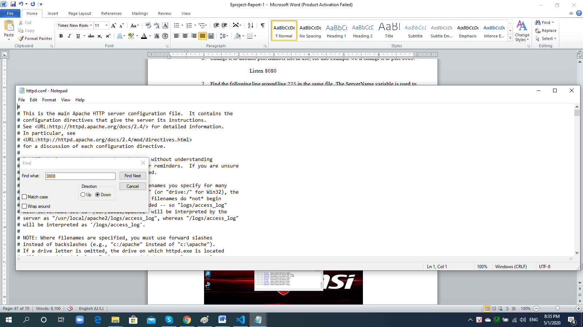



* 1. **Setting MySQL**
  2. Click phpMyAdmin or <http://localhost/phpmyadmin/>
  3. Click User Accounts -> Click Add User account at top menu.

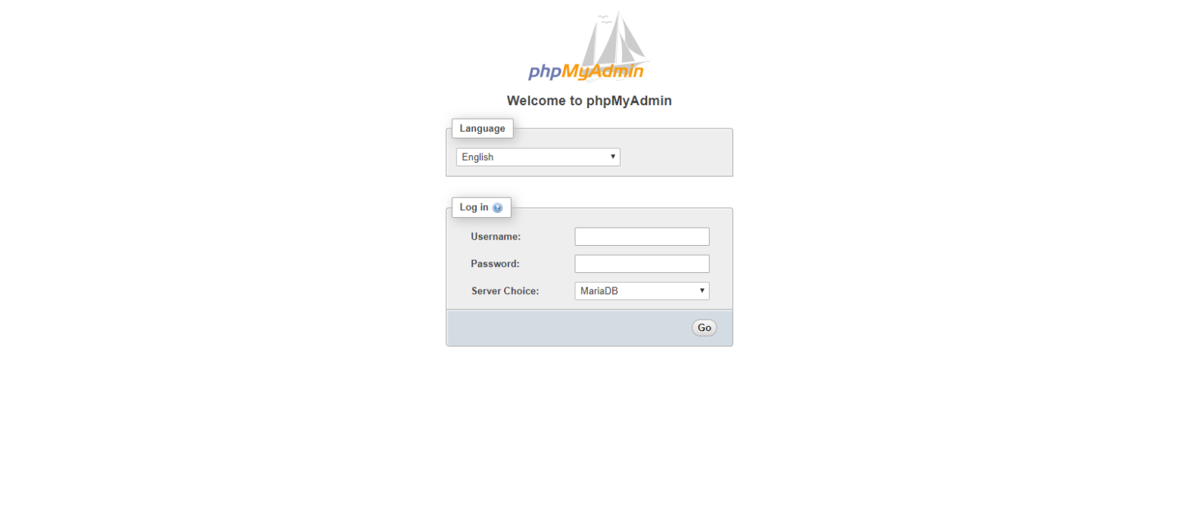

* 1. Fill in serverName = “localhost”; or "localhost:3308";  
       username = "root";

     password = "";

* 1. **Create Database and Data**

1. Click SQL at top menu-> Fill the code in file “Gracious_Garments.sql ” in C:\wamp\www\C1906L_Group1_GRACIOUS_GARMENTS\Database and click Go.

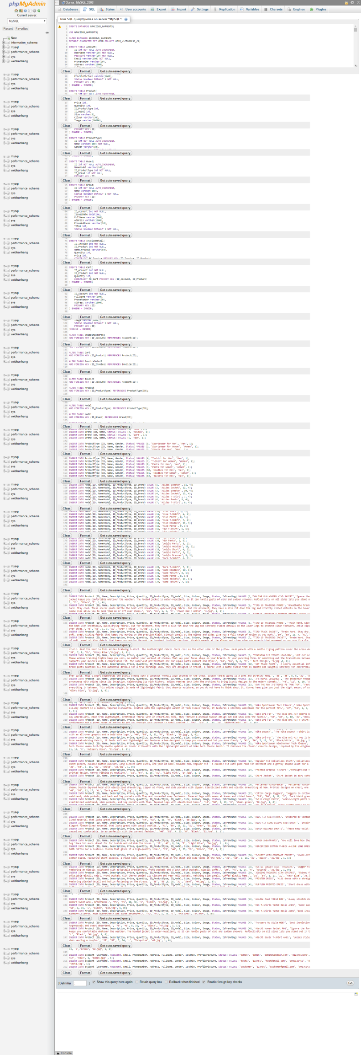

1. Click webdoan

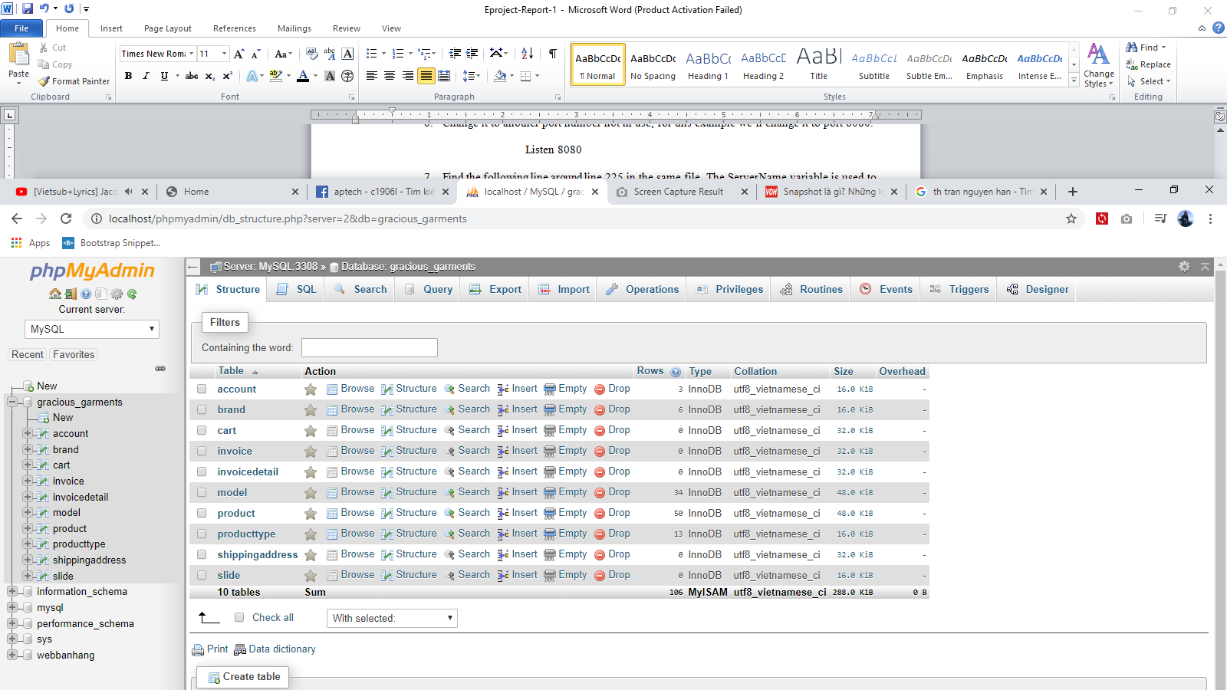

* 1. **Access the website**
     + 1. Copy file C1906L_Group1_GRACIOUS_GARMENTS and paste in file htdocs(Location: C:\xampp\htdocs ) or (C:\wamp\www)
       2. Open your browser and access link below : <http://localhost/C1906L_Group1_GRACIOUS_GARMENTS/E-Project_Gracious_Garments/index.php> And below is the home page of website.